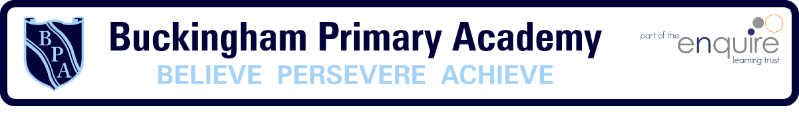
Phonics
Week 3

- Daily phonics sessions should be no longer than 15 minutes
- It is important that children repeat both the activities and the sounds
- Sessions should be practical and involve lots of games (either on an iPad or tablet or you can make your own)

Phase 2 | Phase 3
- Recap Phase 2 sounds s a t p i n  - Recap Phase 2 Tricky words  - Learn Phase 2 sounds m d g  - Create list of words that use the initial sounds m d g  - Watch Geraldine the Giraffe does Phonics on YouTube  https://www.youtube.com/watch?v=Xh6Ux5D2D84  - Listen to the Tricky Word Song on YouTube  https://www.youtube.com/watch?v=e2dx65u59aw  - Create your own Phase 2 word cards using the sounds you have covered so far (sat, pin, pat, tin) and read the words as quickly as you can | - Recap Phase 2 & 3 sounds j v w x y z  - Recap Phase 3 Tricky words  - Learn Phase 3 sounds z zz qu  - Create list of words that use the sounds z zz qu (compare z and zz)  - Watch Geraldine the Giraffe does Phonics on YouTube  https://www.youtube.com/watch?v=O6jgGvZ-3zQ  - Listen to the Tricky Word Song on YouTube  https://www.youtube.com/watch?v=e2dx65u59aw  - Create your own Phase 3 word cards using the sounds you have covered so far to play a game of ‘Beat the Timer’
Phase 4 | Phase 5
- Recap Phase 2, 3 & 4 sounds  - Recap Phase 3 & 4 Tricky words  - Introduce new Phase 4 Tricky words said have like so do  - Listen to the Tricky Word Song on YouTube  https://www.youtube.com/watch?v=R087lYrRpgY  - Using Phase 4 blends create flashcards to hide around the house and go on a Phase 4 treasure hunt (frog, glasses, grandpa)  - Play Phase 4 Buried Treasure https://www.phonicsplay.co.uk/BuriedTreasure2.html  - Create your own Phase 4 word cards to play a game of ‘Beat the Timer’ | - Recap Phase 2, 3, 4 & 5 sounds ay ou ie ea oy ir  - Recap Phase 3, 4 & 5 Tricky words  - Learn Phase 5 sounds ue aw wh  - Create list of words that use the sounds ue aw wh  - Watch Geraldine the Giraffe does Phonics on YouTube  https://www.youtube.com/watch?v=BCeE3B_tAq8  - Listen to the Tricky Word Song on YouTube  https://www.youtube.com/watch?v=e2dx65u59aw  - Create your own Phase 4 word cards using the sounds you have covered so far to play a game of ‘Beat the Timer’

