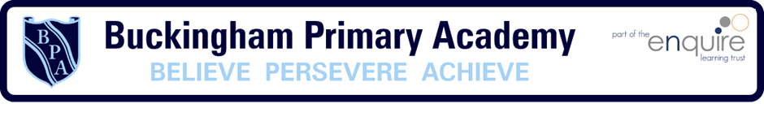

Buckingham Primary Academy –RE Intent

At Buckingham Primary Academy, we believe that it is vital for all our pupils to learn from and about religion, so that they can achieve a broad understanding of the world around them. Through Religious Education, pupils develop their knowledge of the world faiths, and their understanding and awareness of the beliefs, values and traditions of other individuals, societies, communities and cultures. We encourage our pupils to ask questions about the world and to reflect on their own beliefs, values and experiences, which are designed in our 3D curriculum, allowing horizontal and vertical links with previous year groups.
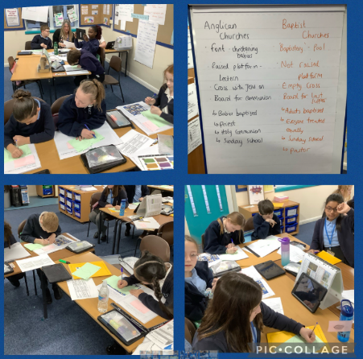
Throughout the curriculum, pupils build knowledge of the world’s main religious and non-religions so as not to imply precedence. We promote the cultural development of our pupils and ensure that our curriculum reflects our community (locally, globally and nationally).
Our curriculum covers:
- Christianity
- Islam
- Judaism
- Hinduism
- Non-religious views (Humanism)
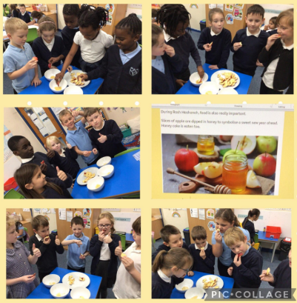
- Other world religions (Buddhism)
Our curriculum is split into three main strands: believing, expressing and living. Through this, pupils receive a wealth of knowledge about the religions studied; allowing them to build upon knowledge as they progress through the curriculum. Sessions all begin with a retrieval task which enables them to bring knowledge back to their working memory, from this, pupils build on their learning, make links and create new schemas. Children show perseverance and respect whilst studying different beliefs and the curriculum enables links between religions to be made.
Our curriculum is supported through visits to religious buildings or visitors into school. This supports our personal development offer and allows pupil to advance their cultural capital.

