At Buckingham Primary Academy school we follow the SCODE spelling programme from years 2 to 6
Introduction
The rationale behind this system is summarised in the diagram below.
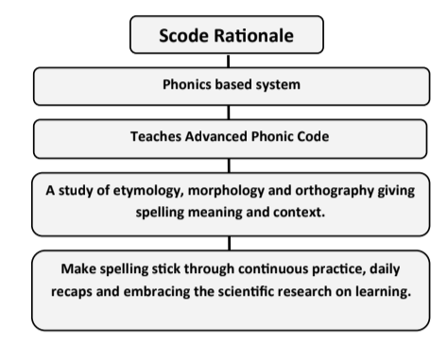
This scheme teaches the spelling requirements of the National Curriculum for years 2-6 by teaching children the Advanced English Phonic Code. The National Curriculum (2013) states; ‘The rules and guidance are intended to support the teaching of spelling. Phonic knowledge should continue to underpin spelling after key stage 1; teachers should still draw pupils’ attention to GPCs that do and do not fit in with what has been taught so far. Increasingly, however, pupils also need to understand the role of morphology and etymology’.
It is widely accepted that English is a complicated language to learn, especially when it comes to writing. In short, the English alphabet is made up of 26 letters, these combine to make the 44 sounds or phonemes we speak. However, when it comes to the writing/spelling of these sounds there are over 150 combinations or graphemes.
Take as an example the sound /ul/ like in the word kettle:
