Substantive knowledge – coverage of science topics across the academic year.
 | Plants | Rocks | Animals Inc humans | Forces & Magnets | Materials | States of Matter | Seasonal changes | Electricity  Physics | Light  Physics | Earth & Space  Physics | Living things and habitats | Evolution and inheritance | Sound
EYFS
1
2
3
4
5
6

EYFS = yellow because topics are covered through continuous provision linked to POR texts and enquiry questions
Autumn = Orange
Spring = Green
Summer = Blue

Biology | Chemistry | Physics
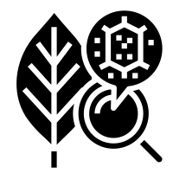

BIOLOGY | CHEMISTRY | PHYSICS

Year 1 | Year 2 | Year 3 | Year 4 | Year 5 | Year 6
Animals including Humans  (types of animal ) | Uses of Everyday Materials | Light | Animals including Humans  (digestive system and teeth) | Animals including Humans (puberty) | Animals including  Humans (changes as humans age)
 |  |  |  | Animals including Humans (puberty)
Everyday  Materials |  | Forces and  Magnets | Animals including  Humans  (food chains) | Properties and  Changes of  Materials | Electricity
 | Living Things and their Habitats  (habitats and food chains) | Animals including  Humans  (skeletons) | Sound | Forces | Animals including  Humans  (circulatory system)
Everyday  Materials | Animals including Humans  (staying healthy ) | Rocks | Electricity | Properties and  Changes of  Materials | Light
Animals including  Humans  (human body) | Plants | Plants | Living things and their Habitats  (classification) | Living things and their Habitats  (life cycles and reproduction) | Evolution and Inheritance
Plants | Animals including  Humans  (life cyles) |  | States of Matter | Earth and Space | Living things and their Habitats (classification)

Disciplinary knowledge

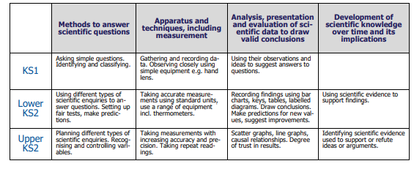
This table links to the document on the inside of the front cover of science books. Teachers date the skills used during science lessons to ensure maximum coverage.

