BUCKINGHAM PRIMARY ACADEMY –Geography
Enquiry Question Why can’t a meerkat live in the North Pole? |  | Year group 1
What will be taught through the unit:  Seasonal and daily weather patterns in the United Kingdom, the location of hot and cold areas of the world in relation to the Equator and the North and South Poles and the animals that live there. |  | Geographical Enquiry:  - Can they answer some questions using different resources, such as books, the internet and atlases?  - Can they think of a few relevant questions to ask about a locality>?  - Can they answer questions about the weather?  - Can they keep a weather chart?
Why does Sunny live in the Kalahari desert? | Meerkats live in the Kalahari Desert, which is on the Southern tip of Africa. They are mammals, which means they have warm blood, are covered in fur and feed their babies with milk. They live in groups called ‘mobs’ with up to 50 members. Meerkats make their homes in underground burrows that keep them safe from predators. They are omnivores, which means they eat both plants and animals. Meerkats are specially adapted to living in the harsh desert environment. Dark patches around their eyes help them be effective lookouts by reducing the glare of the sum. Their eyes also allow them to take in a wide-angle view of the scene. This helps prevent predators from gaining an advantage by sneaking up. | Picture or diagram associated with your unit  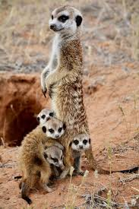  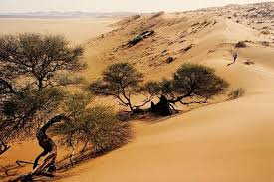  Kalahari desert  Meerkat  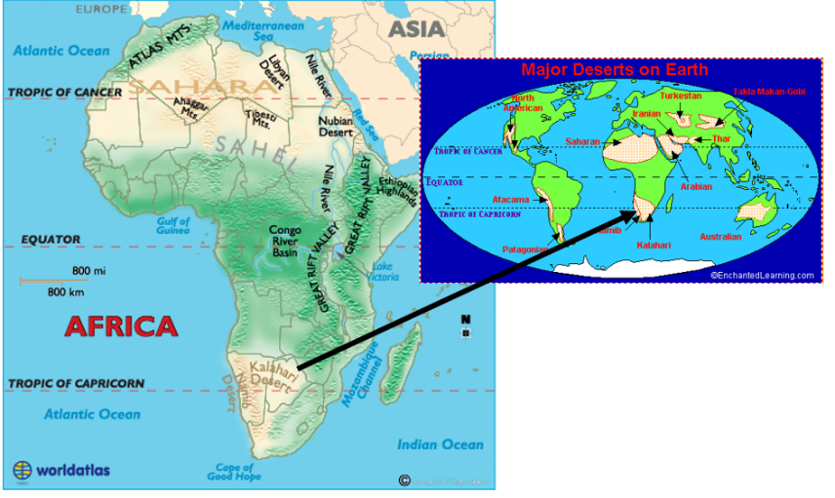
Which animals live in cold places like the North and South Pole? | The Polar regions are located at the two ends of the Earth – the Arctic to the north and Antarctica to the south. These regions have just two seasons, summer and winter, and have very cold climates. There are some plant and shrub life on the tundra, but parts of the polar regions, known as the ice caps, are frozen all year round. Arctic animals include the Arctic fox, Beluga whales, polar bears and reindeer. Antarctic animals include penguins, seals and the Orca whale.
How do Polar Bears keep warm? | Polar bears are incredibly well insulated with a layer of blubber that can be up to 10cm thick covered with another 15cm of fur. Polar bears lose so little heat to their environment that they are almost invisible to thermal imaging cameras.
What do we mean by hot and cold colours? | - Red, orange and yellow (warm colours) have a positive radiation.  - Blue, violet and indigo (cold colours) have a negative radiation.  - Green is both negative and positive and many experts say that it is the link between the two categories.  Creative Art - Mixing paint to create hot and cold paintings.
Why do people usually like going to hot places for their holidays? | Explore popular holiday destinations- create graphs for where children have visited. Look at locality, rainfall, temperature, and cloud cover.
Why do we wear different clothes in summer and winter? | We wear light coloured clothes in summer because light colours reflect heat which helps our body to keep cool, whereas dark colours absorb heat, that is why it is considered to wear dark coloured clothes in winter. Explore different types of clothing suitable for different weather conditions.
How can we recreate a Meerkat dance? | Movement work focusing on the way Meerkats move.  https://www.youtube.com/watch?v=W4og8g_X22o
Reflection: Would you rather be a Meerkat or a Penguin? | Compare meerkats and penguins.

Timeline of significant events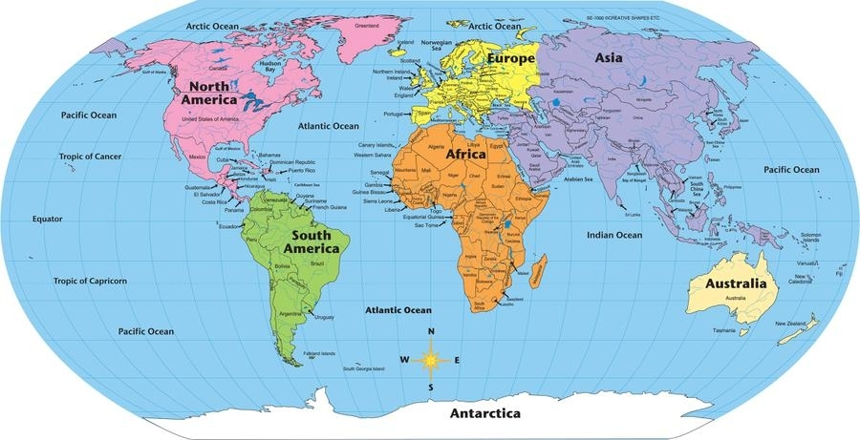 | Vocabulary  - Arctic – the regions around the North Pole  - Antarctica – the regions around the South Pole  Burrow – a hole or tunnel dug by a small animal  Climate – the weather conditions of a place  - Desert – an area of land with little water, usually covered with sand  Habitat – the natural home of an animal or plant  Ice cap – a covering of ice over a large area  Mammal – a warm-blooded animal covered in hair or fur, which feeds its babies with milk  - Meerkat – a small southern African animal of the mongoose family  - Predator – an animal that naturally preys on others  - Temperature – a measurement of how warm or cold a place is  - Tundra – a part of the Arctic region which is flat, treeless and where some of the soil is frozen all the time
Trips/ Visits & Useful Websites:  Yorkshire wildlife park  https://www.youtube.com/watch?v=W4og8g_X22o | Useful information or people to be studied in this particular unit

