BUCKINGHAM PRIMARY ACADEMY –Geography
Enquiry Question Where do leaves go in winter? |  | Year group 1
What will be taught through the unit:  Seasonal and daily weather patterns in the United Kingdom, the location of hot and cold areas of the world in relation to the Equator and the North and South Poles. |  | Geographical Enquiry:  - Can they answer some questions using different resources, such as books, the internet and atlases?  - Can they think of a few relevant questions to ask about a locality?  - Can they answer questions about the weather?  - Can they keep a weather chart?
Why are there so many leaves on the ground? | In autumn, the leaves on the trees turn beautiful shades of yellow and red, before falling off entirely.  It’s a way of protecting the trees, and making sure they survive the winter and beyond. Leaves die during the winter months. If those dead leaves stayed on the trees, and new, working ones didn’t grow in their place, the trees would have no way of processing food for themselves. When trees lose their leaves, they are preparing for hibernation. Winter is cold and trees find it hard to grow. The ground gets colder and harder in autumn meaning that water cannot get to the trees roots. | Picture or diagram associated with your unit  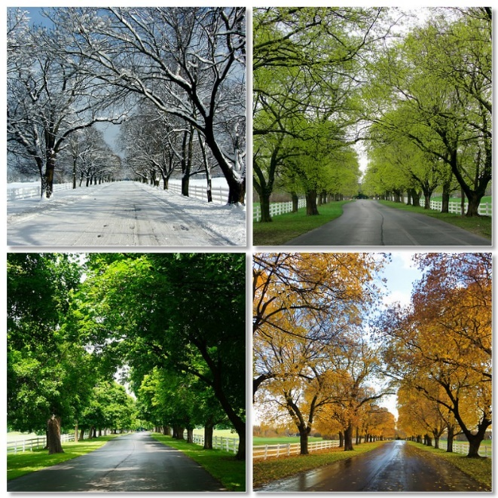  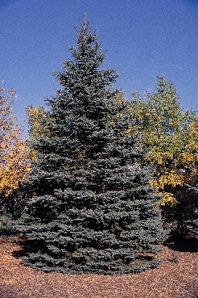  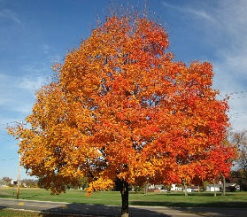  Deciduous trees evergreen trees
What changes do we see in our country with each season? | The passing of a year can bring a marked change in the weather and the surrounding environment. The four seasons — winter, spring, summer, autumn — can vary significantly in characteristics, and can prompt changes in the world around them. In autumn the amount of time it is light becomes less, the leaves start to change colour and fall off the trees. In winter we have colder weather, sometimes snow and frost, the trees have no leaves and the amount of time it is light during the day is at its shortest.  In spring the weather usually turns warmer, trees begin to grow their leaves, plants start to flower and young animals such as chicks and lambs are born. In summer the weather is usually warm, trees have full green leaves and the amount of time is it light for during the day is longer.
Do all trees lose their leaves in winter? | Not all trees will lose their leaves, evergreen trees can survive cold winters without shedding leaves; but deciduous trees, which are most of the trees we see around the UK, must lose their leaves in order to last through the winter.
What would you need to do to become the next weather presenter? | Meteorology is an exciting career. Meteorologist are people whole love science and love learning about the weather. Some of them work as weather reports but many meteorologists work for the government or work for universities. They do research on weather changes and patterns like draughts or globall warming. They write reports so others can understand weather conditions. They alert people toe the dangers like tornadoes and hurricanes.
How can you create patterns using leaves in the style of William Morris? | One of the 19th century's most famous names, William Morris is still renowned today as the designer of patterns such as 'Willow Bough' and 'Strawberry Thief'.  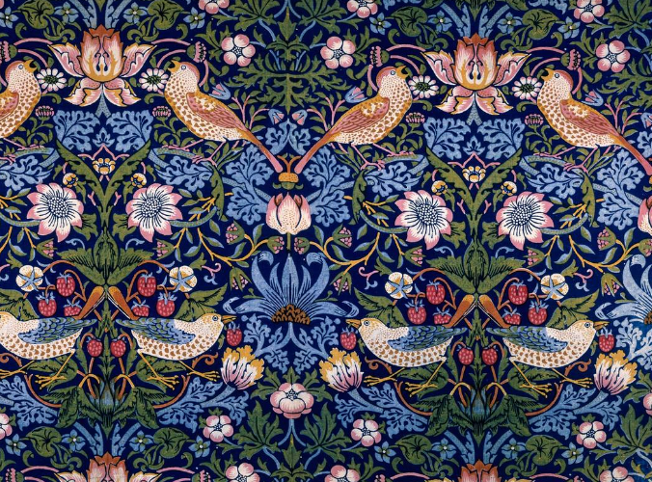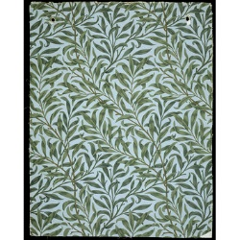  Strawberry Thief Willow Bough
After listening to music entitled the ‘Four Seasons’, can you create your own imaginary picture map including the 4 seasons? | Children to listen to and appreciate classical music.  https://www.youtube.com/watch?v=GRxofEmo3HA
Why are so many of the things you enjoy doing dependent on the time of year and the weather? | One of the first things you probably do every morning is look out the window to see what the weather is like. Looking outside and listening to the day’s forecast helps you decide what clothes you will wear and maybe even what you will do throughout the day. If you don’t have school and the weather looks sunny, you might visit the zoo or go on a picnic. A rainy day might make you think about visiting a museum or staying home to read.  The weather affects us in many ways. Day-to-day changes in weather can influence how we feel and the way we look at the world. Severe weather, such as tornadoes, hurricanes, and blizzards, can disrupt many people’s lives because of the destruction they cause.
Reflection: | In small groups create a typical weather forecast summary which will be filmed.

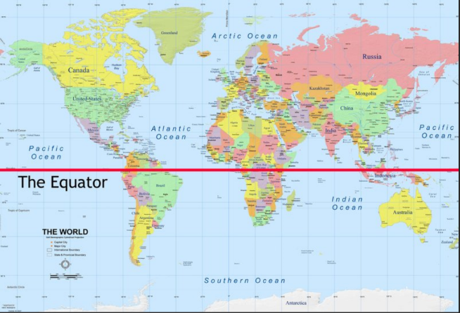  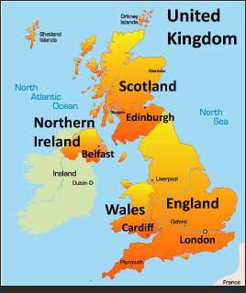 | Vocabulary  Weather- the day to day conditions outside that affect a place.  Temperature- a measurement of how warm or cold a place or living thing is.  Seasons-each of the four divisions of the year (spring, summer, autumn, and winter) marked by particular weather patterns and daylight hours.  Climate- the weather conditions of a place.  Forecast- predict or estimate a future event.  Observe- to look closely at something.  Pattern- a repeated or regular way something happens.  Evergreen- a plant that keeps its green leaves throughout the year.  Equator- a line drawn on the earth form North Pole to South Pole.  Deciduous- a tree that sheds its leaves every year.  - Hibernation- some animals curl up in a safe place and stay there until winter ends
Trips/ Visits & Useful Websites: | Useful information or people to be studied in this particular unit

