BUCKINGHAM PRIMARY ACADEMY - HISTORY
Enquiry Question What has changed since your grandparents have been young? |  | Year group 1
What will be taught through the unit:  Changes within living memory. Where appropriate, these should be used to reveal aspects of change in national life. Children will use artefacts, photographs and real life events to find out about the past when their grandparents were young They will be able to use historical vocabulary to discuss and ask questions about sources of evidence. |  | Historical Enquiry:  Can they ask and answer questions about old and new objects?  Can they spot old and new objects in a picture?  Can they answer questions using an artefact/ photograph provided?  Can they give a plausible explanation about what an object was used for in the past?  Can they put up to three objects in chronological order (recent history)?  Can they use words and phrases like: ‘old’, ‘new’ and ‘a long time ago’?  Can they tell me about things that happened when they were little?  Do they know that some objects belonged to the past?
What was grandma and grandad’s day like at school? | In the 1960s children did not go to nursery so their first day at school was the first time they had been on their own, away from home. Most mums did not work, so for many children this was also the first time they had been apart from their mums. All school children had milk in a glass bottle each day. There were more than 30 children in a class and teachers were very strict! | Picture or diagram associated with your historical unit  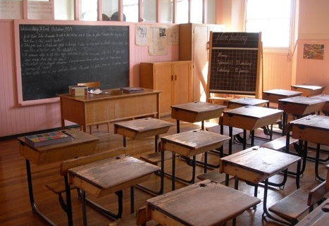  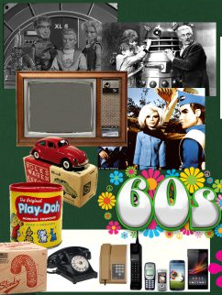  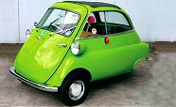  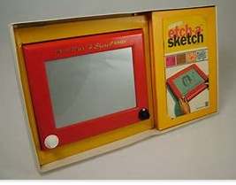  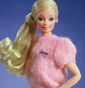  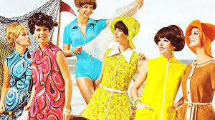
What was grandma and grandad’s day like at school? | Disusing a variety of stories from grandparents, distinguishing between fact and fiction.
What sort of phone did our grandparents use? | Alexander Bell invented the telephone. In 1960 telephones had a dial or buttons. They were plugged in to your house so could not be moved around. The first mobile phone was used in 1973.
How has technology changed over the years? | There have been many changes in technology since our grandparents were young. The typewriter was replaced by digital systems such as a computer and word processing software. Telephones have evolved over time into versions that are portable such as mobile phones and, more recently, smartphones. A smartphone is a mini computer and has many more functions than simply making voice calls as was its only function in the past. A smartphone can be used to capture, edit and store photographs and videos. They can be used to play music and video clips. They can connect to the Internet and be used to send and receive emails and SMS’s and they can be used to access and interact with a wide range of mobile apps. They can also be used to operate global positioning systems (GPS) so people can navigate from one location to another.
How has transportation changed over the years? | 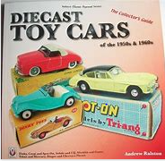  Many different forms of transportation have changed over the years from cars to trains to planes. The most current change is the electric car, although electric cars were built in the 1830s, cars powered by gasoline or diesel fuel were the most common kind of car for most of the last 100 years. Electric vehicles were used in some special cases, such as forklifts used inside a building, golf carts, trolley bus or certain vehicles used around airplanes at an airport. Today people are looking at electric vehicles again as a way to reduce pollution and use less gasoline.
What toys would your grandparents have played with? | Before electric toys were invented, many toys had levers, hinges and wheels, so that the user could move them. Toys changed a lot after TV was invented: many were based on TV shows that children watched. Popular toys were dolls, Barbie, metal toy cars and Kitchen sets.
How do the things we like change as we grow? | Humans learn many things as they grow up: how to talk, walk, swim and make important choices in their life. As we grow up our interests and the things we like also change.
What style of clothes would your grandparents have worn when they were your age? | Clothes in the 1960’s were often bright and colourful. They had bold and bright patterns which were usually stripes or flowers. Dresses were often short and fitted. A popular style in the 60’s was the mini skirt. Trousers had wide bell bottoms and they also wore Capri pants.
Have all the changes been for the better? | Reflect- Children to look at the pros and cons of everything they have learnt this term.

Timeline of significant events  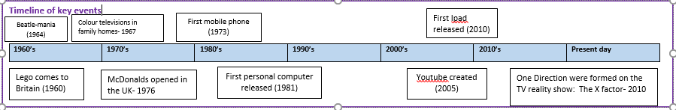 | Word Definition  Mini skirt Short skirt  Capri pants Tight fitting trousers above your ankle  Technology the use of knowledge to invent new devices or tools  Museum a building in which objects of historical, scientific, artistic, or cultural interest are stored and exhibited  Vocabulary
Trips/ Visits & Useful Websites: | Useful information or people to be studied in this particular unit  Alexander Bell

