Year 1 Learning Project week 1

Enquiry Question - What has changed since your grandparents were young?

Weekly Maths Tasks (Aim to do 1 per day) | Weekly Reading Tasks (Aim to do 1 per day)
- Complete Maths Shed activities  ● Get a piece of paper and ask your child to show everything you know about addition and subtraction. This could be pictures, diagrams, explanations, methods etc. They can be as creative as they want to be.  ● Play on Hit the Button - focus on number bonds to 10  https://www.topmarks.co.uk/maths-games/hit-the-button  - New Bitesize lessons from the BBC  https://www.bbc.co.uk/bitesize/tags/zjpqqp3/year-1-lessons/1 | Your child should share a book everyday. This can be reading a book aloud everyday or sharing a book with an adult.  ● Listen to a story read: https://www.storylineonline.net  ● Watch Newsround and find out what is happening in the world. What did you find out? Is there anything you need help understanding?  ● You can sign up free for https://www.getepic.com/ where you have access to over 40,000 books for free  ● Create a mask of one of the characters from a book you have read. Can your child retell the story from the characters point of view.
Weekly Spelling / Phonic Tasks (Aim to do 1 per day) | Weekly Writing Tasks (Aim to do 1 per day)
- Play Spelling frame spelling challenges https://spellingframe.co.uk/  - Complete spelling shed activities  - Complete an online phonic game from the following link https://www.topmarks.co.uk/english-games/5-7-years/letters-and-sounds  - Spell the days of the week  - Spell common exception words  - How many Year 1 HFW can you read in 5 minutes? Can you beat your score daily? | - Write a letter or postcard to a grandparent  asking some questions about what it would have been like when they were younger. What was their favourite toy or game to play with their friends?  - Write 5 sentences about what school life was  like in the past. How different was it to today?  - Can you draw and label a picture of school  equipment from the past and from today?  - New Bitesize lessons from the BBC  https://www.bbc.co.uk/bitesize/tags/zjpqqp3/year-1-lessons/1
Weekly PE Challenge | Weekly ‘Around the World’ challenge
- Join Joe Wicks in his daily PE challenges  - Create calm and serenity by joining in Cosmic Yoga for children https://www.cosmickids.com/category/watch/ | - Take a virtual tour of the White House in America. Can you write down 5 facts about the White House? https://artsandculture.google.com/partner/the-white-house

Year 1 Learning Project week 1

Enquiry Question - What has changed since your grandparents have been young?

What was grandma and grandad’s day like at school?

What can you find out about school life and how it has changed?

Has it changed a lot since your grandparents were young?

How has it changed over the last 100 years?

Can you name 5 toys or games children may have played with over 100 years ago? How are these different to toys you play with today?

Can you draw a picture of a toy from over 100 years ago and a toy you play with now? Label them with the materials they are made from.

Can you explain to a sibling or a parent how to play your favourite game? Are your instructions in the right order? Are they clear so everyone can play?
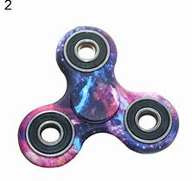
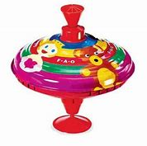
Learn how to play a new game.

Design your own game to play in the garden.

Invent a new toy for the future. What do you think children would like to play with in 100 years’ time?

Year 1 Science Project week 1

Bubble Snakes
Bubble snakes are super easy to make and great fun for kids of all ages. Younger children will enjoy blowing lots of bubbles easily, while older children can design their own bubbles snakes and even create an investigation using them.
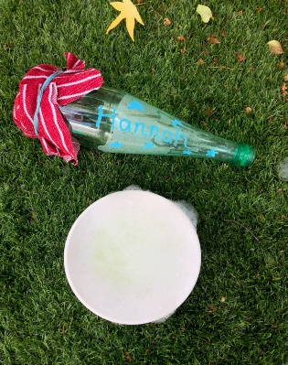

What you need to make a bubble snake
Small tube or plastic bottle
Elastic band
Bubble mix – shop bought or make your own
Old cloth or sock for the end
Sharp scissors or pen knife

Bubble Snake Instructions
First you need to cut the bottom off your water bottle – ask an adult to help and be careful as the end might be sharp.
Cover the end of the bottle with a piece of cloth and secure tightly with an elastic band.
Dip the cloth end into bubble mix.
Blow carefully down the other end of the bottle and watch as a bubble snake appears!
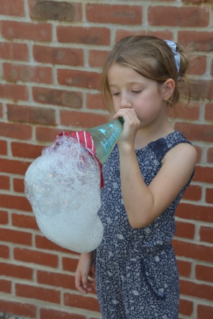
Remember to blow down the bottle NOT suck!!

