Year 1 Learning Project week 3

Enquiry Question - What has changed since your grandparents were young?

Weekly Maths Tasks (Aim to do 1 per day) | Weekly Reading Tasks (Aim to do 1 per day)
- Complete Maths Shed activities  ● Play on Hit the Button - focus on number bonds to 20  https://www.topmarks.co.uk/maths-games/hit-the-button  - Take part in the National academy maths lessons.  - https://www.thenational.academy/online-classroom/year-1/maths#subjects  - New Bitesize lessons from the BBC  https://www.bbc.co.uk/bitesize/tags/zjpqqp3/year-1-lessons/1 | Your child should share a book everyday. This can be reading a book aloud everyday or sharing a book with an adult.  ● Listen to a story read: https://www.storylineonline.net  ● Watch Newsround and find out what is happening in the world. What did you find out? Is there anything you need help understanding?  ● You can sign up free for https://www.getepic.com/ where you have access to over 40,000 books for free
Weekly Spelling / Phonic Tasks (Aim to do 1 per day) | Weekly Writing Tasks (Aim to do 1 per day)
- Play Spelling frame spelling challenges https://spellingframe.co.uk/  - Complete spelling shed activities  - Complete an online phonic game from the following link https://www.topmarks.co.uk/english-games/5-7-years/letters-and-sounds  - Spell the days of the week  - Spell common exception words  - How many Year 1 HFW can you read in 5 minutes? Can you beat your score daily? | - Write instructions to make a bird feeder. Remember to include First, Next, After that, Finally  - https://www.bbc.co.uk/cbeebies/makes/bird-feeder  - Write a diary entry about your grandparent’s memories of The Beatles.  - Take part in the National academy English lessons.  https://www.thenational.academy/online-classroom/year-1/english#subjects  - New Bitesize lessons from the BBC  https://www.bbc.co.uk/bitesize/tags/zjpqqp3/year-1-lessons/1
Weekly PE Challenge | Weekly ‘Around the World’ challenge
- Complete some go noodle challenges  https://www.gonoodle.com/  - Complete Mr Shepard’s PE challenge- make a video  - Complete The Beatles meditation- make a video | - Take a virtual tour of London Zoo. Write down 5 facts that you have learnt on your tour.  - https://www.goodtoknow.co.uk/family/best-virtual-tours-for-kids-536089

Year 1 Learning Project week 3

Enquiry Question - What has changed since your grandparents have been young?

Were the Beatles really better than ‘One Direction’?

Who were The Beatles?

Which city do they come from?

Can you research their greatest hits?

Who are One Direction?

What Reality television programme created One Direction?

Can you write about your Grandparents memories of The Beatles?

Can you create a collage or picture inspired by the cover of Sgt Peppers album by The Beatles?

Can you order events in chronological order?

Year 1 Science Project week 3

Wild plants
We are learning to name a range of common and wild plants

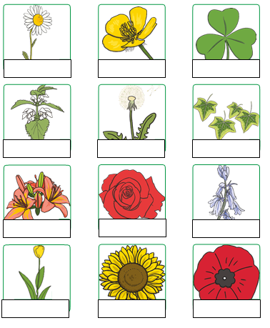

Label the wild plants. Use the key words and check your spellings.

Key words
Buttercup
Clover
Daisy
Dandelion
Ivy
Lily
Nettle
Poppy
Rose
Sunflower
Tulip

