Year 1 Learning Project week 4

Enquiry Question - What has changed since your grandparents were young?

Weekly Maths Tasks (Aim to do 1 per day) | Weekly Reading Tasks (Aim to do 1 per day)
- Complete Maths Shed activities  ● Play on Hit the Button - focus on number bonds to 20  https://www.topmarks.co.uk/maths-games/hit-the-button  - Take part in the National academy maths lessons.  - https://www.thenational.academy/online-classroom/year-1/maths#subjects  - New Bitesize lessons from the BBC  https://www.bbc.co.uk/bitesize/tags/zjpqqp3/year-1-lessons/1 | Your child should share a book everyday. This can be reading a book aloud everyday or sharing a book with an adult.  ● Listen to a story read: https://www.storylineonline.net  ● Watch Newsround and find out what is happening in the world. What did you find out? Is there anything you need help understanding?  ● You can sign up free for https://www.getepic.com/ where you have access to over 40,000 books for free  Lexia/Ed shed
Weekly Spelling / Phonic Tasks (Aim to do 1 per day) | Weekly Writing Tasks (Aim to do 1 per day)
- Play Spelling frame spelling challenges https://spellingframe.co.uk/  - Complete spelling shed activities  - Complete an online phonic game from the following link https://www.topmarks.co.uk/english-games/5-7-years/letters-and-sounds  - Spell the days of the week  - Spell common exception words  - How many Year 1 HFW can you read in 5 minutes? Can you beat your score daily? | - Take part in the National academy English lessons.  https://www.thenational.academy/online-classroom/year-1/english#subjects  Practise writing sentences with a capital letter, full stop and a conjunction.  - New Bitesize lessons from the BBC  https://www.bbc.co.uk/bitesize/tags/zjpqqp3/year-1-lessons/1
Weekly PE Challenge | Weekly ‘Around the World’ challenge
- Complete some go noodle challenges  https://www.gonoodle.com/  - Complete Mr Shepard’s PE challenge- make a video | - Take a virtual tour of Mars. Create a comparison between Earth and Mars. Decide where you would prefer to live and why.  https://accessmars.withgoogle.com/

Year 1 Learning Project week 4

Enquiry Question - What has changed since your grandparents have been young?

What sort of television programmes would grandparents have watched?

What can you find out about the television programmes your grandparents watched?

Have television programmes changed since 1960?

Can you name 5 programmes children may have watched when television was invented? How are these are different to the programmes you play watch today?

Can you draw a character from a television programme in the past?

How have televisions changed?

Can you order objects in chronological order?

Year 1 Science Project week 4

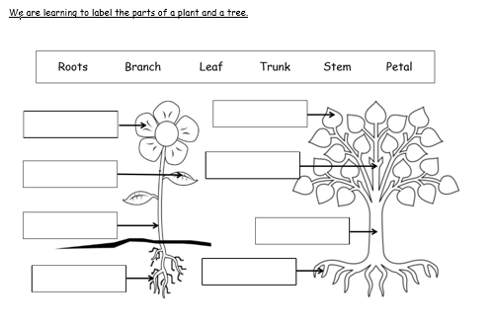

The is pretty to attract insects.

The is like a straw. It moves water around the plant. It is long and the flower and leaves hang from it.

The take in water and food from the soil. They also help the flower to stand up still.

flower Stem Roots

