BUCKINGHAM PRIMARY ACADEMY - Geography
Enquiry Question Why do we love to be beside the seaside |  |  | Year group 2
What will be taught through the unit:  Children will be taught what geographical features you will find at the seaside and what people enjoy doing when they visit. Children will also be taught to identify local coastal locations and identify them on a map. |  | Geographical Enquiry:  - Begin to ask simple geographical questions.  - Begin to use books, maps and the internet as a source of information.  - Make simple comparisons between features of different places.  - Draw a map of a real place.  - Begin to understand the need for a key.  - Follow a route on a map.  - Begin to spatially match places on maps of different scales.
Where do you go to on holiday and why? | A holiday is an extended period of leisure and recreation, especially one spent away from home or in travelling. Some people go on holiday to another country (abroad) but some people go on holiday in their country. People like to do different things on holiday and that is why they go to different places. Lots of people like to go on holiday to the coast to enjoy the beach. |  | Map associated with your Geographical unit  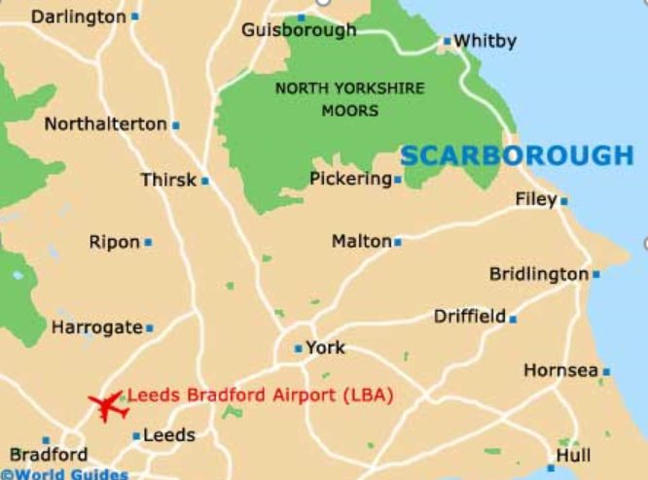  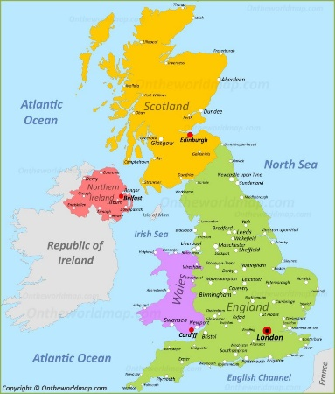
What attracts visitors to seaside resorts? | In the UK early tourists believed that the sea air and bathing in seawater was good for a person’s health and coastal towns such as Brighton became popular. Coastal areas are often cooler than places inland. So, on hot days people go to the beach to cool off and swim in the sea. Many people enjoy relaxing on a beach. In the past sunbathing was very popular, although today tourists are more aware of the dangers of too much sun. There is a wide range of activities which can be undertaken on a beach or in the sea. Coastal areas are appealing to many tourists, because of the landscape of cliffs and beaches.
What do you notice about the coast and how is it different to your town? | Towns are much busier than the coast. Towns are places where there are lots of tall buildings and the roads are busy with traffic. Towns often have more trains and busses than the coast. The types of buildings in a town are different to those at the coast. In towns there are more offices and places for concerts or plays. The coast is quieter and has more bed and breakfasts (B&B’s) for visitors to stay.
What can we learn about lifeboats and lighthouses? | A lifeboat or is a small boat carried for emergency evacuation in the event of a disaster aboard a ship. The RNLI (Roya National Lifeboat Institution) work hard to save people’s lives who are trapped in water. They always have people at the beach to help people who are in danger. A lighthouse is a tower or building designed to light up and move around. This light warns boats and other vehicles on the water that they are near the shore.
What was Scarborough like in the past? | It’s believed that the first bathing machines were used at Scarborough. However, by the early 1800s most seaside resorts had bathing machines available to hire. Queen Victoria had her own personal bathing machine built at Osbourne House on the Isle of Wight. Coastal outdoor pools became a common sight in the 1930s as swimming increased in popularity. One of the earliest was Scarborough’s South Bay bathing pool, which opened in 1915.
Can you create your own digital postcard? | From 1894, the Post Office started allowing postcards to be sent via the postal system. By the 1900s, picture postcards had really taken off. Before 1902, the back of the postcard was strictly for the address and stamp leaving only the space around the image on the front for a message. After 1902, Britain pioneered the divided back, where the address was on one side and the message on the other leaving the image on the front free of writing. The famous comic seaside postcard had its heyday in the 1920s and 1930s.
What can you find in rockpools? | The rock pools closest to the water will be alive with creatures, like fish, crabs and interesting plant life. Rocks can be a great hiding place for beach-loving creatures. Can you spot anything living above and around your pool? How do the rocks feel on your fingers and toes? Can you find any shells, fossils or cracks?

Timeline of significant events  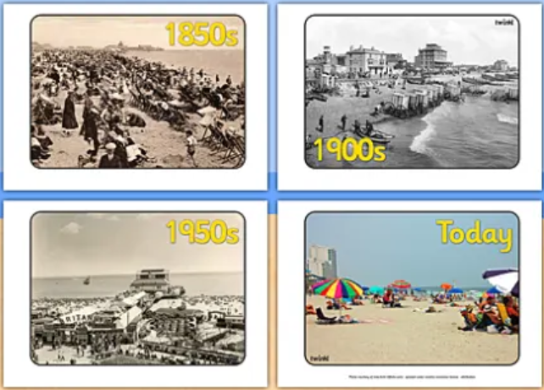 | Vocabulary  coast line- The land along the coast  pier- A platform from the shore into the sea  Promenade - A paved public walk. Along the sea front at a resort  harbour- A place on the coast where ships can anchor  bay- A part of the coast where the land curves in so that the sea is surrounded by land on three sides  lighthouse- A tower with a light to warn or guide ships  rock pool- A pool of water among rocks, typically on the shore line  shore- The land along the end of the sea  beach- A pebbly sand or shore next to the sea  cliff- A steep rock face especially at the edge of the sea  coast- The part of the land adjoining or near to the sea  erosion - The process of eroding (a gentle destruction) by wind, water or other natural agents  habitat - The natural home or environment of an animal, plant or other organism
Trips/ Visits & Useful Websites:  Google maps- explore Bridlington, Scarborough, Hornsea, Blackpool etc | Useful information or people to be studied in this particular unit  English link: The Journey Home  Erosion- link to looking after the planet.

