BUCKINGHAM PRIMARY ACADEMY - Geography
Enquiry Question Where would you prefer to live, England or Zimbabwe? |  | Year group 2
What will be taught through the unit:  Children to develop knowledge and understanding of what life in Zimbabwe is like.  Children to be able to identify explain how life in Zimbabwe is different to life in England.  Children to identify what climate is and understand why it is different in Zimbabwe to England.  Children to make links between our English text and apply this knowledge to Zimbabwe. |  | Geographical Equiry  - Name and locate the World’s 7 continents and 5 oceans.  - Understand geographical similarities and differences through the human and physical geography of a small area of the United Kingdom, and a small area in a contrasting country.  - Identify seasonal and daily weather patterns in the United Kingdom and the location of hot areas of the world in relation to the Equator.  - Use world maps, atlases and globes to identify the United Kingdom and its countries, as well as the countries, continents and oceans studied.  - Use aerial photographs and plan perspectives to recognise landmarks and basic human and physical features; devise a simple map and use basic symbols in a key.
What would you ask a child who lives in Zimbabwe? | Zimbabwe is a country located in Southern Africa. It is located betwwn Zambia, Botswana, Mozambique and South Africa. The capital city is Harare and this is also the largest city. Zimbabwe’s population is around 16 million people. There are 16 official langauges in spoken in Zimbabwe. | 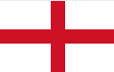  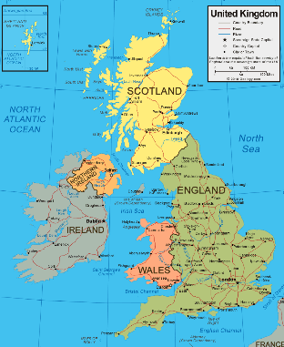
What are Zimbawe proud of? | Across the year there are many celebrations for things the people of Zimbabwe want to celebrate. Their most famous is the Harare Internation Festival of Arts. This is heald every year at the end of April and is one of the largest events in the country. It celebrates local and internations musicians, actors and musicians. Another celebration is the Harare International Food Festival. This is a fairly new celebration and happens every November. This festival celebrates the Zimbabwe cuisine.
What are the main differences in the climate of Zimbabwe and England? | 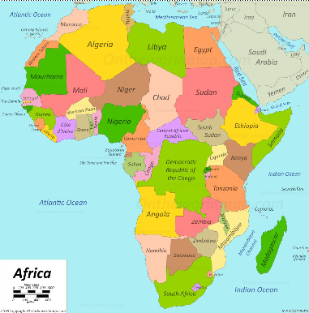  The climate in Zimbabwe is generally warm. Usually, November is the hottest month and July is the coldest month. There is a dry season, including a short cool season during the period May to September when the whole country has very little rain. The hot and dry season is from August to October.The rainy season is typically a time of heavy rainfall from November to March. The best months of weather are April, May, August and September.
Which animals would you find living in the wild of Zimbabwe? | Most of Zimbabwe’s animals are located in the National Parks and private wildlife ranches, however if you visited these you would see a wide range of animals including: buffalo, elephant, leopard, lion, rhinoceros, giraffe and zebra.
Do Africans live a healthier life than we do? | People of Africa have a diet that is based on whole, fresh plant foods. This includes colourful fruits and vegetables, especially leafy greens, beans and nuts. They eat these with rice, flatbreads and other grain foods with oils, homemade sauces and herbs. They also eat fish, eggs and yoghurt. Their diet includes minimal meats and sweets.
What would your school day be like if you lived in Zimbabwe? | 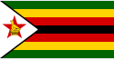  Zimbabwe's education system insists seven years of primary school. The country is currently working towards providing universal and free education to all students by 2030. The school year is broken down into 3 terms with a month break between each term. Their school year starts in January and ends in December. Primary school in the cities teach English but schools in the rural part of Zimbabwe teach their native language. A school day in Zimbabwe starts at 8:30am and finishes at 4pm.
Can you explain where you would prefer to live and why. | Children to gather all of their knowledge over the prvious few weeks and answer the enquiry question. Children will create a guide to the country they would most like to live in, containing information on climate, diet, wildlife, school and day-to-day life.

Timeline of significant events | Vocabulary  Word Definition  Continent Any of the world's main continuous expanses of land (Europe, Asia, Africa, North and South America, Australia, Antarctica).  Location A particular place or position.  Equator A line notionally drawn on the earth equidistant from the poles, dividing the earth into northern and southern hemispheres and constituting the parallel of latitude 0°.  Country A nation with its own government, occupying a particular territory.  Europe The continent in which we live.  Climate The weather.  Human features Something created by humans.  Physical features A natural feature on the surface, such as water, mountains, and deserts.  Place A geographical point, such as a town, city, etc.  City A large town.  Town A densely populated urban area, typically smaller than a city and larger than a village, having some local powers of government and a fixed boundary.  Village A group of houses, together with other buildings such as a church and a school in the countryside.  Rural Relating to, or characteristic of, the countryside or country life.  Surrounding The conditions, scenery, etc, around a person, place or thing; environment.
Trips/ Visits & Useful Websites:  https://kids.kiddle.co/Zimbabwe  https://www.ducksters.com/geography/country.php?country=Zimbabwe | Useful information or people to be studied in this particular unit  Anna Hibiscus’ Song- English text.

