BUCKINGHAM PRIMARY ACADEMY - HISTORY
Enquiry Question What was it like when the Queen came to the throne in 1953? |  | Year group 2
What will be taught through the unit:  Throughout this unit children will look at life in 1953 when the Queen came to the throne. They will link this knowledge to previous learning of studying what life was like when their grandparents were children. Pupils should develop an awareness of the past, using common words and phrases relating to the passing of time. They should know where the people and events they study fit within a chronological framework and identify similarities and differences between ways of life in different periods. They should use a wide vocabulary of everyday historical terms. They should ask and answer questions, choosing and using parts of stories and other sources to show that they know and understand key features of events. They should understand some of the ways in which we find out about the past and identify different ways in which it is represented. |  | Historical Enquiry:  - Can they use words and phrases like: ‘before I was born’, ‘when I was younger’?  - Can they use phrases and words like: ‘before’, ‘after’, ‘past’, ‘present’, ‘then’ and ‘now’; in their historical learning?  - Can they use a range of appropriate words and phrases to describe the past?  - Can they explain why Britain has a special history by naming some famous events and some famous people?  - Can they explain what is meant by a parliament?  - Can they find out something about the past by talking to an older person?  - Can they answer questions by using a specific source, such as an information book?  - Can they research the life of a famous Briton from the past using different resources to help them?  - Can they research about a famous event that happens in Britain and why it has been happening for some time?
What is a coronation and what does one look like? | The coronation is the ceremony of crowning a sovereign. This happens when the reigning King or Queen passes away or abdicates. The Queen succeeded to the Throne on the 6th February 1952 on the death of her father, King George VI. She was in Kenya at the time and became the first Sovereign in over 200 years to accede while abroad.  Coronations have been held at Westminster Abbey for 900 years and her Majesty was the thirty-ninth Sovereign to be crowned there. Queen Elizabeth’s Coronation of 1953 was ground-breaking in it's own right because it was the first ever to be televised, it was watched by 27 million people in the UK alone and millions more audiences around the world. During a coronation, the Soveriegn promises to rule according to the law and receives and orb and sceptres which are part of the Crown Jewels. | Picture or diagram associated with your historical unit  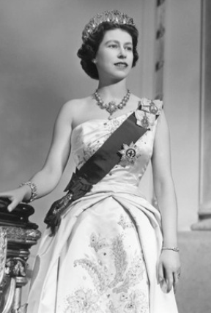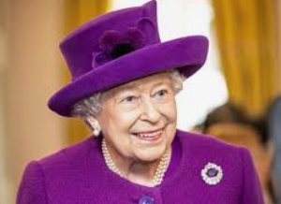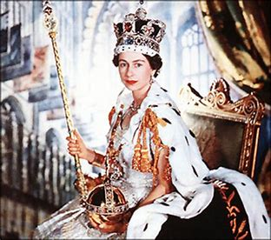  Elizabeth II Queen Elizabeth II The Queen’s Coronation
What would you have done after school if you had lived in 1953? | In the 1950s children often played games outside on the streets near their homes. It was much safer to do this at that time as fewer people owned cars so there was less traffic. Lots of families didn’t have spare money so before most homes had televisions children played different games outside such as; British Bull Dog, hopscotch, blind man’s bluff, skipping and card games.
What job does the Queen do? | The Queen does not govern the country, but does carry out many important tasks. The Queen is the Head of State so she goes on State visits abroad and is able to invite other leaders to come to the UK.  She is the Head of the Armed Forces and is the only person who can declare when the country is at war. The Queen is the Head of the Church of England meaning that she apppints archbisphops and bishops. Each day ‘red boxes’ are delivered to the Queen’s desk full of documents from the government and Commonwealth which must be read.
What has happened in the Queen’s life? | Queen Elizabeth II was born 21st April 1926 in London. Her father is Price Albert, the Duke of York and her mother is Lady Elizabeth Bowes-Lyon. She had a younger sister called Margaret Rose. Following the death of her grandfather King George V in January 1936, Elizabeth’s uncle David became the new King Edward VIII. Prince Albert became King George VI and the young Princess Elizabeth became heir presumptive to the throne. The Queen married Prince Philip, Duke of Edinburgh in 1947. The Queen heard of the death of her father whilst she was on tour in Kenya. Her coronation was held at Westminster Abbey on the 2 June 1953. She has four children – Charles, Prince of Wales; Anne, Princess Royal; Andrew, Duke of York and Edward, Earl of Wessex. She also has eight grandchildren and a growing number of great-grandchildren. In June 2012 the Queen celebrated her Diamond Jubilee – 60 years on the throne. There have been 14 prime ministers in the time of her reign.
What was the British Empire? | An ‘empire’ is a group of countries that are ruled over by a single monarch. The British Empire compirse of Britain, the ‘mother country’, and the colonies ruled by and from Britain to some degree. The British Empire was founded upon trade between the late 16th and early 18th centuries.
What key events have happened since the Queen has reigned? | Since taking the throne, 68 years ago, many key events have taken place from the invention of the television to the Corona virus pandemic. See timeline of significant events below.
Reflection: Children to put together a presentation to do with our monarchy. | Children to take part in a class presentation of life through Queen Victoria’s life.
Facts about the Queen | Name: Queen Elizabeth II  Full Name: Elizabeth Alexandra Mary  Born: April 21, 1926 at 17, Bruton Street, London  Parents: George VI and Elizabeth Bowes-Lyon  House of: Windsor  Ascended to the throne: February 6, 1952 aged 25 years  Crowned: June 2, 1953 at Westminster Abbey  Married: Philip Mountbatten  Children: Prince Charles, Princess Anne, Prince Andrew and Prince Edward  Current Age: 95 years  She has Reigned for: 69 years

Timeline of significant events  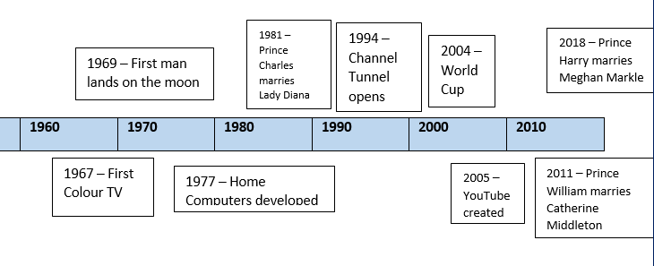  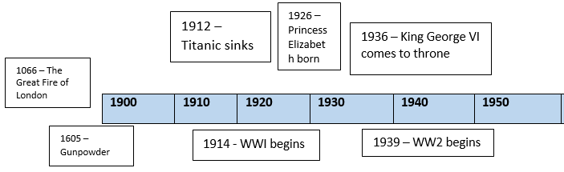 | Word Definition  Coronation The ceremony of crowning a sovereign or a sovereign's consort.  Monarch A sovereign head of state, especially a king, queen, or emperor.  British Empire An 'empire' is a group of countries ruled over by a single monarch or ruling power. An empire doesn't need an 'emperor'. The British Empire comprised of Britain, the 'mother country', and the colonies, countries ruled to some degree by and from Britain  Reigned Hold royal office; rule as monarch  Nonagenarian A person who is between the ages 90-99  Sovereign A supreme ruler, especially a monarch.  Jubilee A special anniversary of an event, especially one celebrating twenty-five or fifty years of a reign or activity  Heir A person legally entitled to the property or rank of another on that person's death  Abdication An act of renouncing the throne.  Ceremony A public occasion, especially one celebrating a particular event, achievement, or anniversary.  Commonwealth The Commonwealth of Nations, normally known as the Commonwealth, is a unique political association of 53 member states, nearly all of them former territories of the British Empire.  Vocabulary
Trips/ Visits & Useful Websites:  http://www.primaryhomeworkhelp.co.uk/war/1950s.html | Useful information or people to be studied in this particular unit

