Year 2 Learning Project week 1

Enquiry Question - What was it like when the Queen came to the throne in 1953?

Weekly Maths Tasks (Aim to do 1 per day) | Weekly Reading Tasks (Aim to do 1 per day)
- Complete Maths Shed activities  ● Get a piece of paper and ask your child to show everything they know about tens and ones. This could be pictures, diagrams, explanations etc. They can be as creative as they want to be.  ● Play Hit the Button - focus on tens and ones up to 99. https://www.topmarks.co.uk/learning-to-count/place-value-basketball  - New Bitesize lessons from the BBC  https://www.bbc.co.uk/bitesize/tags/z7s22sg/year-2-lessons/1 | Your child should share a book everyday. This can be reading a book aloud everyday or sharing a book with an adult.  ● Listen to a story read: https://www.storylineonline.net  ● Watch Newsround and find out what is happening in the world. What did you find out? Is there anything you need help understanding?  ● You can sign up free for https://www.getepic.com/ where you have access to over 40,000 books for free  ● Design a new front cover for one of your favourite books. Can you write a blurb for it? Be creative and use some impressive vocabulary.
Weekly Spelling / Phonic Tasks (Aim to do 1 per day) | Weekly Writing Tasks (Aim to do 1 per day)
- Play Spelling frame spelling challenges https://spellingframe.co.uk/  - Complete spelling shed activities  - Complete an online phonic game from the following link https://www.topmarks.co.uk/english-games/5-7-years/letters-and-sounds  - Spell common exception words  - How many Year 2 HFW can you read in 5 minutes? Can you beat your score daily? | - Imagine you are the Queen and it is the day of your coronation. Brainstorm ideas to write a diary entry.  - Write a diary entry to capture how you are feeling on the day of your coronation. How did you feel when you woke up? What happened during the day? How did you feel after?  - Edit and improve your diary entry.  - Draw a picture of our Queen.  - Label and describe a picture using expanded noun phrases.  - New Bitesize lessons from the BBC  https://www.bbc.co.uk/bitesize/tags/z7s22sg/year-2-lessons/1
Weekly PE Challenge | Weekly ‘Around the World’ challenge
- Join Joe Wicks in his daily PE challenges  - Create calm and serenity by joining in Cosmic Yoga for children https://www.cosmickids.com/category/watch/ | - Take a virtual tour of the Arts and Culture museum. Can you write down 5 facts about Claude Monet? https://artsandculture.google.com/project/monetwashere?hl=e

Year 2 Learning Project week 1

Enquiry Question - What was it like when the Queen came to the throne in 1953?

What is a coronation and what does one look like?

Write a description for your teacher explaining what a ‘coronation’ is.

Can you draw a family tree of the royal family? Use the internet to help you.
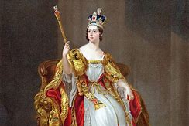
Design a menu fit for a King and Queen.

Design a dress or a crown for the Queen’s coronation.

Explore the virtual tour with examples of Claude Monet. Can you create a picture of the Queen in the style of Claude Monet?

Year 2 Science Project week 1

How many feet tall are you?

Do you know how many feet tall you are (using your own feet)? Investigate by drawing round your own feet, cutting the drawings out and then working out how many of your own feet tall you are.

How many feet tall are you?

Materials
Paper
Scissors
Pens

Method
Draw around your feet.
Cut out the foot shape.
Lie down and ask another person to see how many of your own feet tall you are.

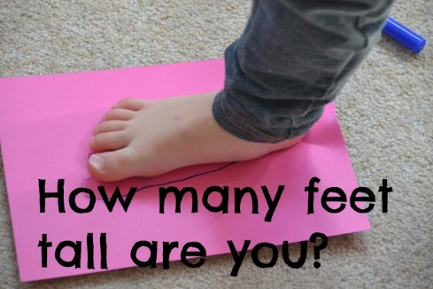
Can you find any similarities between you and the other people living in your house?

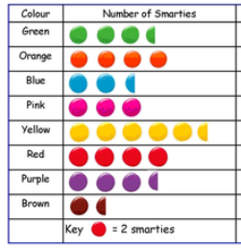
Can you present your findings in a tally chart and a pictogram?

