Year 2 Learning Project week 4

Enquiry Question – What was it like when the Queen came to the throne in 1953?
What was the British Empire?

Weekly Maths Tasks (Aim to do 1 per day) | Weekly Reading Tasks (Aim to do 1 per day)
●Follow the daily link on class dojo.  ●Complete Maths Shed activities  ● Play on ‘Robot addition’ focussing on addition  https://www.topmarks.co.uk/addition/robot-addition  ● Practice counting in 2s, 3s, 5s and 10s.  ●How many numbers can you find that are in the 2s, 3s, 5s and 10 times tables? | Your child should share a book everyday. This can be reading a book aloud everyday or sharing a book with an adult.  ● Listen to a story read: https://www.storylineonline.net  ●Read a book chosen by your parents. What was your opinion of it? Why? Would you recommend it to a friend?  ● Read in as many unusual places around your house as possible. Don’t forget to send pictures on Class Dojo!
Weekly Spelling / Phonic Tasks (Aim to do 1 per day) | Weekly Writing Tasks (Aim to do 1 per day)
- Complete spelling shed activities  - Complete an online phonic buried treasure game  https://www.phonicsplay.co.uk/member-only/BuriedTreasure2.html  - How many words can you write with the suffix ‘ly’ in one minute?  - How many homophones can you list? | - Follow the daily link on class dojo  - Complete an EdShed activity  - Write a fact file about the British Empire.  - The Brits marched into somebody’s country and said, ‘We’re in charge.’  Imagine: You have lived in your house all your life. You are happy with your home. Suddenly, some soldiers march in and say,‘this belongs to us now!’ Can you write a diary on the day that this has happened? How are you feeling? What are you thinking?
Weekly PE Challenge | Weekly ‘Around the World’ challenge
- Join Joe Wicks in his daily PE challenges.  - Create your own obstacle course and time yourself to see how quickly you can complete it. | - Take a virtual tour of Mars. Create a comparison between Earth and Mars. Decide where you would prefer to live and why.  https://accessmars.withgoogle.com/

Year 2 Learning Project week 4

Enquiry Question - What was the British Empire?

What key facts can you tell me about the British Empire?

Create or draw the British flag.

Can you identify these country’s flags?

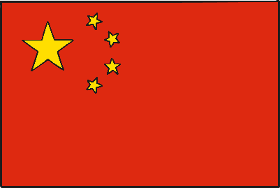

Write a fact file about the British Empire.

Why was the British Empire so successful?

The Brits marched into somebody’s country and said, ‘We’re in charge.’
Imagine: You have lived in your house all your life. You are happy with your home. Suddenly, some soldiers march in and say, ‘this belongs to us now!’ Can you write a diary on the day that this has happened? How are you feeling? What are you thinking?

Year 2 Science Project week 4

Science investigation.

