BUCKINGHAM PRIMARY ACADEMY - Geography
Enquiry Question Why do so many people go to the Mediterranean for their holidays ? |  | Year group Year 3
What will be taught through the unit:  Throughout this unit children will be taught:  that the Mediterranean Sea is the body of water that separates Europe, Africa and Asia. The Mediterranean Sea is connected to the Atlantic Ocean by a narrow passage called the Strait of Gibraltar.  It is between the southern tip of Spain and northern Morocco. The countries surrounding the Mediterranean in clockwise order are Spain, France, Monaco, Italy, Slovenia, Croatia, Bosnia and Herzegovina, Montenegro, Albania, Greece, Turkey, Syria, Lebanon, Israel, Egypt, Libya, Tunisia, Algeria, and Morocco; Malta and Cyprus are island countries in the sea.  The Mediterranean is in the continent of Europe. It is particularly popular as a holiday destination because of the mild climate and physical features (beaches, mountains and lakes).  People visit the cities in this region because of its human features (Leaning Tower of Pisa, Parthenon and La Sagrada Familia).  Size of the Mediterranean Sea: The Mediterranean Sea covers approximately 965,000 square miles with a narrow 8.7mile wide opening to the Atlantic Ocean called the Strait of Gibraltar. Depth: The average depth of the Mediterranean Sea is 4,900 feet. Its deepest point is 17,280 feet, in the Ionian Sea's Calypso Deep. Population: 472 million How many countries surround the Mediterranean? 21 Warmest country: Greece - with temperatures up to 40 degrees in the summer. |  | Geography Enquiry:  - Begin to ask geographical questions about the Mediterranean region of the world  - Use, atlases, pictures/photos and internet as sources of information about countries of the Mediterranean, the climate and people  - Investigate places and themes at more than one scale  - Use 4 compass points to follow/give directions: from country to country throughout the Mediterranean area  - Use letter/no. co-ordinates to locate features on a map of the Mediterranean  - Try to make a map of a short route experienced, with features in correct order; naming countries, cities and physical features within the Mediterranean area of the world  - Locate places on larger scale maps e.g. map of the Mediterranean Follow a route on a map with some accuracy.  - Begin to match boundaries (E.g. find same boundary of a country on different scale maps.)  - Begin to ask/initiate geographical questions.  - Use NF books, stories, atlases, pictures/photos and internet as sources of information.  - Investigate places and themes at more than one scale  - Use 4 compass points to follow/give directions:  - Use letter/no. co-ordinates to locate features on a map  - Locate places on larger scale maps
Where in the world is the Meditteranean? | This biogeographical region includes the Mediterranean Sea and seven Member States, either partially (France, Portugal, Italy, Spain) or completely (Greece, Malta, Cyprus). It has specific regional features: a climate of hot dry summers and humid, cool winters and a generally hilly landscape.
What are the advantages and disadvantages of living in the Mediterranean? | 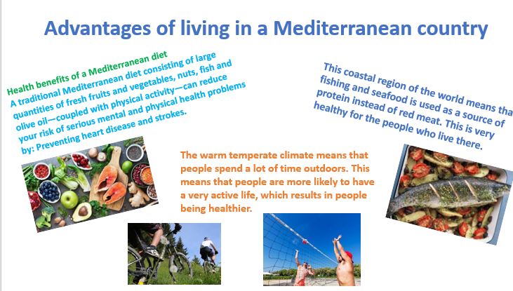 | 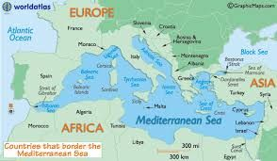  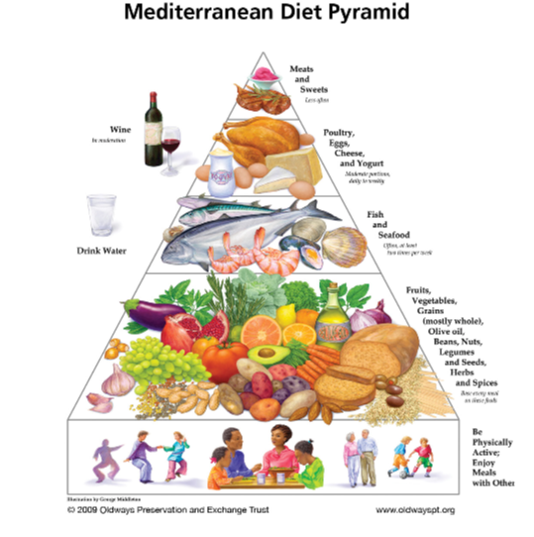  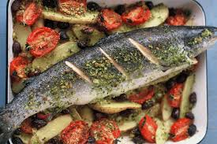  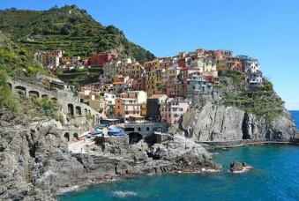  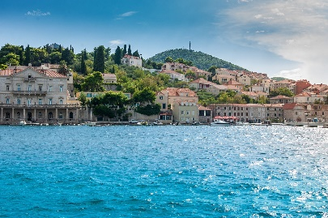  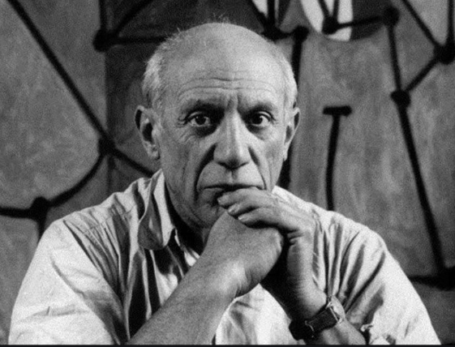 Pablo Picasso  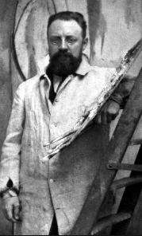  Henri Matisse  -  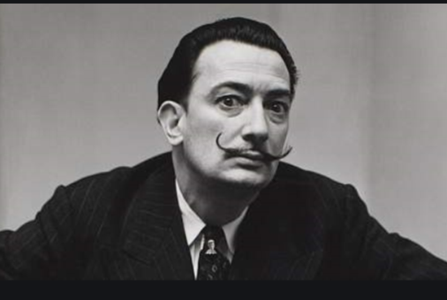 Salvador Dali
Why do Mediterranean countries have a warmer climate than we do? | The climate is known for warm to hot, dry summers and mild to cool, wet winters. ... The cause of this climate is directly related to large bodies of water such as the Mediterranean Sea and ocean currents. During the summer, cold currents keep the climate mild and dry. Ocean currents shift as the seasons change.
What makes a country Mediterranean? | The Mediterranean countries are those that surround the Mediterranean Sea. Twenty sovereign countries in Southern Europe, the Levant and North Africa regions border the Mediterranean, in addition to two island nations completely located in it (Malta and Cyprus).
Which fruits and vegetables are grown in the Mediterranean? | Citrus are grown on the various coasts of the Mediterranean basin where they represent almost 17% of world production. Spain, Morocco and Egypt are the main producers. Oranges, small citrus such as clementines, limes, lemons and grapefruits are the main varieties.  Other foods grown are:  - Olives.  - Cucumbers.  - Celery.  - Artichokes.  - Tomatoes.  - Figs.  - Beans.  - Dates.
How could we go about attracting someone to visit the Mediterranean? | Link to English work. Persuasive writing  Create holiday brochure t.o attract people to visit different countries in the Mediterranean
Why doesn’t everyone speak English and use the same money in all of the different Mediterranean countries? | Languages are: Arabic, Akkadian, Ancient Greek, Old Church Slavic, Egyptian, Aramaic, Hebrew, Coptic, Latin, Sumerian, Ugaritic, Albanian, Berber Languages, Bosnian, Bulgarian, French, Modern Greek, Italian, Catalan, Corsican, Croatian, Kurdish, Maltese, Macedonian, Montenegrin, Occitan, Persian, Portuguese.  The Euro:  France, Greece, Italy, Montenegro, Portugal, Slovenia and Spain use the euro. The euro is also widely accepted in Albania, BiH and Croatia.  Egypt: Egyptian pound  Morocco – Moroccan Dirham
Who are the famous artists of the Mediterranean and what can we learn from them?  What type of music can we associate with different Mediterranean cities? | Picasso  Pablo Picasso (1881-1973) was born in Malaga, Spain, but spent the majority of his adult life in France. In the summer of 1910, Picasso and some of his friends rented a house in Cadaqués for several months and it was believed that this trip influenced his Cubism period, the art movement of which Picasso was a pioneer, and which brought European painting forward towards 20th century Modern Art.  Matisse  Henri Matisse was born in France in 1869, and was best known for his use of colour, and his fluid and original draughtsmanship. He is principally known as a painter, although he was also a draughtsman, printmaker and sculptor.  In 1905, at the age of 36, Matisse arrived in Collioure. At the time he was depressed, short of funds and full of self-doubt. As soon as he arrived he was struck by the colour and the vitality of the Catalan fishing port and his depression lifted. He saw light and colour everywhere, and was about to start a new movement in the history of art, the “Fauves”.  Dali  Salvador Dali ( 1904 – 1989) is probably the artist the most frequently associated with the Costa Brava. He was inspired by the wildness of the area, particularly its rock formations, which can be seen in many of his paintings.  Born in Figueres, Spain, Dali is best known for his striking and bizarre surrealist work. His love of excess and luxury and his eccentric manner sometimes drew more attention than his art, to the irritation of critics who recoginsed him for his skill and talent as an artist and draftsman.  Where in the Mediterranean did they create their art?  Guitar, (Common in Greek music) Darbuka, (Middle Eastern goblet drum, used in many regions around the Mediterranean) Riq, Defi and Tamborello (Tambourines used in folk music from Italy to Egypt) Daouli or Tupan, (Folk bass drum common around the Mediterranean)

Timeline of significant events for The Mediterranean Area | Word Definition  Continent any of the world's main continuous expanses of land (Europe, Asia, Africa, North and South America, Australia, Antarctica).  Equator a line notionally drawn on the earth equidistant from the poles, dividing the earth into northern and southern hemispheres and constituting the parallel of latitude 0°.  Country An area of land that has its own government  Region Part of a country  City A large town  coastline A line that forms the boundary between the land and the ocean or a lake.  Landmark An easily seen object on the land  climate The weather conditions in an area over a long period of time  Temperature How hot or cold something is  Physical feature A natural part of the land eg body of water, mountains and deserts  Human Feature Something to do with the land created by humans  Vocabulary
Trips/ Visits & Useful Websites:  The Mediterranean:  http://www.bbc.co.uk/education/clips/zr7hyrd climate zones  https://www.tes.co.uk/teaching-resource/climatic-zones-6374017  http://www.worldatlas.com/aatlas/infopage/medsea.htm (Provide glossary)  https://sites.google.com/site/climatetypes/mediterranean | Useful information or people to be studied in this particular unit  English Link: The Green Ship  Journey around the Mediterranean  Michael Palin – Pole to Pole ( journey through Mediterranean countries)

