BUCKINGHAM PRIMARY ACADEMY - HISTORY
Enquiry Question Who First Lived in Britain? |  | Year group Year 3
What will be taught through the unit:  Throughout this unit, children will learn about how the Stone Age begins with the first production of stone implements and ends with the first use of bronze. Since the chronological limits of the Stone Age are based on technological development rather than actual date ranges, its length varies in different areas of the world. The earliest global date for the beginning of the Stone Age is 2.5 million years ago in Africa, and the earliest end date is about 3300 BCE, which is the beginning of Bronze Age in the Near East.  The Bronze Age is the name given to the period of time between the Stone and Iron Ages. Bronze is an alloy or mixture of tin and copper. Bronze alloy is harder than either of the metals from which it is made. It could be used to make a greater range of tools and weapons than had previously been possible.  The Iron Age was a period in human history that followed the Bronze and Stone Ages. During the Iron Age, people across much of Europe, Asia and parts of Africa began making tools and weapons from iron and steel. The Iron Age started between 1200 B.C. and 600 B.C., depending on the region. |  | Historical Enquiry:  - Can they describe events from the past( stone,bronze and iron ages ) using dates when things happened?  - Can they use a timeline for the stone,bronze and iron ages to set out the order things may have happened?  - Can they use their mathematical knowledge to work out how long ago the stone,bronze and iron ages would have happened?  - Can they begin to picture what life would have been like for the early settlers?  - Can they recognise that Britain has been invaded by several different groups over time?  - Do they realise that invaders in the past would have fought fiercely, using hand to hand combat?  - Can they suggest why certain events happened as they did in history?  - Do they recognise the part that archaeologists have had in helping us understand more about what happened in the stone,bronze and iron ages?  - Can they use various sources of evidence to answer questions about the stone,bronze and iron ages?  - Can they, through research, identify similarities and differences between the stone,bronze and iron ages?
What jobs do archaeologists do and why are they so valuable in helping us find out about history? | Archaeologists are the scientists who study artifacts, man-made objects that people have left behind. Archaeologists are like detectives. ... Clues archaeologists use to answer these and other questions about past civilizations can sometimes be found in the artifacts they dig up.  Lesson 1 | 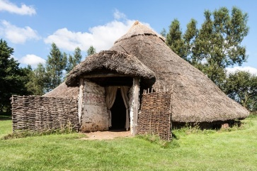  Picture or diagram associated with your historical unit  Bronze age house  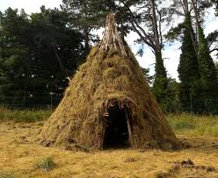  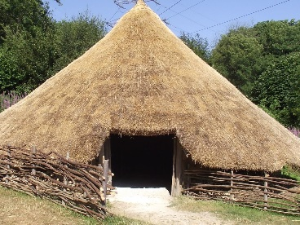  Stone age house  Iron age house
How did the Early Britons make shelters? | In the Stone Age in Britain, archaeologists have found evidence of four different types of Stone Age dwelling across the country: cave dwellings; circular structures like a tepee with wooden poles and possibly animal skin, thatch or turf roof; rectangular buildings made from timber with wattle and daub walls and thatched roof; Midden houses – mounds of stones, shells, mud and animal bones. Bronze Age houses were roundhouses made with wattle and daub, thatched roof with hole for smoke to escape from the fireplace. Some dwellings were for specific purposes eg. Just cooking or textile production. Houses were similar in the Iron Age but new developments were hill forts for defence.  Lesson 2
Would the Early Britons have visited a supermarket for their food? | Early Britons were hunter gatherers.  Our ancestors then took up farming some 12,000 years ago because it was a more efficient way of getting food. It meant that people could stay in one place and create communities.  Lesson 3
What can you find out about the Stone, Bronze and Iron Ages? | During the Stone Age, clothing had to keep people warm so it was often made from animal skin. Animals were hunted for their meat and skin by using stone spears. The animal would be skinned which was then washed to make sure there was no dirt left so they could be turned into clothes. Wool was discovered in the Bronze Age and clothes were often made from wool. The clothes of Iron Age people were made from wool and dyed with natural vegetable dyes (from plants and berries) in: blue, yellow or red. Bracae (trousers) would be worn under a tunic, held at the waist with a belt. Over this would have been a cloak with a striped or checked pattern, fastened by a brooch. Lessons 4 - 6
What do we know about the life styles of the early Britons through the art they produced? | Cave art is important because it was what people in prehistoric times did in order to record history and culture. But, prehistoric cave art was also significant because it also served as a warning to people who were to come later. For example, they could show the way to kill a beast or warn them of a beast. Lessons 7 - 8
What do we know about the way they moved heavy items around? | In the Stone Age people moved things around using inclined planes and levers. In the Bronze Age the wheel was invented. Wheels bring a mechanical advantage by allowing you to turn something heavy through the use of an axle that is attached to the heavy item. The invention of the wheel is thought to be one of the major reasons that civilizations made such great advancements. Included in lesson 9
How do you think the early Britons would have communicated? | Cave paintings illustrate the human need to communicate. This communication takes its form in leaving a mark for the future- to help guide, or communicate something so important that it needs a permanent representation. Archaeologists believe the sites were an early form of 'social networking' used by Bronze Age tribes to communicate with each other. The site gave different clans the opportunity to build up knowledge and share tips on hunting and other necessities for survival.  In the Bronze Age and Iron Age a form of proto-writing formed as a way of communicating. Included in lesson 8

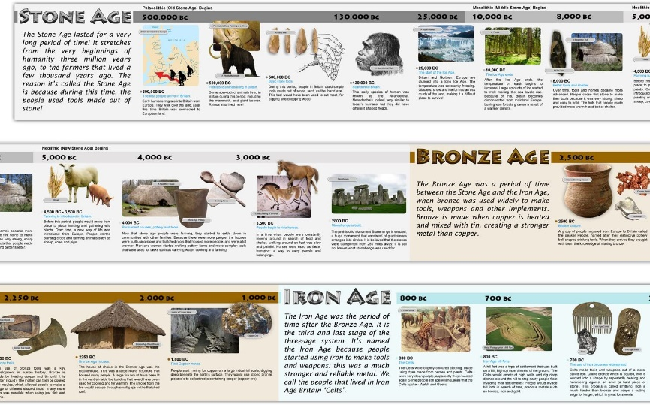  Timeline of significant events | Word Definition  Agriculture The raising of crops and animals for human use  Hunter-Gatherer A person who meets their needs by hunting animals and gathering plants  Neolithic Era The last period of the Stone Age when humans began to develop agriculture and use tools and weapons  Paleolithic Era The earliest part of the Stone Age characterised by tools made of crudely chipped stone and by cave art  Archaeology The study of the buildings, graves, tools and other objects that belonged to people who lived in the past, in order to learn about their culture and society  Stone Age The Stone Age is the name given to the earliest period of human culture when stone tools were first used.  Bronze Age The Bronze Age is the time period when bronze replaced stone as the preferred materials for making tools and weapons.  Iron Age The Bronze Age is the time period when bronze replaced stone as the preferred materials for making tools and weapons.  Neolithic The Neolithic period is the youngest part of the Stone Age. The word "Neolithic" comes from two words in Greek: "neo", meaning "new" and "lithic", meaning "stone". The Neolithic period is the time when farming was invented and when people started caring for animals, such as cows, sheep and pigs.  Forage To look widely for nourishment or other provisions.  Thatched A thatched house or a house with a thatched roof has a roof made of straw or reeds.  Prehistoric Prehistoric means the time before recorded history.  Monument A group of huge stones, often set up in a line or circle.  Tribe Iron Age people who lived in the same area and did similar things.  BC Before Christ was born.  AD The time after Christ was born.  Decade A period of time lasting 10 years.  Century A period of time which lasted for 100 years.  Ancient belonging to the very distant past and no longer in existence  Vocabulary
Trips/ Visits & Useful Websites:  https://www.bbc.co.uk/bitesize/topics/z82hsbk  https://historicengland.org.uk/services-skills/education/teaching-activities/timeline-stone-age-to-iron-age/  https://www.tes.com/teaching-resource/stone-age-to-iron-age-timeline-plan-and-worksheet-6355256 | Useful information or people to be studied in this particular unit

