Year 3 Learning Project week 1

Enquiry Question - Who first lived in Britain?

Weekly Maths Tasks (Aim to do 1 per day) | Weekly Reading Tasks (Aim to do 1 per day)
- Complete Maths Shed activities  ● Get a piece of paper and ask your child to show everything you know about multiplication and division. This could be pictures, diagrams, explanations, methods etc. They can be as creative as they want to be.  ● Play on Hit the Button - focus on number bonds to 100 and the 2,3, 4, 5 and 10 x tables  https://www.topmarks.co.uk/maths-games/hit-the-button  - New Bitesize lessons from the BBC  https://www.bbc.co.uk/bitesize/tags/zmyxxyc/year-3-lessons/1 | Your child should share a book everyday. This can be reading a book aloud everyday or sharing a book with an adult.  ● Listen to a story read: https://www.storylineonline.net  ● Watch Newsround and find out what is happening in the world. What did you find out? Is there anything you need help understanding?  ● You can sign up free for https://www.getepic.com/ where you have access to over 40,000 books for free  ● Read a new story and write a book review. Can you score it and say what you liked or disliked about the story.
Weekly Spelling / Phonic Tasks (Aim to do 1 per day) | Weekly Writing Tasks (Aim to do 1 per day)
- Play Spelling frame spelling challenges https://spellingframe.co.uk/  - Complete spelling shed activities  - Spell common exception words  - How many Year 3 HFW can you read in 5 minutes? Can you beat your score daily?  - How many words can you write with the ending ‘ing’? Can you play against an adult and beat them? | - Can you write a setting description of a house in the Stone Age?  - Write a job description for an archaeologist.  - Write an information factfile about either the Stone age, Iron age or the Bronze age.  - Research the different weapons and tools archaeologists may use to excavate their finds. Draw and label the different types they may use.  - New Bitesize lessons from the BBC  https://www.bbc.co.uk/bitesize/tags/zmyxxyc/year-3-lessons/1
Weekly PE Challenge | Weekly ‘Around the World’ challenge
- Join Joe Wicks in his daily PE challenges  - Create calm and serenity by joining in Cosmic Yoga for children https://www.cosmickids.com/category/watch/ | - Take a virtual tour of the Louvre museum. Can you write down 5 facts about an exhibition you liked. https://www.louvre.fr/en/visites-en-ligne

Year 3 Learning Project week 1

Enquiry Question - Who first lived in Britain?

What jobs do archaeologists do and why are they so valuable in helping us find out about history?

Imagine you are an archaeologist; write a diary entry after you have discovered something invaluable to history.

Write instructions for someone who is a new archaeologist. How will they dig up something they have found? What will they need to be careful not to do?

Create a timeline to show the different periods in history. Where would you place the Stone age, Iron age and Bronze age?

Use the internet to find out what you believe could be the most valuable find archaeologists have made.

Draw a picture, which shows archaeologists digging up some remains from the Stone age.

Write 5 facts about the Stone age, Iron age and the Bronze age.
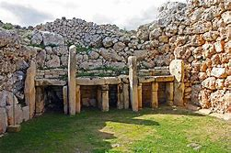

How have things changed since the Stone age?

Year 4 Science Project week 1

coloured flowers

All materials are made of atoms.
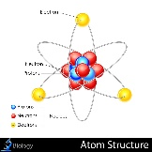
Atoms contain tiny particles called protons, neutrons and electrons (subatomic particles ). Protons and neutrons are found in the nucleus of an atom. Electrons orbit the nucleus, but occasionally break away
.
Balloons and some other objects like a fluffy jumper can steal electrons from other surfaces. The extra electrons give the balloon a negative charge, which attracts other objects, like the tissue paper we use in this activity.
A fun way to demonstrate static electricity is by making jumping frogs.
Static Electricity Experiment – Jumping Frogs

Equipment
Balloon
Paper, cut into shapes. We used sugar paper, but tissue paper would also work brilliantly.
Woolly jumper or hair
Method
Cut up your different types of paper into frog shapes ( or anything else you want to make jump )
Blow up your balloon, and rub it on your jumper or hair. Hold above the frogs, and watch them jump up.
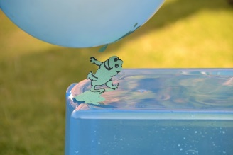

How does this static electricity experiment work?
Rubbing the balloon on your jumper or hair, charges it with static electricity, this attracts the frogs making them jump up to the balloon. They will stick until the charge wears off.

