BUCKINGHAM PRIMARY ACADEMY - GEOGRAPHY
Enquiry Question 4: Why are rainforests the oldest ecosytem on Earth? |  | Year group 4
What will be taught through the unit:  We will be looking at the importance of rainforests. A rainforest is a region with evergreen trees with a high amount of rainfall. Rainforests are one of the oldest living ecosystems on planet Earth, with some flora and fauna surviving in their present form for at least 70 million years.  We will recognise where in the world rainforest are, we will explore life in a rainforest, the climate, look at why the rainforest is such a significant ecosystem, what an ice age is and how the rainforest survived the ice ages. |  | Geographical Enquiry:  - Ask and respond to questions and offer their own ideas.  - Extend to satellite images, aerial photographs  - Identify the position and significance of the Equator, Northern Hemisphere, Southern Hemisphere and the Prime/Greenwich Meridian.  - Describe and understand key aspects of: physical geography, including: climate zones, rivers and mountains.  - Use 4 compass points well:  - Begin to use 8 compass points;
What is a rainforest? Where are rainforests situated? | A rainforest is a luxuriant, dense forest rich in biodiversity, found typically in tropical areas with consistently heavy rainfall.  Tropical rainforests are mainly located between the latitudes of 23.5°N (the Tropic of Cancer) and 23.5°S (the Tropic of Capricorn)—the tropics. Tropical rainforests are found in Central and South America, western and central Africa, western India, Southeast Asia, the island of New Guinea, and Australia | Picture or diagram associated with your Geography unit  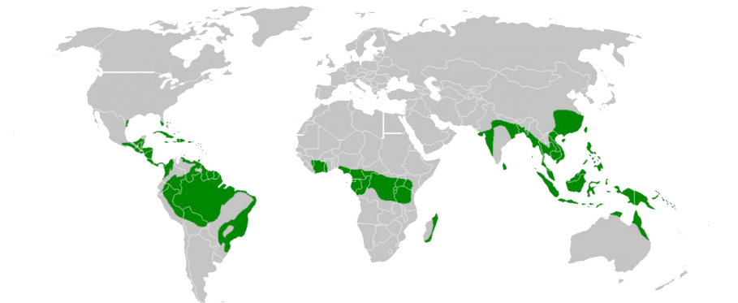  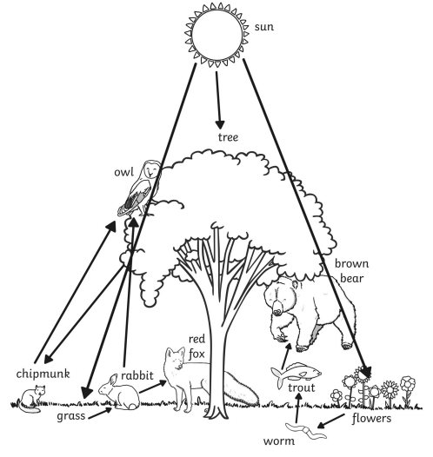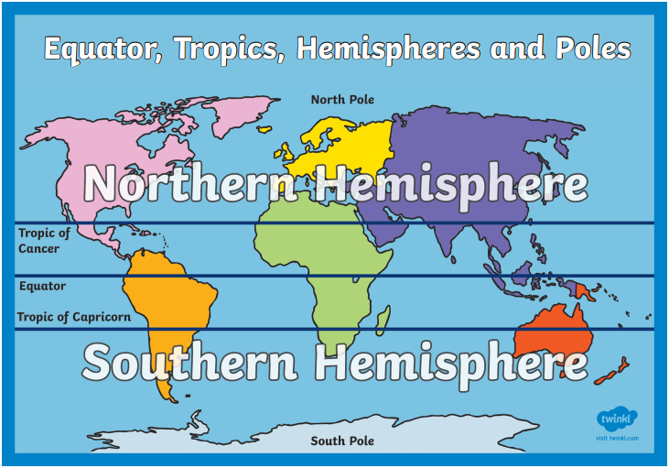  Vocabulary  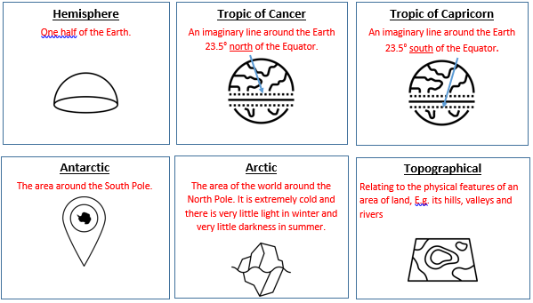
What does a rainforest consist of? | - Most rainforests (except evergreen forests in Europe and North America) are structured in four distinct layers: emergent, canopy, understory, and forest floor. Each layer has unique characteristics based on how much water, sunlight and air circulation it experiences. Although the animal and plant species differ in each layer, they are all dependent on each other and influence each other every day.
What is an ecosystem? | An ecosystem is a biological community of interacting organisms and their physical environment.
What does the rainforest ecosystem need to thrive? | An ecosystem must contain producers, consumers, decomposers, and dead and inorganic matter. All ecosystems require energy from an external source – this is usually the sun. An ecosystem must contain producers, consumers, decomposers, and dead and inorganic matter.
What is an ice age and how does it affect ecosystems? | An ice age can also be called glacial age, any geologic period during which thick ice sheets cover vast areas of land
What are rainforests the oldest ecosystem? | Bring together previous learning and make links between the rainforest’s climate, its refuges and get children to explain how the rainforests may have survived the ice ages and why the rainforests hold 50% of the Earth’s plants and animals.
End product-
Create and observe an ecosystem in a bottle.
Create a factfile.

Timeline of significant events  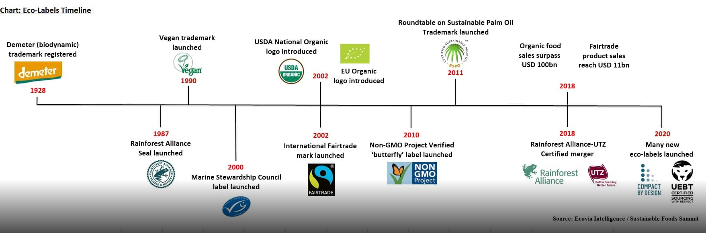 | 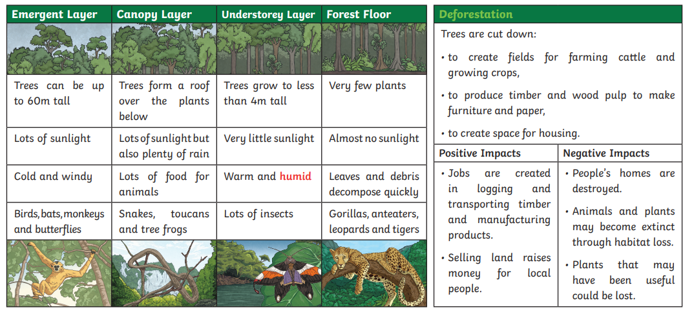
Trips/ Visits & Useful Websites:  https://rainforestfoundation.org/engage/10-things-you-can-do/ | Useful information or people to be studied in this particular unit

