BUCKINGHAM PRIMARY ACADEMY - Geography
Enquiry Question Would you prefer to live in London or Hull? |  |  | Year group 4
What will be taught through the unit:  Pupils will be taught about the cultural difference between Hull and London and will look at the reasoning behind so many people choosing to live in London as opposed to the North of England (Hull). We will explore how population has grown and dropped over the previous 100 years. We will compare the differences in employment opportunities whilst making links with previous work from a range of different topics. |  | Geographical Enquiry:  - label the same features on an aerial photograph as on a map  - carry out a survey to discover features of cities and villages  - describe the main features of a well-known city  - describe the main physical differences between cities and villages  - explain why people are attracted to live in cities  - explain how a locality has changed over time with reference to human features  - know the difference between the British Isles, Great Britain and UK  - name up to six cities in the UK and locate them on a map  - name the areas of origin of the main ethnic groups in the UK & in their school
Why do you think London is the capital city of the United Kingdom? | The city of London was founded by the Romans and their rule extended from 43 AD to the fifth century AD, when the Empire fell. During the third century, Londinium, the name given to the town by the Romans, had a population of 50,000, mainly due to the influence of its major port. As a consequence of repeated Anglo-Saxon invasions during the fifth century, Londinium declined and during the eighth century it became the capital of the Kingdom of Essex. During the ninth century, the town suffered numerous Viking attacks. As a consequence, Danish settlers established themselves in the area, encouraging trade and opening businesses in the town, transforming it into the first urban centre of England. The town’s wealth and power attracted the Danish Great Heathen Army, which besieged the city until it was captured by King Alfred the Great in 886. In 1067, following the Norman invasion and conquering of England, the city's existing rights, laws and privileges were established by the newly crowned King of England, William Duke of Normandy. The Tower of London was built during William's reign. In 1199, King John reinforced the city's self-government, and in 1215 the city could elect a different mayor every year. For many years, England had no capital city. However, the institutions of central government were moved to Westminster, close to London. This and the rise of trade in the area were two decisive factors in London's emergence as the capital of England.
Why do so many people live in London? | A large number of people move to London in their 20s, drawn from all corners of the country. This is because of the range and number of job opportunities that the capital offers. But among almost every other age group, the capital sees more people leaving than arriving. This is most pronounced for very young children, people aged 18-20 and people in their 30s. |  | Map associated with your Geographical unit  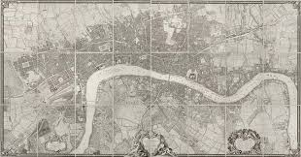  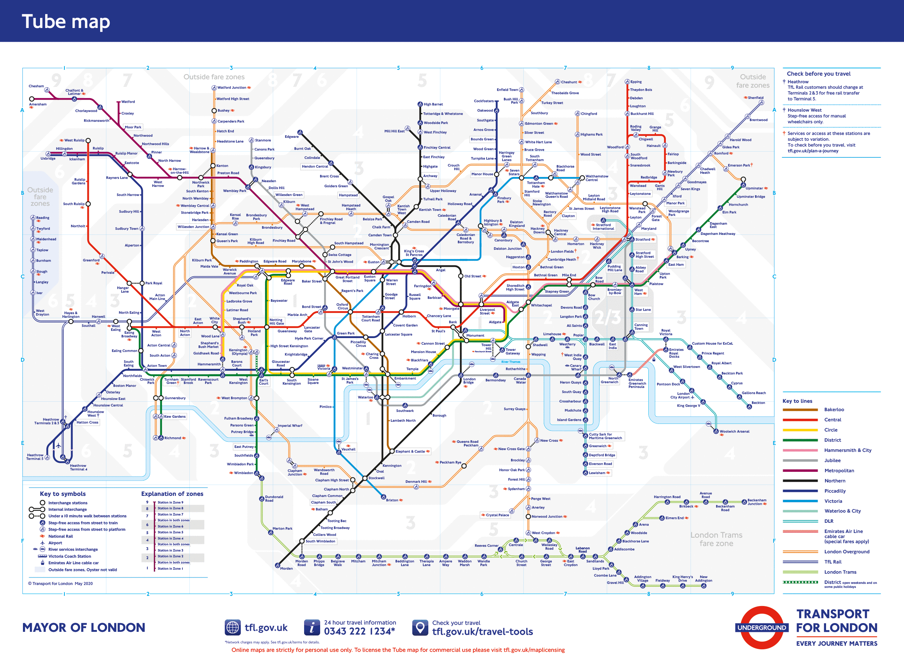  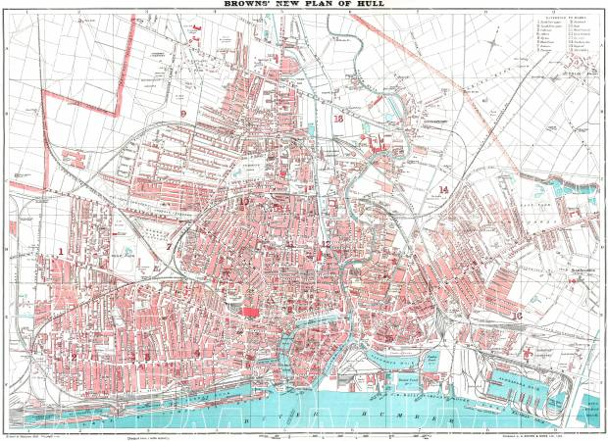
Can you trace the growth in London’s population over the past 100 years? | The size of London's population has changed dramatically over the past century; falling from a pre-Second World War high of 8.6 million people in 1939 to around 6.8 million in the 1980s. London's population has been growing since the early 1990s and hit a new high of 8.9 million in 2018.
Can you choose 5 popular monuments or buildings in London and write a promotion leaflet on them? | Big Ben  The London Eye  Houses of Parliament  Buckingham Palace  Tower Bridge  The Shard  The Gherkin  London Underground
From photographs you have taken, can you paint one of your favourite places in London? | Big Ben  The London Eye  Houses of Parliament  Buckingham Palace  Tower Bridge  The Shard  The Gherkin  London Underground
What would be the main advantages and disadvantages of living in London? | The main benefits of living in London include access to a great public transport system, job opportunities, and exceptional cultural and musical entertainment. The main disadvantages of London include expensive housing, traveling in rush hour, pollution, and tourists.

Timeline of significant events  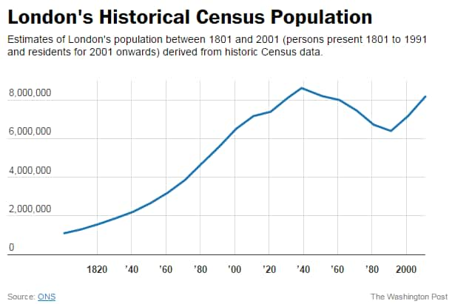 | Vocabulary  Population: Amount of people in a specific place.  Capital city: The city or town that functions as the seat of government for a country or region.  United Kingdom: Group of countries made up of England, Scotland, Wales and Northern Ireland.  England: Country within the United Kingdom  Tourism: visiting a place of interest.  Parliament: (in the UK) the highest legislature, consisting of the Sovereign (The Queen), the House of Lords, and the House of Commons.  Topographical: Representation of the physical features of an area.  Cantilever bridge: It is a bridge built using cantilevers, structures that project horizontally into space, supported on only one end.  Cultural Diversity: The existence of a range of cultures within a certain geographical area.
Trips/ Visits & Useful Websites:  https://londontopia.net/history/how-london-became-the-united-kingdoms-capital/ | Useful information or people to be studied in this particular unit

