BUCKINGHAM PRIMARY ACADEMY - HISTORY
Enquiry Question – Who were the early lawmakers? |  | Year group - 4
What will be taught through the unit:  Throughout this unit children will look at the early development of law, how laws were made and why. They will link this knowledge to what they know about laws and modern parliament while also understanding how acts such as the Magna Carta affect use today. They use research skills, presentation and the delivery of speeches. Through research, they will have the opportunity to compare different periods of history, how they created laws in those eras and also the consequences and punishments of that period. |  | Historical Enquiry:  Use their mathematical skills to round up time differences into centuries and decades.  Explain how events from the past have helped shape our lives.  Research two versions of an event and say how they differ.  Give more than one reason to support an historical argument.  Communicate knowledge and understanding orally and in writing and offer points of view based upon what they have found out.  Appreciate how historical artefacts like the Magna Carta have helped us understand more about British lives in the present and past.
What is the Magna Carta and why is it so important even today? | The Magna Carta a document that gave certain rights to the English people. King John of England agreed to it on June 15, 1215. The Magna Carta stated that the king must follow the law. It was one of the first documents to state that citizens had such rights. | Picture or diagram associated with your historical unit  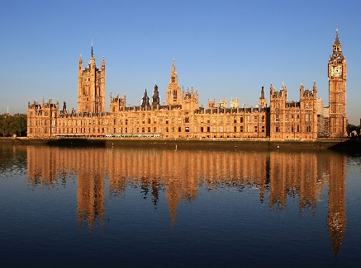  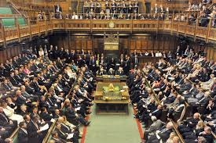  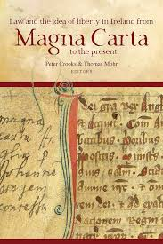
What is a Parliament and what is its connection to laws? | Parliament is the legislature, or lawmaking group, in the government of the United Kingdom (Great Britain). The government leader, called the prime minister, is always a member of Parliament. Overall the United Kingdom is governed from the Houses of Parliament in London. The Houses of Parliament are the House of Commons and the House of Lords. If the government wants to change the law or make certain other important decisions, it will need to pass a vote in the House of Commons.
Who created the first British Parliament and how did it work? | The first English Parliament was assembled in 1215, with the creation and signing of the Magna Carta, which established the rights of barons (wealthy landowners) to serve as consultants to the king on governmental matters in his Great Council. The Great Council was first referred to as “Parliament” in 1236.
Who makes our laws today and who upholds them? | Parliament acts like a factory that makes laws. To make a law you start with a 'bill', which is an idea that someone thinks will make a good law. The idea normally comes from the government. The government’s leader is the prime minister (Boris Johnson). The bill can start in the Commons or the Lords, but it must pass through both Houses. Then, it goes to the Queen for Royal Assent - meaning official approval from the monarch - which always happens last.
What were punishments like 750 years ago? | Anglo-Saxon punishments were decided by fellow villagers in a court called moot. If you were found guilty there was always the option of trial by ordeal. Examples of ‘Ordeals’ were  • Walking at least nine feet on hot coals  • Putting your hand in boiling water to retrieve a stone  • Picking up a red hot iron  • Tied up and thrown into a river  Other forms of punishments included fines and execution.
Reflection: Recreate a court held in the 12th or 13th century. | Create dialogue and scripts including roles within small groups of a courtroom scene in the 12th or 13th Century. Film and use green screening for performance.

Timeline of significant events | Word Definition  Law A set of rules in a county that one must follow otherwise there will be a punishment  Magna Carta A charter of rights agreed to by King John of England at Runnymede, near Windsor, on 15 June 1215.  Parliament A group of people who make or change laws  Democracy A system of government in which the people choose who is in charge or the rules they follow by voting in elections  Lawmakers A legislator. A person who makes laws; a member of a legislative body.  Communication The imparting or exchanging of information by speaking, writing, or using some other medium.  Punishment The infliction or imposition of a penalty as retribution for an offence.  Consequence Something that occurs because of an event (e.g. the impact on people, society and beliefs)  Vocabulary
Trips/ Visits & Useful Websites:  https://www.bl.uk/magna-carta/articles/magna-carta-english-translation#  https://www.theschoolrun.com/homework-help/the-magna-carta  https://www.parliament.uk/about/how/role/  https://www.nationalarchives.gov.uk/education/candp/ | Useful information or people to be studied in this particular unit  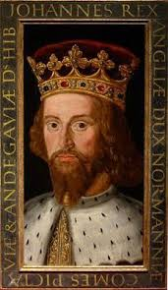  King John was the person who created the Magna Carta.  The Barons- a member of the lowest order of the British nobility. Baron is not used as a form of address, barons usually being referred to as ‘Lord’

