Year 4 Learning Project week 3

Enquiry Question - Who were the early lawmakers?

Weekly Maths Tasks (Aim to do 1 per day) | Weekly Reading Tasks (Aim to do 1 per day)
- Complete Maths Shed activities.  ● Play on multiplication fishing focusing on all your times tables.  https://mathsframe.co.uk/en/resources/resource/306/Maths-Fishing-Multiplication  - Answer as many multiplication or division questions as you can in a minute. Can you beat your score daily? Can you get more than a family member?  - Practice telling the time in both words and on the clock.  https://mathsframe.co.uk/en/resources/resource/117/telling-the-time-in-words | Your child should share a book everyday. This can be reading a book aloud everyday or sharing a book with an adult.  ● Listen to a story read: https://www.storylineonline.net  ● You can sign up free for https://www.getepic.com/ where you have access to over 40,000 books for free.  ● Read a newspaper article. What was it about? How did it make you feel?  ● Read a book and create a comic strip of the 6 main events of the book.
Weekly Spelling / Phonic Tasks (Aim to do 1 per day) | Weekly Writing Tasks (Aim to do 1 per day)
- Play Spelling frame spelling challenges https://spellingframe.co.uk/  - Complete spelling shed activities  - Using the year 4 spelling words, how many of them can you add a prefix or suffix to? Can you put these new words into a sentence?  - How many of the year 4 spelling words can you spell in a minute? Can you beat your score daily?  - How many words can you write with the suffix ‘ed’ in a minute? What pattern do you notice?  e.g. shop- shopped, remain- remained, stay- stayed, top- topped. | - Practice using fronted adverbials to start your sentences. Remember your comma after the fronted adverbial!  - Write a speech or letter to Boudicca telling her why she was a powerful woman.  - Write a newspaper article about an alien arriving on Earth and crash landing in your street.  Don’t forget to include:  - The name of the newspaper  - A byline (date, author, price of newspaper)  - A headline  - Paragraphs  - Direct speech  - Quotes  - Facts
Weekly PE Challenge | Weekly ‘Around the World’ challenge
- Join Joe Wicks in his daily PE challenges  - Create your own obstacle course and time yourself to see how quickly you can complete it. | - Take a virtual tour of Yellowstone National Park. Check out Mud Volcano, Mammoth Hot Springs and Fort Yellowstone. Can you create a tour guide full of pictures and facts?  https://www.nps.gov/yell/learn/photosmultimedia/virtualtours.htm

Year 4 Learning Project week 3

Enquiry Question - Who were the early lawmakers?
Who created the first British Parliament and how did it work?

Create a timeline of how Parliament has developed from 1236 to now.

Design a new version of the Magna Carta with new rules for 2020. Explain why you chose these rules.

Research King John of England and why the Magna Carta was created.

Describe the difference to Parliament in 1236 to Parliament in 2020.

Create a list of all the Kings and Queens that have been involved with the development of Parliament. Can you illustrate it with pictures? (https://www.history.com/topics/british-history/british-parliament)

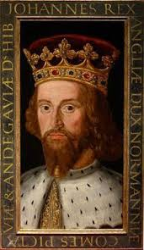
Create a fact file for the first British Parliament. Can you include a ‘did you know’ section?
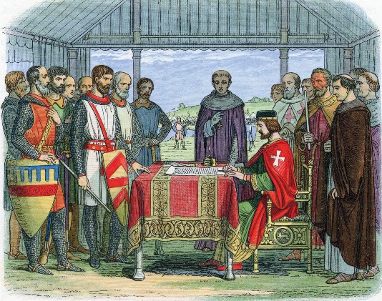

Year 4 Science Project week 3

Classifying objects into solids, liquids and gasses.

Research what a solid, liquid and gas is and create a fact file defining these.

For each a solid, liquid and gas include the following:
Their characteristics.
What temperature water is at each of these states.
A diagram showing the particles in each of these states.

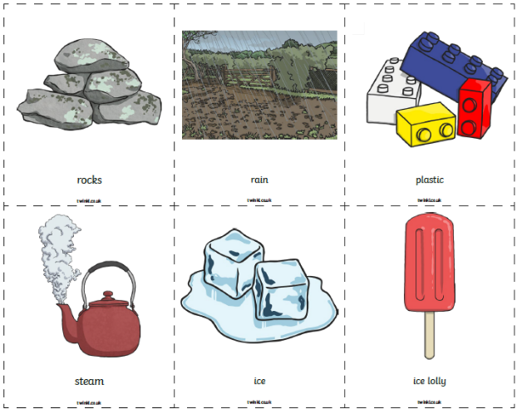
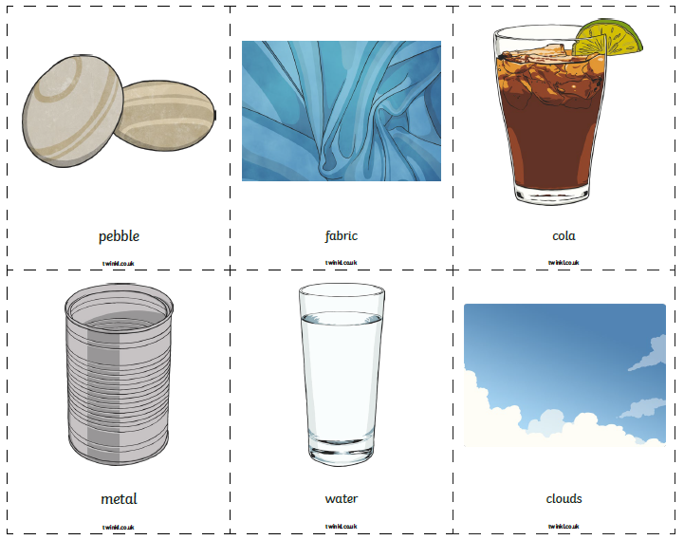
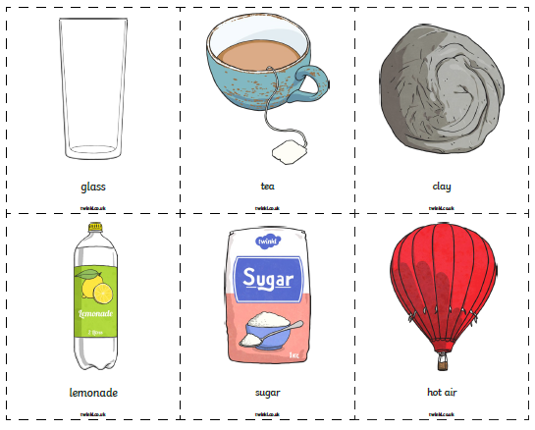
Can you classify these objects into solid, liquid or gas?
