Year 4 Learning Project week 4

Enquiry Question - Who were the early lawmakers?

Weekly Maths Tasks (Aim to do 1 per day) | Weekly Reading Tasks (Aim to do 1 per day)
- Complete Maths Shed activities.  ● Play on multiplication fishing focusing on all your times tables.  https://mathsframe.co.uk/en/resources/resource/306/Maths-Fishing-Multiplication  - Practice calculating how much change you will get by playing the change game.  https://natwest.mymoneysense.com/students/students-5-8/the-change-game/  - Practice adding and subtracting fractions with the same denominator.  e.g. ¼ + ¾ = | Your child should share a book everyday. This can be reading a book aloud everyday or sharing a book with an adult.  ● Listen to a story read: https://www.storylineonline.net  ● You can sign up free for https://www.getepic.com/ where you have access to over 40,000 books for free.  ● Read a book chosen by your parents. What was your opinion of it? Why? Would you recommend it to a friend?  ● Read in as many unusual places around your house as possible. Don’t forget to send pictures on Class Dojo!
Weekly Spelling / Phonic Tasks (Aim to do 1 per day) | Weekly Writing Tasks (Aim to do 1 per day)
- Play Spelling frame spelling challenges https://spellingframe.co.uk/  - Complete spelling shed activities  - Using the year 4 spelling words, create your own dictionary. Remember to put them into alphabetical order!  - Create mnemonics for the year 4 and 5 spelling words.  - How many words can you write with the prefix ‘un’ in a minute? Can you beat your score daily?  e.g. do-undo, sure- unsure. | - Practice using direct speech. Remember to use the correct punctuation.  - Write a short story set in London.  - Write a diary entry as if you were a Stone Age boy/girl.  - Interview a parent or sibling about Lockdown. Remember to ask them interesting questions with questions that do not have a yes or no answer.
Weekly PE Challenge | Weekly ‘Around the World’ challenge
- Join Joe Wicks in his daily PE challenges  - Create your own obstacle course and time yourself to see how quickly you can complete it. | - Take a virtual tour of Mars. Create a comparison between Earth and Mars. Decide where you would prefer to live and why.  https://accessmars.withgoogle.com/

Year 4 Learning Project week 4

Enquiry Question - Who were the early lawmakers?
Who makes our laws today?

Create a diagram explaining how laws are made.

Think of a new law. Write a letter to Boris Johnson explaining your idea for a new law and persuade him why we need the law.

Research old laws from the UK and other countries. Create a leaflet of old and unusual laws.

Create a list of all the current laws we have in the UK that you can find. Add in the dates they became a law.

Pick a law we have and design a poster explaining what the law is and the punishments for breaking the law.
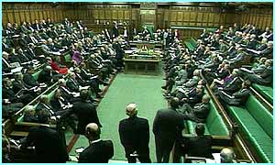
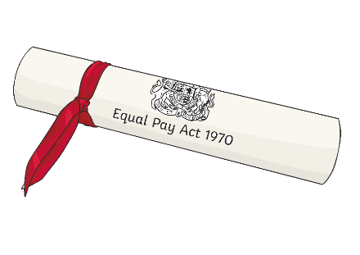
Hold a debate in your household over a new law for your house. The law may be no phones at the table or that Saturday nights are family nights.

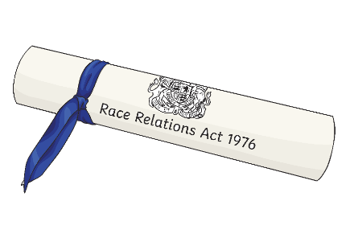

Year 4 Science Project week 4

How do we measure temperature and how does temperature vary during the day and across the world?

Create a guide explaining how we measure temperature:
- What do we measure the temperature of?
- How to measure the temperature?
- Why do we need to know the temperature?
- Why are some countries warmer/colder?

Using a thermometer and/or a weather app create a weather comparison chart for Hull and another country of your choice.

Day | Temperature of place 1  (Hull) | Temperature of place 2  (________)
Monday
Tuesday
Wednesday
Thursday
Friday
Saturday
Sunday

Write a summary of your findings and explain why the results show what they do.

Extend your knowledge further:
Explain why the temperature changes throughout the day and why it is warmer at midday than it is during the night. Use your knowledge/research of the solar system. Remember to use the correct scientific vocabulary (temperature, location, Degrees Celsius, solar system, Earth, Sun, Equator)

