BUCKINGHAM PRIMARY ACADEMY - Geography
Enquiry Question How has the fishing industry shaped Hull? |  |  | Year group 5
What will be taught through the unit:  Children will be taught how to investigate Hull throughout the years, paying particular close attention to why Hull was built near a River and how the fishing industry helped Hull develop into a city which could trade. |  | Geographical Enquiry:  - Begin to suggest questions for investigating  - Begin to use primary and secondary sources of evidence in their investigations.  - Investigate places with more emphasis on the larger scale; contrasting and distant places  - Analyse evidence and draw conclusions e.g. compare historical maps of varying scales  - Use 8 compass points; Begin to use 4 figure co- ordinates to locate features on a map.  - Begin to use primary and secondary sources of evidence in their investigations.  - Measure straight line distance on a plan.
What was Hull like in the 12th century? | The town of Hull was founded late in the 12th century. The monks of Meaux Abbey needed a port where the wool from their estates could be exported. They chose a place at the junction of the rivers, Hull and Humber, to build a quay. The exact year Hull was founded is not known but it was first mentioned in 1193. It was called Wyke on Hull. |  | Map associated with your Geographical unit  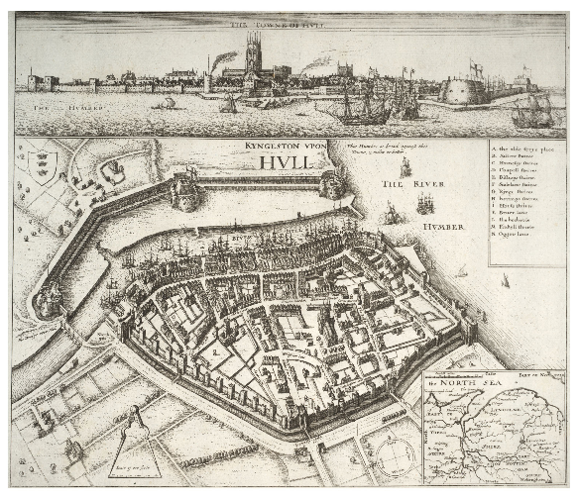  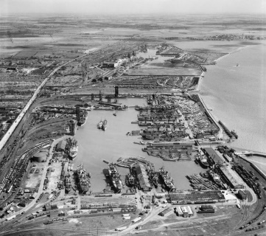  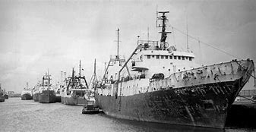
Why was Hull chosen to be a main fishing port? | Hull’s rise as a major fishing port began with the discovery of the rich Dogger Bank fishing grounds in the mid-1800s. As steam replaced sail, around the turn of the century, vessel owners and skippers began to look further afield to the rich fishing grounds off Iceland, and a little later in the Barents Sea.
How did the development of Hull Docks influence Hull today? | From its medieval beginnings, Hull’s main trading links have been with Scotland and northern Europe. Scandinavia, the Baltic and the Low Countries were all key trading areas for Hull’s merchants. In addition, there was some trade with France, Spain and Portugal. As sail power gave way to steam, so Hull’s trading links extended throughout the world. Docks like Alexandra Dock were specifically opened to serve the frozen meat trade of Australia, New Zealand and South America. Hull was also the centre of a thriving inland and coastal trading network, serving the whole of the United Kingdom.
How important was the fishing industry to Hull? | Hull has a rich fishing and maritime past and many seamen have passed through the port of Hull during its long history. Fishermen have been operating out of Hull since the 16th century and Hull also has a strong whaling heritage. Over the years communities and institutions have developed in Hull to aid and assist sailors and their families.
Can you create a print using Haukasi or Gyottaku as inspiration? | - As was the custom of the time, Hokusai changed his name many times during his life. ... In 1811 he created the Hokusai Manga, a series of thousands of cartoons carved on woodblocks. The art form helped to influence the modern Japanese manga comics.  - Katsushika Hokusai also influenced the Art Nouveau and Impressionist art movements of the 19th century. Several famous artists collected his work, including Manet, Degas and Vincent van Gogh.
How would you survive as a fisherman? | Fishermen/women/Skippers are part of a fishing vessel's crew, travelling out to sea in order to catch fish. Their working environment is tough and potentially dangerous.  Vessels range in size from single-handed boats to large factory ships crewed by as many as 20 people. A typical boat has a crew of three to six hands.  Large modern vessels use advanced electronic systems to navigate, locate fish and monitor the storage conditions of the catch. Modern equipment also reduces the need to lift and shovel the fish.  Fishermen/women may also be expected to develop skills such as net making and splicing rope. With experience they may also learn to use some of the electronic equipment on board.  A ship's mate may have additional responsibilities, including reading charts and navigating, radio communications, using more advanced equipment and deputising for the skipper
Can you plan a journey as a fisherman to another part of the world? | Using a variety of map skills, you will need to plan where you will be fishing and the best way to get there. Once you have planned your trip you will need to be organised and gather all of the equipment needed for your boat, food supplies, maps and emergency and medical equipment. Do you have all the correct documents required from the country you are visiting? How will you transport all of the fish back to Hull? Once you arrive back who will you sell your fish to?

Timeline of significant events  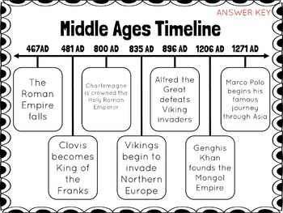 | Vocabulary  Arctic - place at the northernmost point of the earth  Charter - a document giving people special rights  Declined - something that has become smaller or fewer  Edible - something people can eat  Imported - to bring goods into another country  Medieval - period of history from the 5th to 15th century  Monks - men who have dedicated their lives to religion and live in special communities  Salted - when salt is used to make food last longer  Scandinavia - group of countries in Northern Europe, including Norway, Denmark and Sweden  Shambles - street in a historic town where animals were butchered  Whaler - special ship designed to capture whales
Trips/ Visits & Useful Websites:  http://www.hullhistorycentre.org.uk/research/research-guides/maritime-history.aspx | Useful information or people to be studied in this particular unit  English link: Shackleton’s Journey

