BUCKINGHAM PRIMARY ACADEMY - GEOGRAPHY
Enquiry Question What is so special about the USA? |  |  | Year group 5
What will be taught through the unit:  Children will be taught how to investigate the USA using geographical and other subject skills, in particular using map skills, whilst making links with previous work from a range of different topics. |  | Geographical Enquiry:  - Collect information about a place and use it in a report, map land use, find possible answers to their own geographical questions and plan a journey to a place in another part of the world, taking account of distance and time.  - Physical geography: Explain why many cities of the world are situated by rivers, how a location fits into its wider geographical location; with reference to physical features ad explain why water is such a valuable commodity.  - Human geography: Explain why people are attracted to live by rivers, explain how a location fits into its wider geographical location; with reference to human and economical features, and explain what a place might be like in the future, taking account of issues impacting on human features.  - Geographical knowledge: Name and locate many of the world’s major rivers on maps, name and locate many of the world’s most famous mountain regions on maps and locate the USA and Canada on a world map and atlas.
What would you ask the President of the USA? | Today, the President of the United States of America is the elected head of state and head of government. He is also commander-in-chief of the United States Armed Forces. The American president is considered to be one of the most powerful political figures in the world. The official residence and work place is the White House in Washington, DC. Since 1800, every president has lived here.  Trump, the USA’s current president, was born in New York in 1946 into a wealthy family. Trump studied economics at college then began to build up his real estate business, making him a very wealthy man. His company builds and manages properties all over the world. In recent years, he became a huge television star when appearing in the American version of ‘The Apprentice’. |  | 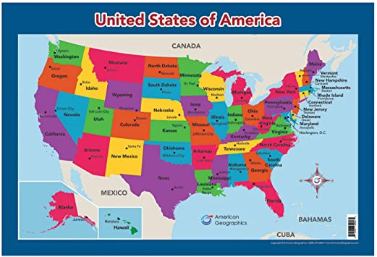  Picture or diagram associated with your geographical unit  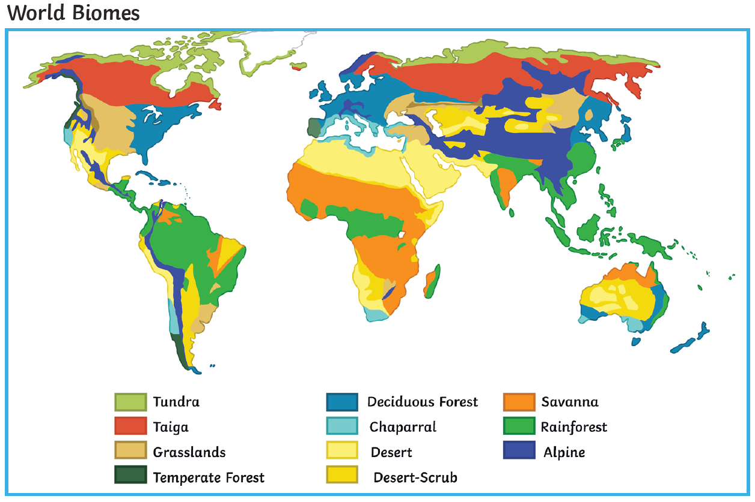
Why is New York one of the world’s most visited cities? | New York is the 27th largest state made up of 5 boroughs; Manhattan, Brooklyn, Staten Island, The Bronx and Queens. Its landscape is made up of cities, mountains, lakes and waterfalls. It is famous for its vast range of food and education in New York is considered to be of a very high standard. There are over 800 languages spoken in New York, making it the most linguistically diverse place in the world. 7 of the presidents were born in New York including our current president Trump.
Can you carry out your own research on one of the American states? | The United States is divided into 50 states. However, state each varies in size considerably and are spread over a range of different climates and biomes.
Who were the original Americans?  (Link with English text, Sacagawea) | There is a lot of controversy about who the original Americans were however people believe that many thousands of years ago, the Americas were inhabitable. Historians believe that the original Americans may have come from Siberia across the Bering Land Bridge, which existed between Alaska and Eurasia from the end of the last Ice Age until about 10,000 years ago. The area has now submerged with water.
What do you know about the climate of the USA? | The major mountain ranges in the United States run in a north-south direction, they have a large impact on the climate of the country's various regions. The west coast, for example, has a milder climate than the interior because it is moderated by its proximity to the ocean, whereas places like Arizona and Nevada are very hot and dry because they are on the leeward side of mountain ranges. The lowest temperature ever recorded in the United States was at Prospect Creek, Alaska on January 23, 1971. The temperature was -80 degrees.  The hottest temperature recorded in the United States (and in North America) was in Death Valley, California on July 10, 1913. The temperature that day measured 134 degrees (56°C).
Reflection: Children to create a documentary which explains why they should visit the USA. | Above skills and information learned to be collated as a documentary using additional Computing/English skills.

Timeline of significant events | Vocabulary  Word Definition  State the civil government of a country  Latitude the angular distance of a place north or south of the Earths Equator  Longitude the angular distance of a place east or west of the Greenwich meridian  Hemisphere a half of the Earth, usually as divided into northern and southern halves by the western and eastern halves by an imaginary line passing through the poles  Time Zone an area or stretch of land having a particular characteristic, purpose or use
Trips/ Visits & Useful Websites:  https://www.smithsonianmag.com/history/interactive-map-compares-new-york-city-1836-today-180947939/  http://www.bbc.com/earth/story/20170328-the-first-people-who-populated-the-americas | Useful information or people to be studied in this particular unit  English link: English text ‘Sacagawea’ (make links with Who were the original Americans?)  Art link: Using the art of Andy Warhol, can you recreate his work using a famous American as your subject?

