BUCKINGHAM PRIMARY ACADEMY - HISTORY
Enquiry Question Why should gunpowder, treason and plot never be forgotten? |  | Year group 5
What will be taught through the unit:  A study of an aspect or theme in British history that extends pupils’ chronology beyond 1066: The beheading of Charles 1; Civil War; Great Fire of London |  | Historical Enquiry:  - Know and sequence key events of time studied  - Use relevant terms and period labels  - Make comparisons between different times in the past  - Examine causes and results of great events and the impact on people  - Compare accounts of events from different sources – fact or fiction  - Offer some reasons for different versions of events  - Begin to identify primary and secondary sources  - Use evidence to build up a picture of a past event  - Select relevant sections of information  - Use the library and internet for research
Who were the Roundheads and the Cavaliers? | Roundheads and Cavaliers made up the two opposing sides in the English Civil War, fought between 1642 and 1651. The term “roundhead” appears to originate with the short, cropped hairstyle worn by many Puritans, a stark contrast to the longer ringlets and wigs fashionable with opposing Cavaliers. Yet much more than different styles of haircut separated Roundheads and Cavaliers; their widely differing political and religious beliefs lay at the heart of the Civil War. | Picture or diagram associated with your historical unit  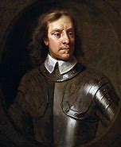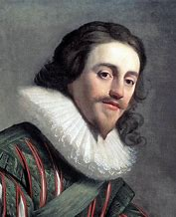  Oliver Cromwell Charles I
Was Oliver Cromwell right to stop the monarchy? | Oliver Cromwell rose from the middle ranks of English society to be Lord Protector of England, Scotland and Ireland, the only non-royal ever to hold that position. He played a leading role in bringing Charles I to trial and to execution
Why was the execution of Charles 1 a major event in British history? | Charles I was the first of our monarchs to be put on trial for treason and it led to his execution. This event is one of the most famous in Stuart England’s history – and one of the most controversial.  The execution of Charles, led to an eleven-year gap in the rule of the Stuarts (1649 to 1660) and it witnessed the rise to supreme power of Oliver Cromwell – whose signature can be clearly seen on the death warrant of Charles.
Why do you think the monarchy was restored after a short while? | Until 1640, Charles ruled without a Parliament – this period is often referred to as the 'Eleven Years Tyranny'.  War with Scotland forced Charles to recall Parliament. Instead of granting Charles money, Parliament sent him the Grand Remonstrance (1641). This was a list of 204 complaints about the way he was running the country. After Charles had tried and failed to arrest the five leaders of the Parliament, a civil war broke out.
Why do some people think that the Great Fire was one of the best things that happened to London? | 5 major changes to society were:  Insurance, Terraced housing, A practical approach to planning, The peaceful and orderly settlement of property disputes, A culture of rational improvement
Who was Samuel Pepys and would he have been a modern day blogger? | Samuel Pepys was a British Member of Parliament, and Chief Secretary to the Admiral. He is famous for his diary, which provides an accurate picture of life in England in the 17th century.  He was born in London in 1633 and died in 1703.  During his lifetime, he played several musical instruments, and was interested in the theatre, books and science.  Pepys started his diary in 1660, writing in it daily for almost 10 years. He wrote about his daily life as well as historic events such as the Great Fire of London and the Plague
Reflection: VLOG about the topic – newsreaders and historical sources and people. (documentary style) | - Green screen  - Ipads  - Microphones  - Cloaks/ wigs?

Timeline of significant events  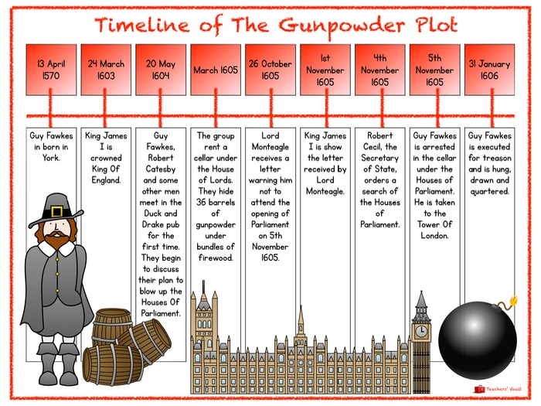 | Vocabulary  Word Definition  Conflict a serious disagreement or argument, typically a protracted one.  Machinations a plot or scheme  Puritan a member of a group of English Protestants of the late 16th and 17th centuries who regarded the Reformation of the Church under Elizabeth I as incomplete and sought to simplify and regulate forms of worship.  Usurper a person who takes a position of power or importance illegally or by force.  Saviour person who saves someone or something from danger or difficulty  Republic a state in which supreme power is held by the people and their elected representatives, and which has an elected or nominated president rather than a monarch.  Patronage the power to control appointments to office or the right to privileges.  Parliament (in the UK) the highest legislature, consisting of the Sovereign, the House of Lords, and the House of Commons.  Democracy a system of government by the whole population or all the eligible members of a state, typically through elected representatives.
Trips/ Visits & Useful Websites:  Oliver Cromwell- http://www.bbc.co.uk/history/british/civil_war_revolution/cromwell_01.shtml | Useful information or people to be studied in this particular unit

