Year 5 Learning Project - Week 4
Enquiry Question - Why should gunpowder, treason and plot never be forgotten?
Weekly Maths Tasks (Aim to do 1 per day) | Weekly Reading Tasks (Aim to do 1 per day)
- Daily Oak Academy lessons  - Complete Maths Shed activities  - BBC Bitesize lessons  https://www.bbc.co.uk/bitesize/tags/zhgppg8/year-5-lessons/1  - Play on Hit the Button - focus on multiplication or division facts. Can you beat your score daily?  https://www.topmarks.co.uk/maths-games/hit-the-button  - IXL Maths  https://uk.ixl.com/math/year-5 | - Complete Lexia online.  - Share a book every day. This can be reading a book aloud or sharing a book with an adult.  - Watch Newsround and find out what is happening in the world.  - Write a book review.  - Create a wanted poster for the villain in your story – remember to include physical description, reward and contact information.  - Listen to a free audio book from Audible  https://stories.audible.com/start-listen
Weekly Spelling / Phonic Tasks (Aim to do 1 per day) | Weekly Writing Tasks (Aim to do 1 per day)
- How many words can you make out of the word EDUCATION? You can only use each letter once.  - How many words can you write with the prefix ‘sub’ and the suffix ‘cious’  - Complete spelling shed activities  - Play Spelling frame spelling challenges  https://spellingframe.co.uk/  - Scrabble word game  https://www.arkadium.com/gb/games/scramble-words-game/ | - Daily Oak Academy lessons  - BBC Bitesize lessons  https://www.bbc.co.uk/bitesize/tags/zhgppg8/year-5-lessons/1  - Take on the challenge of an independent writing activity  http://www.phoenixjuniors.co.uk/wp-content/closurework/Year%205%20Independent%20Writing%20Acitivities.pdf  - IXL English  https://uk.ixl.com/ela/year-5
Weekly PE Challenge | Weekly ‘Around the World’ challenge
- Count to 100 workout with Jack Hartmann  https://youtu.be/NWHc9MdkhWY  https://youtu.be/MiUw36s9V_g  https://youtu.be/1dkPouLWCyc  - Join in with dances from Just Dance  https://youtu.be/gCzgc_RelBA  https://youtu.be/dnOL4V5_qaM?t=10  https://youtu.be/dpY4ZTV7Fm0?t=110  - Mr Shepherd’s weekly PE challenge. | - Take a virtual tour of exhibitions at The Louvre in Paris, France.  https://www.louvre.fr/en/visites-en-ligne#tabs  - Watch Beluga Whales in the Georgia Aquarium, USA.  https://www.georgiaaquarium.org/webcam/beluga-whale-webcam/

Year 5 Learning Project - Week 4
Enquiry Question - Why should gunpowder, treason and plot never be forgotten?
Why do you think the monarchy was restored after a short while?

Write a paragraph answering the challenge question “Why do you think the monarchy was restored after a short while?”

Write an argument for and against the monarchy being restored.

Create a timeline of how long it took to restore the monarchy and label events that happened during this time.

Create a newspaper article about the return of Charles II.

Research how the monarchy was restored and by who.

Design your own vocabulary definitions, complete with illustrations for the following words: monarchy, advisers, resign, commonwealth, dictator, Quakers, constitutional, levellers, siege, dictatorship.

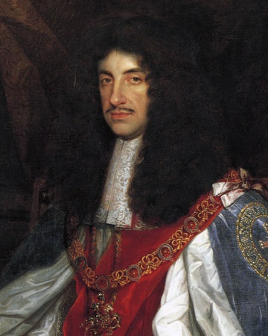

Year 5 Science Project - Week 4
Why Soap Works Experiment
In this experiment, you are going to find out why soap works and why it is better than using just water to wash your hands. Throughout this experiment, the surface of the water in the bowl represents your hands and the pepper (or other spice) represents the harmful dirt and germs that need to be washed away. There are two tests in this experiment which will show you what happens when you wash your hands with and without soap.

Before you start the experiment, make a prediction about what will happen when you don’t put soap on your finger and when you do put soap on your finger. You may want to use a camera to take a photographic record about what happens in the experiment.

You will need:
• A bowl | • Liquid hand soap
• Some water | • A hand towel
• A sprinkle of black pepper (or another spice) | • A camera (optional)

What to do:
- Fill the bowl with water, but not all the way to the top.
- Sprinkle some black pepper on the surface of the water. You should see the black pepper floating.
- Test 1: Dip your finger into the centre of the bowl of water. Watch what happens to the pepper and record this.
- Dry your hand, then dip your finger into the liquid soap.
- Test 2: Dip your soapy finger in to the centre of the bowl of water. Watch what happened to the pepper and record this.

Conclusion:
- Why was there a difference in how the pepper behaved when the soap was added?
- Think of the surface of the water as the skin on your hands and the pepper as microbes on your hand. Write a sentence to explain what happens when soap meets the microbes on your skin.
- Why should we use soap when we wash our hands?

