Year 5 Learning Project - Week 5
Enquiry Question - Why should gunpowder, treason and plot never be forgotten?
Weekly Maths Tasks (Aim to do 1 per day) | Weekly Reading Tasks (Aim to do 1 per day)
- Daily Oak Academy lessons  - Complete Maths Shed activities  - BBC Bitesize lessons  https://www.bbc.co.uk/bitesize/tags/zhgppg8/year-5-lessons/1  - Play on Hit the Button - focus on multiplication or division facts. Can you beat your score daily?  https://www.topmarks.co.uk/maths-games/hit-the-button  - IXL Maths  https://uk.ixl.com/math/year-5 | - Complete Lexia online.  - Pick your favourite character from a book of your choice. Using that character create a character profile.  - Draw a timeline of events that happen in a book of your choice.  - Rewrite the ending to a story.  - Share a book every day. This can be reading a book aloud or sharing a book with an adult.  - Listen to a free audio book from Audible  https://stories.audible.com/start-listen
Weekly Spelling / Phonic Tasks (Aim to do 1 per day) | Weekly Writing Tasks (Aim to do 1 per day)
- Play Spelling frame spelling challenges  https://spellingframe.co.uk/  - How many words can you make out of the word ALTERNATIVE? You can only use each letter once.  - Scrabble word game  https://www.arkadium.com/gb/games/scramble-words-game/  - Complete spelling shed activities  - How many words can you write with the prefix ‘anti’ and the suffix ‘ible’ | - Daily Oak Academy lessons  - BBC Bitesize lessons  https://www.bbc.co.uk/bitesize/tags/zhgppg8/year-5-lessons/1  - Take on the challenge of an independent writing activity  http://www.phoenixjuniors.co.uk/wp-content/closurework/Year%205%20Independent%20Writing%20Acitivities.pdf  - IXL English  https://uk.ixl.com/ela/year-5
Weekly PE Challenge | Weekly ‘Around the World’ challenge
- Join Joe Wicks in his daily PE sessions at 9am  https://www.youtube.com/thebodycoachtv  - Mr Shepherd’s weekly PE challenge.  - Count to 100 workout with Jack Hartmann  https://youtu.be/NWHc9MdkhWY  https://youtu.be/MiUw36s9V_g  https://youtu.be/1dkPouLWCyc | - Take a virtual tour of The Van Gogh Museum.  List 5 pieces of artwork by Van Gogh and describe what is in each image.  http://shorturl.at/gjpsv  - Watch the ‘Panda Cam’ streaming live from Atlanta Zoo in Georgia, USA  https://zooatlanta.org/panda-cam/

Year 5 Learning Project - Week 5
Enquiry Question - Why should gunpowder, treason and plot never be forgotten?
Why do some people think that the Great Fire was one of the best things to happen to London?

Write a list of pros and cons about the Great Fire of London.

Write a piece explaining what happened to London after the Great Fire.

Create a fact file about the Great Fire of London.

Create a timeline of the Great Fire of London.

Write a short piece information about each of the key people linked to the Great Fire.

Create a timeline of key events that have taken place in London, i.e. the Olympics, from the Great Fire of London to present day.

Using different materials, recreate a piece of artwork of the Great Fire of London.

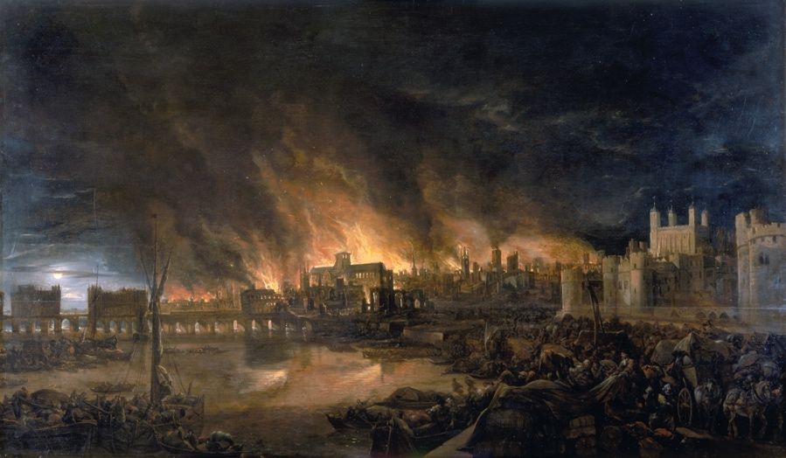

Year 5 Science Project - Week 5
Dissolving
In this experiment, you are going to find out all about dissolving substances.

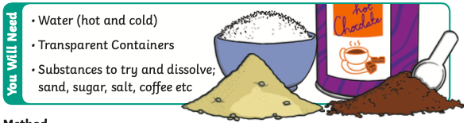
Before you start the experiment, make a prediction about which of your substances will dissolve and which won’t. You can also make a prediction about which water temperature will dissolve the substances the quickest.

Method:
- Add a teaspoon of whichever solid you are testing to a glass of cold water and a glass of hot water, stir and observe the difference.
- Look to see if the solid dissolves in the hot water and cold water and if one is better than the other.
- After making your observation, record your findings and repeat the process with another substance.

The Science Bit:
Things like salt, sugar and coffee dissolve in water. They are soluble. They usually dissolve faster and better in hot water. Pepper and sand are insoluble, they will not dissolve even in hot water.

Everything is made of particles which are always moving. When a soluble solid (solute) is mixed with the right liquid (solvent), it forms a solution. This process is called dissolving.

Two things that affect the speed at which the solid dissolves are temperature and the size of the grains of the solid. Caster sugar, which is made of fine particles will dissolve quickly, but bigger sugar particles will take longer.

Solids dissolve faster in hot water as in hot water the water molecules are moving faster, so bump into the solid more often which increases the rate of reaction.

