BUCKINGHAM PRIMARY ACADEMY - Geography
Enquiry Question How can we re-discover the wonders of Ancient Egypt? |  | Year group 6
What will be taught through the unit:  Pupils will be taught about the ancient egyptian period with particular reference to the location and area of Egypt. Pupils will be locating Egypt on a world map and then identifying further locations such as the 7 wonders of the ancient world on a more specific and detailed map. Pupils will be taught about the importance of the River Nile and the purposes behind it. Pupils will be applying their knowledge of coordiantes and how to navigate their way down the River Nile using coordnaites as part of their instructions. Pupils will also be investigating human features of georgrpahy such as the building of the pyrmaids and discussing if this has taught us anything in todays age. |  | Geographical Equiry  - use the eight points of a compass, four and six-figure grid references, symbols and key (including the use of Ordnance Survey maps) to build their knowledge of the United Kingdom and the wider world  - physical geography, including: climate zones, biomes and vegetation belts, rivers, mountains, volcanoes and earthquakes, and the water cycle  - locate the world’s countries, using maps to focus on Europe (including the location of Russia) and North and South America, concentrating on their environmental regions, key physical and human characteristics, countries, and major cities
Who were the Ancient Egyptians and where did they live? | The Ancient Egyptians lived along the banks of the river Nile in Egypt. Farmers first settled in Egypt along the River Nile around 5000 B.C. Where do most people in Egypt live today? About 95 % of Egypt's population still live in the Nile valley (the area next to the river).  Children to identify the location of the Egyptians using a world map/contient (Afirca)m then leading into a more detiled map of Egypt. | 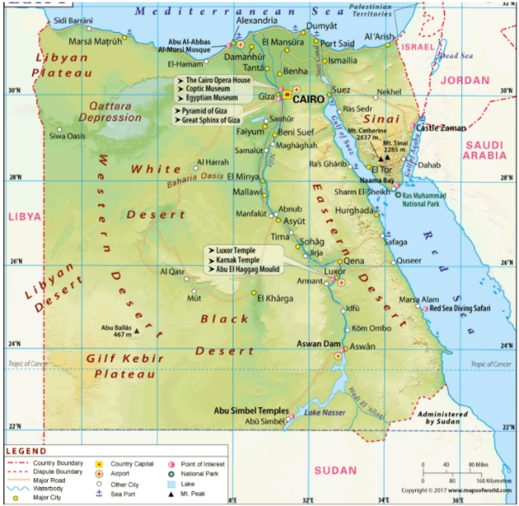  Diagram associated with your geographical unit  Map of Egypt  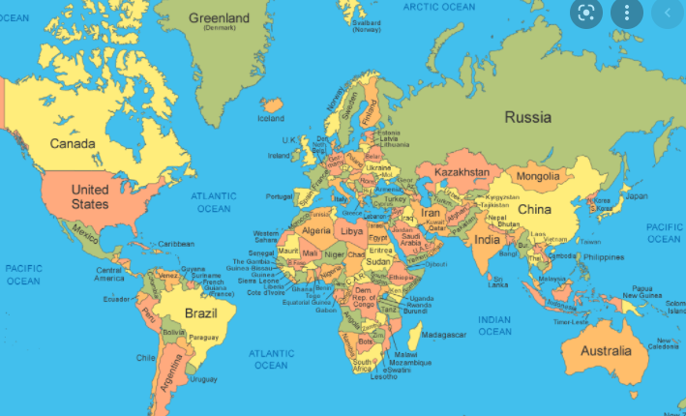
What are the 7 Wonders of Ancient Egpyt- Can you locate them on your map? | - Great Pyramid of Giza. Giza, Egypt  - The Great Sphinx. Giza, Egypt  - Temple of Luxor. Luxor, Egypt  - Cairo. Cairo, Eygpt.  - Abu Simbel. Southwest of Aswan, Egypt  - Saqqara. South of Cairo, Egypt  - Temple of Karnak. Al-Karnak, Egypt  https://www.ancient.eu/The_Seven_Wonders/
Can you navigate your way along the River Nile? | RSC Lessn.  From the previous lesson children will have understanding of Coordintes/location. Children to navigate and explain how to get from one place to another using geographical terms such as N/E/S/W
Can you plan a journey to and from the UK and Egypt and take into account the different time zones? | 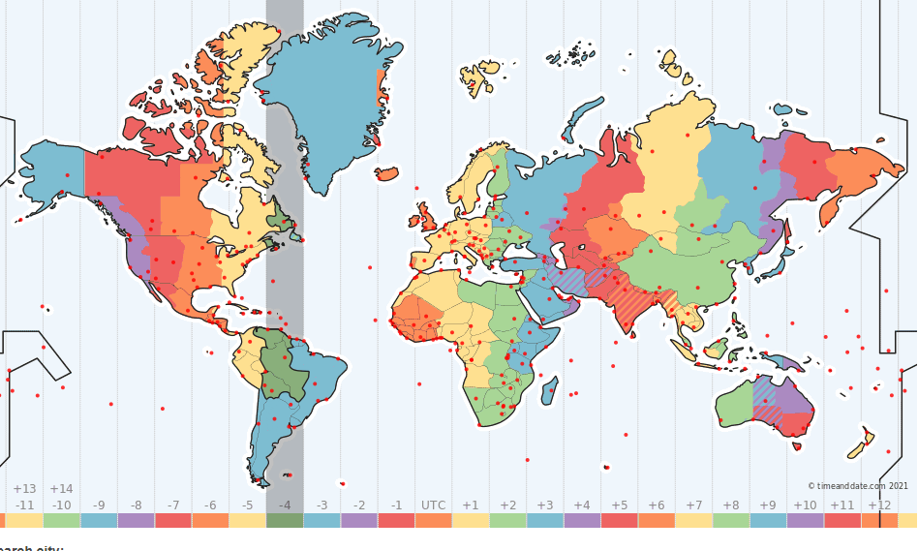
Why does Egypt have warmer weather than the UK? | The prevailing northwesterly wind from the Mediterranean Sea continuously blows over the northern coast without the interposition of an eventual mountain range and thus, greatly moderates temperatures throughout the year.
Create a persuasive leaflet for people to visit Egypt | This will combine all of the learning throughout the spring term. Children to choose a seven wonder to focus their learning on throughout their pieces of writing.

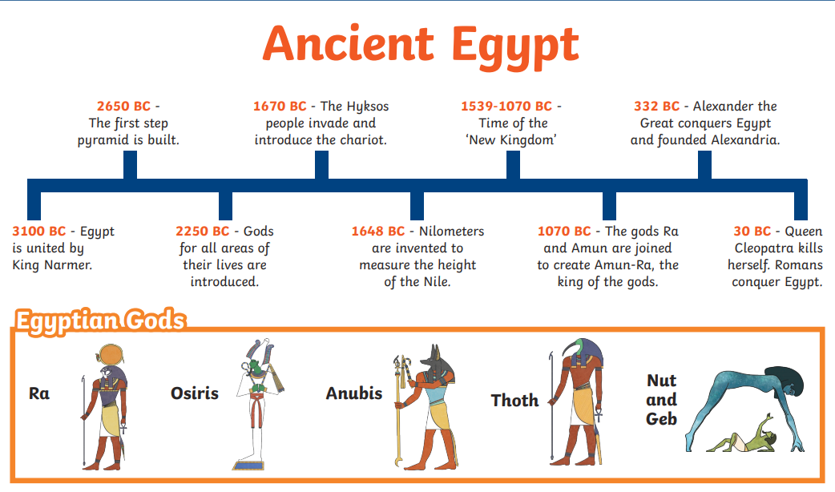  Timeline of significant events | Vocabulary  Word Definition  Civilasation The stage of human social and cultural development and organization that is considered most advanced  Ancient Egypt Ancient Egypt was a civilization of ancient North Africa, concentrated along the lower reaches of the Nile River, situated in the place that is now the country Egypt.  Pyramid The Egyptian pyramids are ancient pyramid-shaped masonry structures located in Egypt  Advanced Modern and recently developed.  Time zone An area or stretch of land having a particular characteristic, purpose, or use, or subject to particular restrictions.
Trips/ Visits & Useful Websites: | Useful information or people to be studied in this particular unit

