BUCKINGHAM PRIMARY ACADEMY - Geography
Enquiry Question Will you ever see the water you drink again? |  | Year group 6
What will be taught through the unit:  Children to develop knowledge and understanding of the water cycle and how the process of water works.  Children to develop scientific understading and be able to compare the water system here in the UK to Zimbabwe.  Children to identify how land changes over time and a result of the development.  Children to make links between our English text and geography and be able to apply and make the links. |  | Geographical Equiry  - locate the world’s countries, using maps to focus on Europe (including the location of Russia) and North and South America, concentrating on their environmental regions, key physical and human characteristics, countries, and major cities  - name and locate counties and cities of the United Kingdom, geographical regions and their identifying human and physical characteristics, key topographical features (including hills, mountains, coasts and rivers), and land-use patterns; and understand how some of these aspects have changed over time  - Physical geography, including: climate zones, biomes and vegetation belts, rivers, mountains, volcanoes and earthquakes, and the water cycle  - Human geography, including: types of settlement and land use, economic activity including trade links, and the distribution of natural resources including energy, food, minerals and water.  - use maps, atlases, globes to locate countries and describe features studied
How does water form in the first place? | The water cycle shows the continuous movement of water within the Earth and atmosphere. It is a complex system that includes many different processes. Liquid water evaporates into water vapor, condenses to form clouds, and precipitates back to earth in the form of rain and snow. Water in different phases moves through the atmosphere (transportation). Liquid water flows across land (runoff), into the ground (infiltration and percolation), and through the ground (groundwater). Groundwater moves into plants (plant uptake) and evaporates from plants into the atmosphere (transpiration). Solid ice and snow can turn directly into gas (sublimation). The opposite can also take place when water vapor becomes solid (deposition). | Diagram associated with your geographical unit  The water cycle  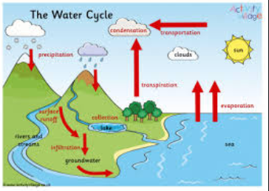  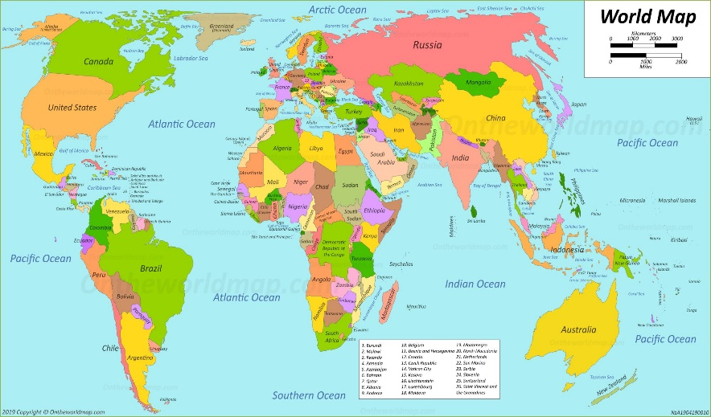  Map of the world
Create a plan of how water makes its journey into our homes | 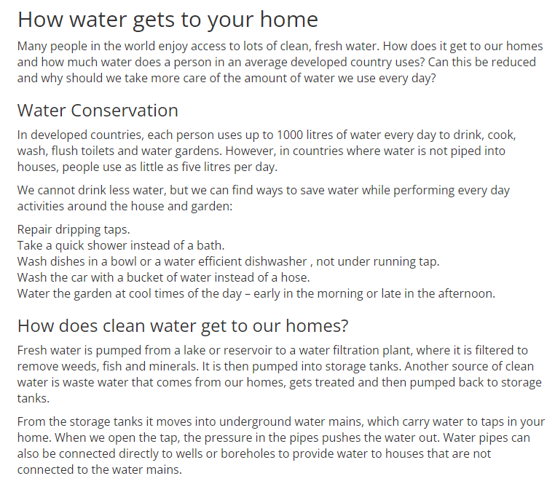
Why is water a major necessity in any village, town or city? | 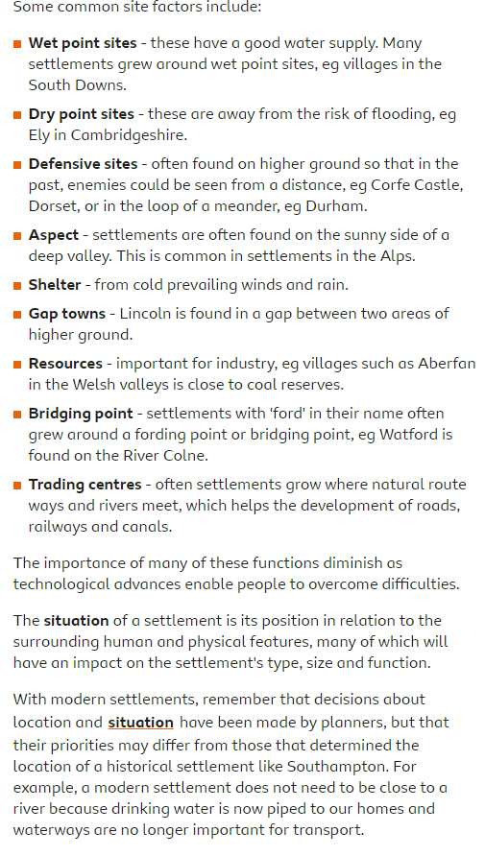
Use four figure grid references to locate different settlements | Use this website to help with the location and compass maps  https://www.usgs.gov/mission-areas/water-resources/maps
How has land changed overtime? | This will be covered in an English Lesson
How is water used to help provide energy to many places? | A hydroelectric power plant consists of a high dam that is built across a large river to create a reservoir, and a station where the process of energy conversion to electricity takes place.  The first step in the generation of energy in a hydropower plant is the collection of run-off of seasonal rain and snow in lakes, streams and rivers, during the hydrological cycle. The run-off flows to dams downstream. The water falls through a dam, into the hydropower plant and turns a large wheel called a turbine. The turbine converts the energy of falling water into mechanical energy to drive the generator. It turns a shaft, which rotates a number of magnets in the generator. When the magnets pass copper coils a magnetic field is created, which aids the production of electricity. Step-up transformers will than increase the voltage of the electricity, to levels needed for the journey to communities. After this process has taken place electricity is transferred to the communities through transmission lines and the water is released back into the lakes, streams or rivers.
Recreate concept map

Create a double page spread about why it was important for Kielder Valley to be created.

Timeline of significant events | Vocabulary  Word Definition  Continent any of the world's main continuous expanses of land (Europe, Asia, Africa, North and South America, Australia, Antarctica).  Location a particular place or position.  Equator a line notionally drawn on the earth equidistant from the poles, dividing the earth into northern and southern hemispheres and constituting the parallel of latitude 0°.  Statistics the practice or science of collecting and analysing numerical data in large quantities, especially for inferring proportions in a whole from those in a representative sample.  Country a nation with its own government, occupying a particular territory.  System a set of things working together as parts of a mechanism or an interconnecting network; a complex whole  Process a series of actions or steps taken in order to achieve a particular end.  Precipitation the action or process of precipitating a substance from a solution.
Trips/ Visits & Useful Websites:  https://www.yorkshirewater.com/education/learning-zone/education-centre-availability/ | Useful information or people to be studied in this particular unit  The Dam- English text (make links)

