BUCKINGHAM PRIMARY ACADEMY - HISTORY
Enquiry Question I’m a year 6, get me out of here! |  |  | Year group 6
What will be taught through the unit:  Children will study the history of the school grounds and how it has changed overtime. The subject area will link to prior learning from Autumn 2 (WW2). |  |  | Historical Enquiry:  - Place current study on a timeline  - Use relevant dates and terms  - Sequence up to 10 events on a timeline  - Find out about beliefs, behaviour and characteristics of people recognising that not everyone shares the same views and feelings.  - Know key dates, characters and events of time studied  - Confidently use the library and internet for research  - Link sources and work out how conclusions were arrived at  - Bring knowledge gathered from several sources together in a fluent account
What does our school look like from a birds eye view? | Children will look at their school from a birds eye view. Children will be using their knowledge both geographical skills and historical skills to identify key concepts on the map. The use of digimaps programme will be used to support children in identifying key areas both in and around the school. |  | Picture or diagram associated with your historical unit  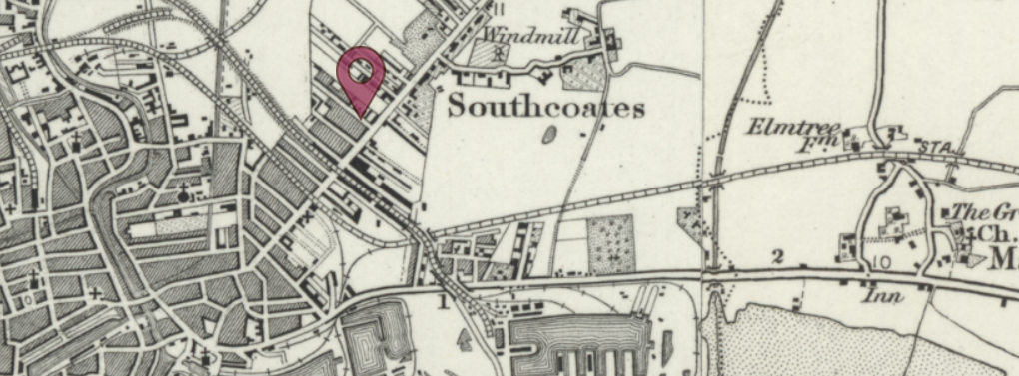
Can you compare past and present maps of the school ground and identify the changes? | Following on from the bird’s eye view lesson, children will be looking further into the maps of the school grounds. Children will look at the comparisons between the maps using the programme digi maps to allow historical enquiry to take place.
Can you compare and contrast the way the land had changed around our local secondary school? | Children will be applying their skills from the previous lesson to allow them to research and understand the history of their secondary school. Links will start to be made to WW2 and the effects this had on the local area.
What is the history of our town? | Children will now take their learning to the history of our town. Children will research and complete a timeline activity looking into the historical events. Links will be made to how the town has changed because of WW2.
What is the history of our school in relation to WW2? | Children to look at how the area around them has been affected because of WW2. Bomb maps will be used to understand the key location and target areas and how this would have affected ‘children’. Links and reference will be made to Autumn 2 enquiry question.
Retrieval Quiz | Children to complete their retrieval quiz to retrieve key knowledge from the unit.

Timeline of significant events | Vocabulary  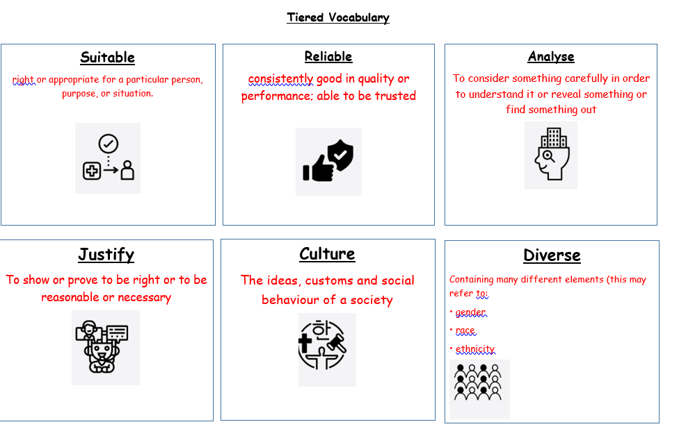
Trips/ Visits & Useful Websites: | Useful information or people to be studied in this particular unit

