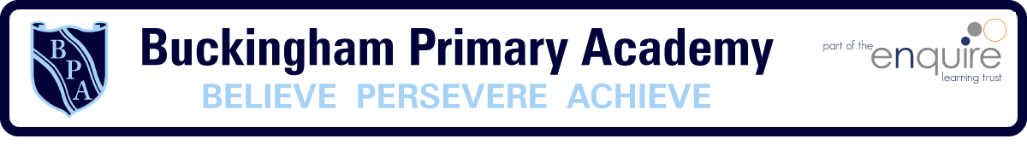

Year 6 Learning Project week 2

Enquiry Question - Who were the Mayans and what have we learnt from them ?

Weekly Maths Tasks (Aim to do 1 per day) | Weekly Reading Tasks (Aim to do 1 per day)
● Get a piece of paper and ask your child to show everything you know about addition and subtraction- Think about the different methods  ● Play on Hit the Button - focus on x tables. Can you beat your score daily?  https://www.topmarks.co.uk/maths-games/hit-the-button  - New Bitesize lessons from the BBC  https://www.bbc.co.uk/bitesize/tags/zncsscw/year-6-lessons/1  - White rose maths lesson | Your child should share a book everyday. This can be reading a book aloud everyday or sharing a book with an adult.  ● Listen to a story read: https://www.storylineonline.net  ● Watch Newsround and find out what is happening in the world. What did you find out? Is there anything you need help understanding?  - David Walliams is reading a book everyday https://www.worldofdavidwalliams.com/activities/  - Reading Plus/Lexia
Weekly Spelling / Phonic Tasks (Aim to do 1 per day) | Weekly Writing Tasks (Aim to do 1 per day)
- Play Spelling frame spelling challenges https://spellingframe.co.uk/  Spell common exception words  - How many Year 5/6 HFW can you read in 3 minutes? Can you beat your score daily?  - How many year 5/6 words can you change by adding different prefixes and suffixes on? | - Write a holiday brochure for Mexico  - Use your senses to describe a Mayan civilisation  - What odes a school look like in Mayan Civilisation? Can you draw, picture/research, and explain what it is showing?  - New Bitesize lessons from the BBC  https://www.bbc.co.uk/bitesize/tags/zncsscw/year-6-lessons/1
Weekly PE Challenge | Weekly ‘Around the World’ challenge
- Join Joe Wicks in his daily PE challenges  - Create calm and serenity by joining in Cosmic Yoga for children https://www.cosmickids.com/category/watch/ | - Can you find out what is happening in Chester Zoo?  - https://www.chesterzoo.org/virtual-zoo/

Year 6 Learning Project week 1

Enquiry Question - Who were the Mayans and what have we learnt from them ?

Who were the Mayans and where did they live?

Create a timeline of the Mayans and illustrate it.

Can you design a Mayan Mask and illustrate it?

Can you research a Mayan Hot Chocolate recipe and make one of your own?

Compare/contrast Mayan Education and your Education- think about the positives and the negatives.

Using the Mayan Number system, can you create some maths questions?

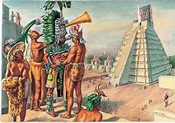

Year 6 Science Project week 1

Tornado in a Jar
Make a Tornado in a Jar
To whip up our mini tornado, Grab a clean mason jar and the ingredients:
3 cups of tap water
1 teaspoon of dish soap
1 teaspoon vinegar
Glitter or other small objects {optional}

Fill the mason jar with water – making sure to leave about an inch of space at the top. Pour in the dish soap and vinegar and closed the lid. {I gave the cap a double check just to make sure that our tornado wouldn’t get free and make a big mess.}
Holding one hand on top and one below swirl the jar for about 5 seconds and then set it down on the table to watch the tornado do its thing. So simple and easy.
To add some extra wow, try adding glitter or mini Legos to the jar.

The Science Behind It
When you spin the water in the jar, it creates a vortex in the centre. As the water spins, centripetal force causes the water to spin around that vortex making a mini tornado. (Hurricanes have a vortex too.)

