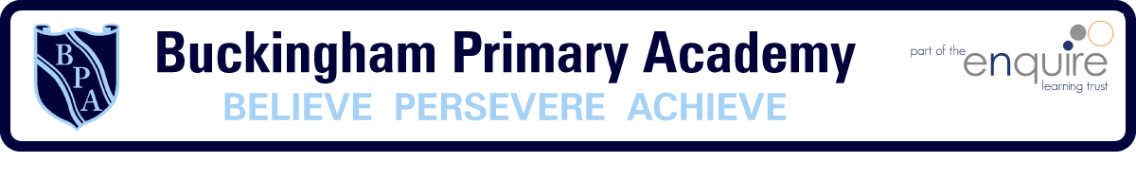

Year 6 Learning Project week 3

Enquiry Question - Who were the Mayans and what have we learnt from them ?

Weekly Maths Tasks (Aim to do 1 per day) | Weekly Reading Tasks (Aim to do 1 per day)
● Get a piece of paper and ask your child to show everything you know about addition and subtraction- Think about the different methods  ● Play on Hit the Button - focus on x tables. Can you beat your score daily?  https://www.topmarks.co.uk/maths-games/hit-the-button  - New Bitesize lessons from the BBC  https://www.bbc.co.uk/bitesize/tags/zncsscw/year-6-lessons/1  - White rose maths lesson  - Maths Mats- 1 Weekly | Your child should share a book everyday. This can be reading a book aloud everyday or sharing a book with an adult.  ● Listen to a story read: https://www.storylineonline.net  ● Watch Newsround and find out what is happening in the world. What did you find out? Is there anything you need help understanding?  - David Walliams is reading a book everyday https://www.worldofdavidwalliams.com/activities/  - Reading Plus/Lexia
Weekly Spelling / Phonic Tasks (Aim to do 1 per day) | Weekly Writing Tasks (Aim to do 1 per day)
- Play Spelling frame spelling challenges https://spellingframe.co.uk/  Spell common exception words  - Choose 5/6 spellings and create a short story. Remember to include of the year 6 features expected e.g. brackets, punctuation and high-level vocabulary. | - Compare/contrast the life of a Mayan child in comparison to yours.  - Could you write a letter to a Mayan Child explaining what is currently happening in our country? – Think back to when we did our letter to Zimbabwe. They need to include all of the features and expectations. Remember high quality!  - SPAG Mat- 1 Weekly.
Weekly PE Challenge | Weekly ‘Around the World’ challenge
- Join Joe Wicks in his daily PE challenges  - Can you create one of your own PE lessons e.g. it could be on football/dodgeball/cricketrounders/netball | - https://britishmuseum.withgoogle.com/  Find out about the significant events in history and create a poster on one of them.

Year 6 Learning Project week 3

Enquiry Question - Who were the Mayans and what have we learnt from them ?

Who were the Mayans and where did they live?

Have a look at the Mayan Alphabet can you create a code breaking activity?

Research why they decided to have their own alphabet

Have a look at the creation story
Could you re-tell the story? It could be as a picture/word document/acting it out.

Using the Mayan Number system, can you create some maths questions? Can you add reasoning and problem solving to this?

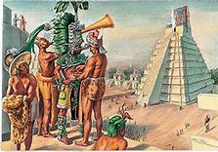

Year 6 Science Project week 3

Setting up an experiment
Set up a simple experiment to observe how materials change in different temperatures.

In order to do this you simply need:
- Ice cubes or squares of chocolate.
- Containers.
How to carry out the experiment
Place one ice cube or square of chocolate in each container.
Place each container in a different location (in a cupboard, near the window, in the car) make sure you have some warm and cold locations.
Observe the changes to each container every 10 minutes.
Can you write your own hypothesis of what you think will happen and when?

Recording results.
Create a table with the locations down the side and the times across the top.
Fill in each box noting the changes, this can be written or drawn using pictures.
Which one changes the most? Why?
Which one changes the least? Why?

Investigating further.
Place chocolate or ice in a pan and slowly heat it until it melts. Measure the temperature and observe how hot it needs to be for it to change states. Allow it to cool and observe what happens. Does it go back to how it started? Is this change reversible or irreversible? Explain how you know.

