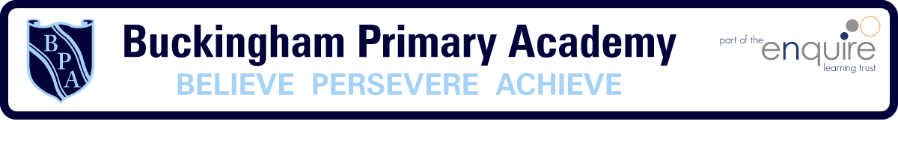

Year 6 Learning Project week 4

Enquiry Question - Who were the Mayans and what have we learnt from them?

HISTORY

Weekly Maths Tasks (Aim to do 1 per day) | Weekly Reading Tasks (Aim to do 1 per day)
- Play on Hit the Button - focus on division facts. Can you beat your score daily?  https://www.topmarks.co.uk/maths-games/hit-the-button  - Spot the calculation mistakes!  https://www.topmarks.co.uk/Flash.aspx?f=WhatsWronggrid  - BBC Bitesize lessons  https://www.bbc.co.uk/bitesize/tags/zhgppg8/year-5-lessons/1  - Choose from a range of popular Maths games!  https://mathsframe.co.uk/en/resources/category/22/most-popular | - What book would you want with you if you were trapped on a desert island? Why is this your chosen book?  - Share a book everyday. This can be reading a book aloud or sharing a book with an adult.  - Watch Newsround and find out what is happening in the world. Write down five things you find out? Was there anything you need help understanding?  - List your recommended top 10 books  - Listen to the story The Atrocious Fairytale  https://www.freechildrenstories.com/the-atrocious-fairytale-1
Weekly Spelling / Phonic Tasks (Aim to do 1 per day) | Weekly Writing Tasks (Aim to do 1 per day)
- Complete the weekly spelling activities on the PowerPoint.  - Complete the vocabulary ninja work. | - SPAG Mat- 2 Weekly.  - Write a short story using as many of the year 5 and 6 spellings as possible.
Weekly PE Challenge | Weekly ‘Around the World’ challenge
- Create an obstacle course in your garden and challenge your family to see who can complete the course in the fastest time.  - Join Strictly Come Dancing star Oti Mabuse for a dance extravaganza  https://www.youtube.com/channel/UC58aowNEXHHnflR_5YTtP4g  - Join in with dances from Just Dance  - https://www.youtube.com/watch?v=gCzgc_RelBA | - Take a virtual tour of The Great Wall of China.  https://www.thechinaguide.com/destination/great-wall-of-china  - Take a virtual tour of The National Museum of National History.  Write down 5 things you saw when taking the tour.  https://naturalhistory.si.edu/visit/virtual-tour

Year 6 Learning Project week 3

Enquiry Question - Who were the Mayans and what have we learnt from them ?

Who were the Mayans and where did they live?

Can you research and present all about the Mayans?

Can you find out about the architecture of the different pyramids and create a spider diagram of everything that you have found out.

Can you create a piece of Drama work related to the creation story?
Can you act out part of it?

Can you create a fact file about the life of a Mayan Child?

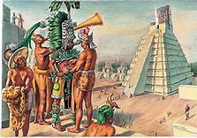

Year 6 Science Project week 3
Growing your own Rainbow
Did you know that you can grow your own rainbow?

You will need a scientific process called the capillary action. This action happens when a liquid moves up through a hollow tube or into a spongy, solid material. It happens when three forces work together: cohesion, adhesion and surface tension.

Water molecules like to stick to each other - this is called cohesion. They also like to stick to solids in a process called adhesion.

In this experiment, you are going to use kitchen roll. The fibres in kitchen roll have lots of little holes. Water is absorbed through the kitchen roll because when the first water molecule adheres to it and begins to move upward, it pulls the next water molecule up with it, like a chain.

You will need:
• Kitchen roll/paper towel
• Felt-tip pens
• Two small bowls of water
• Paperclip
• Thread

What to do:
1. Cut the kitchen roll into the shape of a rainbow.
2. At each end, use the felt-tip pens to colour a rainbow about 2cm up from the bottom. Remember the order of the colours: red, orange, yellow, green, blue, indigo, violet.
3. Attach the paperclip to the top of the rainbow and tie a piece of thread to it. This will allow you to hold your rainbow.
4. Add water to the two bowls.
5. Hold the rainbow with both ends slightly submerged into each bowl of water and watch your rainbow grow.

