Burrowmoor Primary School

Opening up the world for our children and families

A member of the Active Learning Trust

Statement / Policy Summary
This policy looks at the school’s approach to Attendance.
Date ratified: | Spring 2023
Date of review: | Autumn 2025

Equalities Impact Statement
Has this policy fully considered the school’s equality objectives and statement? | Yes
Is there any impact upon the school’s equality objectives? | No
If ‘yes’, are these clearly described and their impact assessed? | N/A

School Ethos

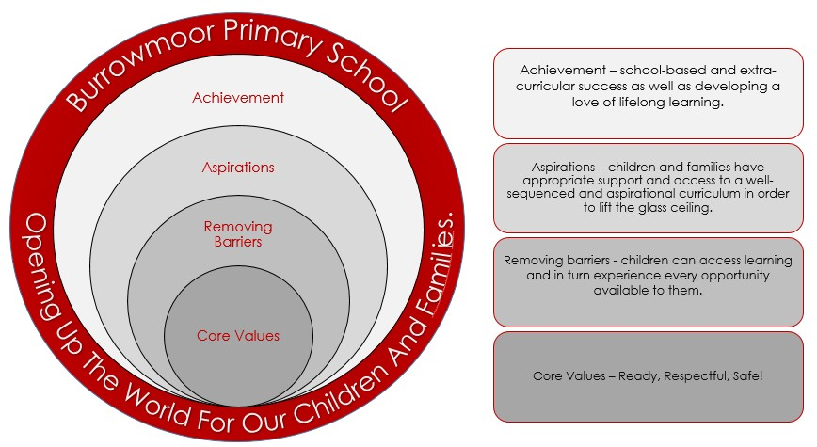

Principles

Burrowmoor School aims to work together with Parent/Carers and the Local Authority Attendance Officers (LAAOs) to ensure that all children registered at school attend every day and on time, unless the reason for the absence is unavoidable. We aim to improve the achievement of pupils by ensuring high levels of attendance and punctuality by creating an ethos in which attendance and punctuality are recognised and seen to be valued by the whole school. At the same time, ensuring that our policy applies to Reception aged children in order to promote good habits from an early age. The recognised expected level of attendance at school is 100% unless pupils have chronic health issues or there are exceptional or unavoidable reasons for absence.

Good attendance by pupils is recognised and celebrated with House and individual rewards/prizes being presented at the end of each term throughout the school year.

3. Parent/Carers Responsibilities

Parent/Carers have a legal responsibility to ensure that children of statutory school age (term after the child turns five) attend school on a regular and full time basis. Permitting an absence from school without good reason is an offence. A pupil whose attendance drops to 90% each year will, over their time at primary school, have missed the equivalent of two whole terms of learning.

Parent/Carers must:
- Ensure all children registered at Burrowmoor Primary School attend regularly and punctually everyday unless prevented from doing so by illness or medical appointment.
- Inform school in advance of any medical appointments during school time, parents may on occasions be asked to provide supporting evidence from the hospital, doctor or dentist, such as appointment details card/letter/text message in relation to the time requested.
- Ensure their child arrives at school in time for registration. Lateness is monitored and may be recorded as unauthorised.
- Inform the school as soon as possible about any child’s reluctance to come to school so that any problem can be quickly identified and dealt with.
- Follow application procedures regarding a request for leave of absence during term time, which should only be taken if absolutely necessary. Leave is not automatically authorised unless considered an exceptional circumstance. Any leave taken during term time, that has been unauthorised, could be subject to a penalty notice/fine.
- Report any changes to the contact details to the Office to ensure the school has the most up to date contact information.

Registration

Reception to Year 6:

- The classroom door is opened at 8.35 am.
- All external classroom doors are locked at 8.45 am.
- Once the external classroom door has been locked, entry to the school is via the main entrance.
- Registers are open at 8.35am and closed at 8.45am. Pupils who arrive at school after this time will be recorded as L, late on the register.
- Pupils who arrive at school after 9.15 am, without an unavoidable reason, will have their lateness recorded as U, unauthorised late which then impacts on their overall attendance level.

Lateness

Registration takes place between 8.35am and 8.45am. This is also when the teacher informs the class of their daily timetable of learning and prepares the pupils for the day ahead. Pupils who arrive after the registration period and up to 9.00am will be marked as late. Any pupil who arrives after 9.15am will be marked as an unauthorised late. Children who are persistently late to school will miss a significant amount of their education.

Where pupils show a persistent pattern of lateness, Parent/Carers will initially receive a letter informing them of the school’s concerns. This will advise Parent/Carers to speak to a member of staff to help address the issue. Should the lateness continue, Parent/Carers will be invited to a meeting at school to discuss their child’s lateness.

If there is no improvement, despite the school’s attempts to address unauthorised absences, a referral could be made to the Local Authority Attendance Officer (LAAO) for pupils who are of statutory school age.

Reporting a Pupil Absence

Parent/Carers must contact school on the first and every subsequent day of absence by 8.30am.

For any pupil not present at the close of registration, and the reason is still unknown, a member of the Attendance team will attempt to make contact with the Parent/Carers once the registers have closed at 9.00am.

The member of staff will ring every contact, starting with the priority contact, until a reason for absence is known. Failure to make contact with the Parent/Carers to establish a reason for an absence will result in emails and telephone calls being made to all contacts. Any unexplained absence will be recorded as unauthorised absence if there is no response from a Parent/Carer to an enquiry regarding their child’s absence from school. A safe and well check will be carried out by the school safeguarding team on the first day of absence with no contact, and will be considered a safeguarding concern.

For absences relating to a medical appointment, supporting evidence may be requested to authorise this absence. This can be a text message which clearly identifies who the appointment is for, a letter that is headed from the medical professional or an appointment card. A period of absences will only be authorised in relation to the length of the appointment. Children who fail to return to school within a reasonable time following their medical appointment could result in an am/pm session being unauthorised.

Illness

Children who are unable to attend school due to diarrhoea can return after they have been 48 hours clear. Children who are unable to attend school due to sickness can return once they are able to keep food down.

Children with mild coughs, colds, sore throats, sneezing and runny noses who are otherwise well can continue to attend school. However, if they develop a high temperature they should stay at home until their temperature has reduced and are well enough to return to school.

COVID-19

If a pupil tests positive for COVID- 19 and this has been reported to school, the pupil should stay at home and can return to school after 3 days if they feel well enough and do not have a high temperature.

As a school, we are continuing to maintain the good practice of regular handwashing and pupils are encouraged to cough and sneeze into a tissue to help reduce the risk of passing on any infections.

School Responsibilities

All members of the school staff have a safeguarding responsibility for identifying trends in attendance and lateness; with the Headteacher having overall responsibility in the monitoring of attendance and lateness of every pupil. Where there are concerns, parents will always be informed by letter and or telephone conversation and given an opportunity to come into school to meet with designated staff.

If applicable, support strategies with a monitoring period will be put in place to help improve the attendance or lateness of a pupil. Should a pupil’s attendance or lateness continue to be a concern despite the support strategies in place, with no improvement to the expected level set by school, a referral will be made to the Local Authority Attendance Officer (LAAO) for statutory aged pupils. This could result in a penalty notice/fine, or prosecution being issued by Cambridgeshire County Council, as per section 444 Education Act 1996. This may result in a fine of up to £2500 and/or 3 months in prison.
Classroom Staff

School staff will aim to contact the Parent/Carers of any pupil who is absent from school and a reason has not been provided once the registers have closed at 8.45am.

Staff will ring the first priority contact number to establish a reason for the absence. If unable to make contact, they will call the next contact until we have been provided with a
reason for absence.

If the reason for absence is unknown at the close of registration, staff will:

- Phone the contact numbers provided by the Parent/Carers to enquire about a pupil’s absence
- Complete the registers in accordance to the guidelines relating to correct usage of codes
- Leave a message on voicemail requesting parents to contact school regarding their child’s absence
- Log the outcome of the phone call on sims – pupil data system
- Inform the School Attendance Officer should there be a particular concern regarding an individual pupil’s attendance or lateness

The School Attendance Officer

Lateness and attendance is monitored daily by the school attendance officer who will:

- Scrutinise the registers daily, monitoring authorised/unauthorised absence and other reasons provided for pupil absence and lateness.
- Raise concerns with Parent/Carers of identified patterns of lateness with an initial ‘Late Letter’.
- Contact parents by telephone, email, or letter to establish a reason for a pupil’s absence if reason unknown.
- Raise concerns with Parent/Carers once attendance has fallen below the threshold set of 90%.
- Offer support or sign post to other areas of support within the community.

Burrowmoor School’s early intervention process

- Step One. A letter advising Parent/Carers of our concerns regarding the level of their child(ren) attendance and/or lateness
- Step Two, informal contact. This can be via telephone or a brief catch up at the start/end of the school day by any member of staff, to ascertain barriers to accessing education and offering support and signposting.
- Step Three. A formal Parent Contract Meeting to be held in school, with Parent/Carers to discuss concerns and, working together, identifying support which can be offered and signposting. Targets will be set to improve the attendance and/or lateness. These targets will be reviewed at the end of an agreed monitoring period.
- Step Four. Should the targets set at step three not be met following a review, despite every attempt by the school to support the family, a request for the issue of a penalty notice/fine or prosecution could be made to the Local Authority Attendance Officer (LAAO) for children of statutory school age.
- Liaise with other external organisations in relation to a pupil’s attendance and/or lateness.
- Monitor pupils attendance within specific and identified groups.
- Monitor pupil absences for those with additional medical needs.
- Monitor pupils and follow procedures for pupils ‘Child Missing in Education’.
- Follow reporting procedures for parents who have requested to Home Educate their child(ren).
- Follow procedures when deleting a pupil from roll.
- Meet with LAAO on the allocated visits to school, who will also monitor the registers and follow up any identified concerns.
- Monitor absences for illness and requests for leave to attend medical appointments.
- Complete a Medical Needs Assessment on pupils with absences of 15 days during the school year.
- Monitor and act upon requests for term time leave of absence and ensure Parent/Carers are informed of procedures in relation to authorised/unauthorised leave.

Only the Headteacher or a designated member of staff may authorise any absence for a legitimate reason, not all absence supported by Parent/Carers will be classified as authorised.

Definitions of Leave

Burrowmoor Primary School expects attendance to be 100%, unless there are exceptional or unavoidable reasons for absence.

Authorised leave:

- An absence is classified as authorised when a pupil has been away from school for a legitimate reason such as illness, subject to pattern of illness or a medical appointment where supporting evidence has been provided to cover the period of absence. However, there is an expectation that the pupil will be in school for registration or return to school after the appointment, depending where the appointment falls within the school day.
- Religious Observance - only day (s) exclusively set apart for religious observance by the religious body to which the pupil’s parents belong to.
- The leave of absence has been authorised due to a short and exceptional, unavoidable circumstance.

Unauthorised leave:

- An absence is classified as unauthorised when a child is away from school without the permission of the school, even with the support of the Parent/Carers, such as shopping, hair appointments, visiting family or birthdays.
- Medical appointments where supporting evidence of appointment details have not been provided when asked for.
- There has been no reason provided by the Parent/Carers to support an absence.
- Failure to follow school procedures or inform the school when taking a pupil out of school during term time.
- A leave of absence that has not been authorised due to not being considered an exceptional circumstance.

Term Time Leave

Parents do not have the right or entitlement to take their child out of school for a term time holiday. Recent government guidelines have removed the discretion on head teachers agreeing to term time leave. Any requests for leave of absence need to be submitted before the leave is taken. Parents must complete a Term Time Leave Request form and provide any supporting evidence, if applicable, with their request. This also applies to parents requesting to take their child out of school during the school day.

If the school suspect Term Time Leave has been taken but the parent/carers have not completed a Term Time Leave Request Form, we will write to all parent/carers giving them an opportunity to clarify the reason for absence and provide supporting evidence. Failure to respond to or provide supporting evidence will result in a referral to the Local Authority for unauthorised leave from school.

Exceptional circumstance (definition of exceptional: rare, unavoidable, short) will be considered on an individual basis, such as up to two days absence from school to visit a dying relative, death of a family member, attendance at a funeral or any unavoidable one off event, but the following examples of requests for leave of absence that do not meet the criteria of an exceptional circumstance and will not be authorised and could be subject to a penalty notice/fine for pupils of statutory school age are:

- Cheaper holidays/flights in the UK or abroad
- Holidays that overlap the beginning or the end of term
- Trip of a life time
- Visiting family or friends who have different half term holiday dates
- Family weddings for more than 1 day or visits to see family abroad
- Relatives coming to visit
- Extension of leave if a pupil has not returned to school after an agreed absence if does not meet grounds for an exceptional circumstance

Penalty Notice

The fine for a penalty notice is £60 per child, per parent/carer, increasing to £120 if not paid after 21 days but within 28 days for pupils who are of statutory school age. If a penalty notice remains unpaid, parents may be the subject of court proceedings for failing to ensure the regular school attendance of their child (ren) this could result in a fine of up to £2,500 and/or a term of imprisonment of up to 3 months per parent.

Parent/Carers who take unauthorised leave during term time or whose child has a pattern of unauthorised absence over any 4 week period could be subject to the issue of a penalty notice or prosecution.

The definition of parent in relation to a Penalty Notice includes and step-parent and the partner of a parent who lives in the same household.

Impact of Persistent Absence

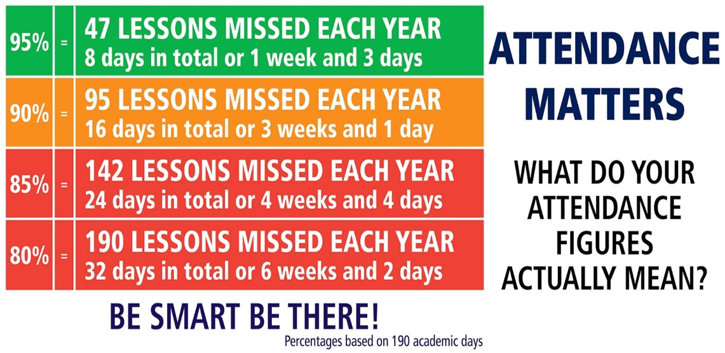

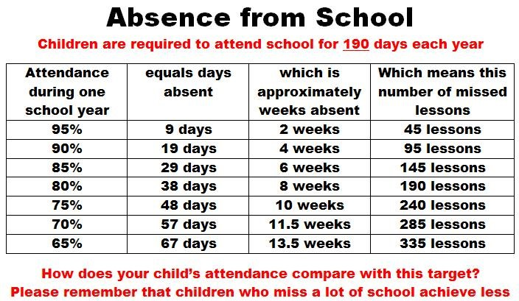

Attendance Codes
