Burrowmoor Primary School

A member of the Active Learning Trust
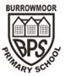
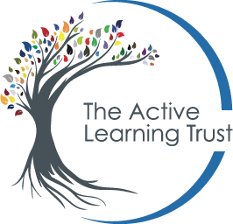
Statement / Policy Summary
This policy looks at the school’s approach to teaching phonics.
Date ratified: | 16.12.22
Date of review: | Autumn Term 2024

Equalities Impact Statement
Has this policy fully considered the school’s equality objectives and statement? | Yes
Is there any impact upon the school’s equality objectives? | Yes
If ‘yes’, are these clearly described and their impact assessed? | Positive impact upon inclusion

Phonics Policy – Floppy’s Phonics
At Burrowmoor Primary School, we are committed to the delivery of excellent teaching and learning of phonics. We aim to develop each child so that they are able to read with fluency as well as develop a love of reading that will stay with them for all of their lives.
Being able to read is the most important skill children will learn during their early schooling and has far-reaching implications for lifelong confidence and well-being. The use of phonics is one of many skills needed to be able to be a successful reader and writer. At Burrowmoor, we teach high quality phonics sessions to ensure that all children have the best start possible in reading and writing. The learning of phonics is the beginning of children’s body of knowledge, skills and understanding that are an essential part of learning to read. In order to read and understand texts, children must learn to recognise/decode the words on the page. Good quality phonics teaching allows the children to be secure in the skills of word recognition and decoding which allows children to read fluently. This will result in children being able to read for pleasure and will allow them to move onto developing higher order reading for meaning skills. These phonics skills are taught systematically on a daily basis.

Our aims
Our children are entitled to a phonics curriculum which enables them to:
- Gain a progressively deeper understanding of the phonetic structure of the English language.
- Apply their phonic knowledge and skills to decode unfamiliar words fluently and accurately.
- Read rapidly to apply what they have learned across the whole curriculum.
- Create fluent readers, confident speakers and willing writers.
- Develop a life-long love of reading.
We use the systematic and structured phonics programme, Floppy’s Phonics. The Floppy’s Phonics programme teaches the letter/s-sound correspondences of the English alphabetic code explicitly and comprehensively for reading and spelling.
During their journey through the Early Years Foundation Stage (EYFS) and Key Stage 1 (KS1), the children are taught the 44 phonemes (sounds) that are required for reading and spelling.
Children are taught the key skills of blending sounds together for reading and segmenting (breaking up) words for spelling.
As children grow in confidence and experience, they are introduced to alternative ways of representing the same sound. They also learn when to apply simple spelling rules and use verbs in the correct tense.
We ensure that our teaching of phonics is rigorous, structured and enjoyable. In Nursery, we start with short daily sessions focussing on phase 1 of the phonics programme. In Reception and KS1 children have discrete daily phonics sessions where they are introduced to new phonemes and have the opportunity to explore, practise and revise previous learning with ample opportunities to apply the knowledge they have.
We use a range of multi-sensory strategies to enthuse and engage the children including interactive whiteboards, individual whiteboards, books and pencils, magnetic letters and tiles, speaking and listening and a variety of practical activities. Children work with pace and are encouraged to apply their knowledge across the whole curriculum.

Implementation
Through the robust daily teaching of phonics following Floppy’s Phonics, the children are explicitly taught the essential skills needed for reading. Phonics is taught daily to all children in Reception and KS1. In Reception and KS1 the children have two discrete phonics sessions daily.
Each phonics lesson includes the flowing elements:
- Revise – Overlearn the previous graphemes and words
- Teach – Introduce a new grapheme/words
- Practise – Develop GPCs (Grapheme Phoneme Correspondences)/read and spell new words
- Apply – Use new graphemes/words in games and activities to secure knowledge
- Assess – Monitor progress within each phase to inform planning and possible interventions

Teaching and Learning
Our children are provided with a variety of opportunities to develop and extend their phonics skills in Reception and KS1. It also continues into Key Stage 2 (KS2) to support those children who do not have the phonics knowledge and skills they need. Links are made between phonics knowledge and understanding and how this is applied in both reading and writing. The lessons proceed at pace and incorporate a wide range of practical and interactive learning opportunities to engage the children, such as use of phoneme fingers and sound buttons. These learning opportunities are carefully chosen to ensure that the children develop their skills in aural discrimination and phonemic and rhyme awareness, blending and segmenting as well as grapheme-phoneme correspondence.
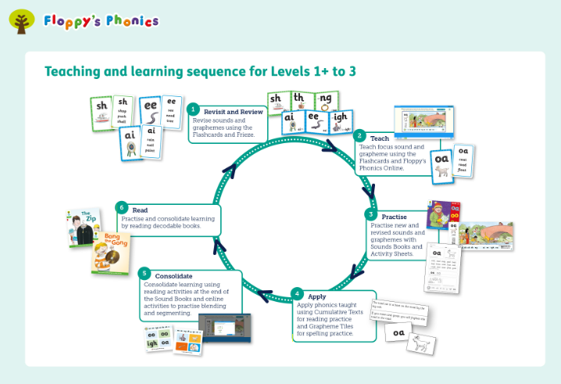
In lessons, teachers use the resources from Floppy’s Phonics and Letter Join. The school is equipped with Floppy’s Phonics flashcards, frieze frames, sound mats, Oxford Owl (Floppy’s Phonics – interactive books) and Floppy’s Phonics reading books. The Floppy’s Phonics online subscription is able to be accessed at home by the children and parents. The Floppy’s Phonics cycle is followed:

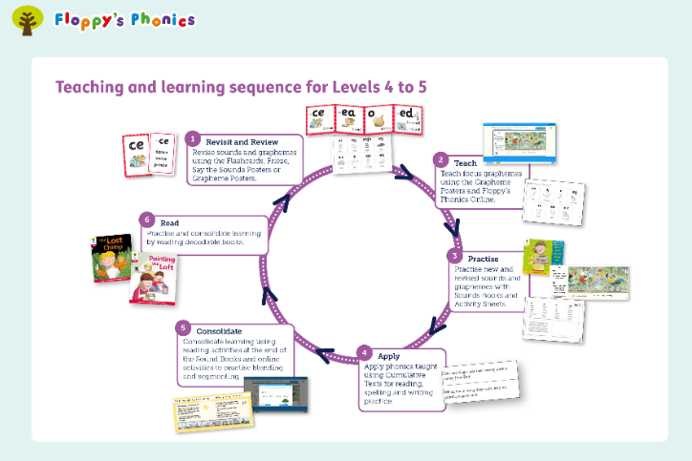

Age related expectations for the end of the school year:
By the end of EYFS all children at the expected level of development will:
- Say a sound for each letter in the alphabet and at least 10 digraphs.
- Read words consistent with their phonics knowledge by sound-blending.
- Read aloud simple sentences and books that are consistent with their phonic knowledge, including some common exception words.
- Write recognisable letters, most of which are correctly formed.
- Spell words by identifying sounds in them and representing the sounds with a letter or letters.
- Write simple phrases and sentences that can be read by others.
By the end of Year 1 all children should:
- Apply phonics knowledge and skills as the prime approach to reading unfamiliar words that are not completely decodable.
- Read many frequently-encountered words automatically.
- Read phonically decodable three-syllable words.
- Read a range of age appropriate texts fluently.
- Demonstrate understanding of age appropriate texts.
- Read decodable words that end –s, -es, -ing, -ed, -er, -est.
- Say the correct sound to grapheme for all the 40+ phonemes up to Stage 5.
By the end of Year 2 all children should:
- Read accurately most words of two or more syllables.
- Read most words containing common suffixes.
- Read and spell most ‘Helpful Words’ for Year 2.
- Read words accurately and fluently without overt sounding and blending.
- Sound out most unfamiliar words accurately, without hesitation.
- Segment spoken words into phonemes and represent these by graphemes.

The Alphabetic Code
All readers will be taught four key skills:
- Grapheme-phoneme correspondences (that is, the alphabetic code) in a clearly defined, incremental sequence and it will be referred to in every lesson.
- To synthesise (blend) phonemes (sounds) in order, all through a word, to read it.
- To segment words into their constituent phonemes for spelling.
- That blending and segmenting are reversible processes.
English represents the sounds of the language and uses an alphabet to do this.

Correct Articulation
Correct articulation is vital in helping children to learn to blend the sounds together. We make sure that the sound produced (each individual phoneme) is as precise and accurate as possible and that no additional sounds are added. For instance, the sound /m/ that starts ‘mother’ or is embedded in ‘impress’ needs to sound /mmm/ and not /muh/. The clearer the sound, the easier it is for a child to blend together (synthesise) the individual sounds to read a word because there are no unnecessary sounds getting in the way.

Helpful words
Children will be taught to read words that are not completely phonetically regular. Floppy’s phonics call these ‘Helpful Words’. Children need to be taught to read these words on sight, so they do not have to spend time puzzling them out. Teachers explicitly teach children to learn and practise their speedy recall of helpful words.

Planning
We follow the systematic approach laid out by Floppy’s Phonics programme to meet the requirements of the Early Year Foundation Stage and National Curriculum. Children who require extra support are targeted within the class through quality first teaching. Teachers adapt the Floppy’s Phonics planning to meet the needs of their class and to incorporate pre-cursive and cursive handwriting style, using Letter Join. All teachers and teaching assistants have been trained by the school’s phonics lead and follow the programme. Floppy’s Phonics lessons are designed to be delivered in two distinct sessions:
- Session 1 – This is a teacher-led session focusing on revision of past letter/s- sound correspondences and the introduction of sounds and graphemes, as well as modelling and practising the skills of blending, segmenting and handwriting, using the flashcards, frieze and interactive lessons on Floppy’s Phonics online.
- Session 2 – This provides a revise and apply routine in which children focus on their own learning at their own level. The teacher plans this lesson based on the first phonics lesson earlier in the day. The second session takes place later in the day.
The timing for each session is approximately 30 minutes.
Teachers use the sounds books on the interactive books online. The children can also access them at home using their own Oxford Owl account.
Children will either record their learning on whiteboards or in a text book.

Reading Books
Oxford Reading Tree provide a wide variety of resources to deliver high quality phonics teaching and practise. Children can further practise and consolidate by taking home Floppy’s Phonics reading books or Big Cat reading books. These books are decodable and the children will be given books linked to the sounds they have been taught in class (where possible). Books are changed at least once a week.

Assessment
Assessment is regarded as an integral part of teaching and learning and is a continuous process. We strive to make our assessment purposeful, allowing us to match the correct level of work to the needs of the pupils, thus benefitting the pupils and ensuring progress. It is the class teacher’s responsibility to keep track of the progress made by all the children in their class regardless of their phonic ability. The sounds and word assessments provided by Floppy’s Phonics are carried out half termly. The teachers use this assessment information to plan further work and set new targets. At the end of Year 1, children participate in the national Phonics Screening Check which assesses their knowledge of grapheme-phoneme correspondence and their skills in blending. This information is submitted to the LA. Those children who do not succeed in the phonics screening check are highlighted for further intervention and targeted support before completing the screening check again at the end of Year 2.
Children are provided with constructive and timely feedback in lessons. Teachers provide parents / carers with feedback on their child’s progress and achievement at parents evening and through the end of year report. Assessment information is also passed onto the next teacher as part of the transition between year groups.

Organisation of Phonics - Staffing
The Head of School and Phonics Lead are responsible for phonics throughout the school. This includes:
- Ensuring continuity and progression from year group to year group and the transition between phases.
- Providing all members of staff with training, a curriculum progression document and policy to show how aims are achieved and how phonics is to be taught using Floppy’s Phonics.
- Advising and supporting colleagues in the implementation and assessment of phonics across the school.
- Assisting with the requisition and maintenance of resources required for teaching phonics and the purchasing of decodable reading books for all ages, within the confines of the school budget.
- Monitoring the quality of teaching and learning in phonics across the school.
- Ensuring all staff feel confident in the teaching of phonics.
The class teacher is responsible for:
- Ensuring progression in the acquisition of phonic knowledge and skills with due regard to the EYFS and National Curriculum for English.
- Developing and updating skills, knowledge and understanding of phonics.
- Identifying needs in phonics and adapting planning to meet the needs of all children.
- Keep appropriate on-going records.
- Planning effectively for phonics, liaising with the phonics leader when required.
- Informing pupils and parents of their progress, achievements and attainment.
- Working with other teachers to ensure children receive a consistent approach.

