BURSCOUGH VILLAGE PRIMARY SCHOOL

NURSERY ADMISSIONS & CHARGING POLICY



Burscough Village Nursery aims to provide a welcoming and caring environment which values diversity, promotes equal opportunities and has an ethos of inclusion.  Each child has their own special talents which we endeavour to nurture and develop in our school. Our philosophy ‘Striving for the Future’ is at the heart of everything we do, providing the children with vital skills, knowledge, and experiences that they need to become well-rounded individuals now and in adult life. We encourage children, staff and parents to have a growth mindset, and this continued learning creates a vibrant, exciting atmosphere and environment for everyone.

Our nursery children are taught by a fully Qualified Teacher and two teaching assistants. We are proud to have been reaccredited ‘The Step into Quality Award’ in July 2022 for our Outstanding teaching and learning. Parents like our nursery because we provide the challenge and nurture the children need before they start primary school.

We are committed to offering an inclusive curriculum to ensure the best possible progress for all children, whatever their needs or abilities. We are able to cater for all pupils including children with English as an Additional Language, Special Educational Needs and Gifted and Talented.

**ENTITLEMENT TO NURSERY EDUCATION**

Burscough Village Primary School offers parents of two, three and four year olds nursery education, 38 weeks per year, during term time only. If your child is eligible for fifteen hours funding or the extended thirty hours funding this can be used in a variety of ways including breakfast and after school club. You are also able to share your funding between more than one nursery setting. Parents will be required to sign a **parent** **and school contract** stating when and where children are accessing any funding entitlement. Failure to compete the contract could lead to problems with the funding and you may have to pay for your child’s nursery sessions.

**Rising Three’s**

We can enrol your child at the start of the term they turn three. Your child will be two for this time. If you would like your child to start the nursery before your funding is available, you are able to pay for these sessions privately until funding is available. Some parents may be eligible for thirty funded hours due to the new funding changes outlined by the Government the term after their child turns two. Parents and Carers can check their availability on the Childcare Choices website <https://www.childcarechoices.gov.uk/>. The cost for a rising three child is based on £8.00 per hour for the full term that they are a rising three.

We understand that this could be a large sum of money, the school asks that your child’s nursery fees are paid a month in advance. We will be asking for the first month’s payment to be made before your child starts nursery. Any non-payments could lead to the nursery place been reallocated. We are happy to offer payment plans, however these must be agreed in writing prior to your child’s start date, agreed by the school and the full invoice to be cleared the month before the end of term e.g., Autumn Term final payment – End November.

**BURSCOUGH VILLAGE NURSERY SESSION TIMES**

|  |  |  |
| --- | --- | --- |
| **Session** | **Time** | **Total Hours\*** |
| Morning | 08:45 – 11:45am | 3 hours |
|  |  |  |
| Morning with Lunch | 08:45 – 12:30pm | 3.75 hours |
|  |  |  |
| Afternoon with Lunch | 11:45-15:30pm | 3.75 hours |
|  |  |  |
| Afternoon | 12:30 – 15:30pm | 3 hours |
|  |  |  |
| School Day | 08:45 – 15:30pm | 6.75 hours |
|  |  |  |
| Total School Week - 5 days | 08:45 – 15:30pm | 33.75 hours |
|  |  |  |
| Full day | 7:45 – 5:45pm | 10 hours** |
| Morning session with  Breakfast club | 7:45-11:45am | 4 hours |
| Morning sessions with lunch  and breakfast club | 7:45-12:30pm | 4.75 hours |
| Afternoon session with after  school club | 12:30-6:00pm | 5.5 hours |
| Afternoon session with after  school club and lunch | 11:45-6:00pm | 6.75 hours |
|  |  |  |
| **Additional hours costs \*\*\*** |  |  |
| Two year old (rising 3) |  | £8.00 Per hour |
| Three year old (3-4year old) |  | £6.00 Per hour |

*We are unable to deviate from these set hours outlined above due to staffing requirements and funding allocation.

**The total amount of funding hours in one day cannot exceed 10 hours; however, the school will remain open until 6:00pm which can be attended at an additional cost.

**\*\*\***Any additional hours used above your child’s funding allocation will be charged at this hourly rate. These costs are determined by the funding costs outlined to us by the Government.

**FUNDING**

There are several ways to take **fifteen or thirty hours** of funded entitlement. We can be flexible, and time can be taken across different sessions such as morning, afternoon or a full-day. Parents have an option of their child staying for a school dinner/lunchtime as well. Please visit [**www.childcare choices.gov.uk**](https://8882695-my.sharepoint.com/personal/datastore_burscough-pri_lancs_sch_uk/Documents/1.%20SchoolOffice21/Office/Nursery/2023%20Nursery%20Admissions/www.childcare%20choices.gov.uk)to check your eligibility.

Burscough Village Primary School offers Breakfast and After School Club provision for two, three and four year olds. (Kids’ Club) This is part of the school and there are options for this to be included within the funded hours. This must be reflected in the parental agreement form and committed to before the start of any new term. If you require any sessions outside of your funded hours, then these must be paid for via the cash payers' option through School Gateway.

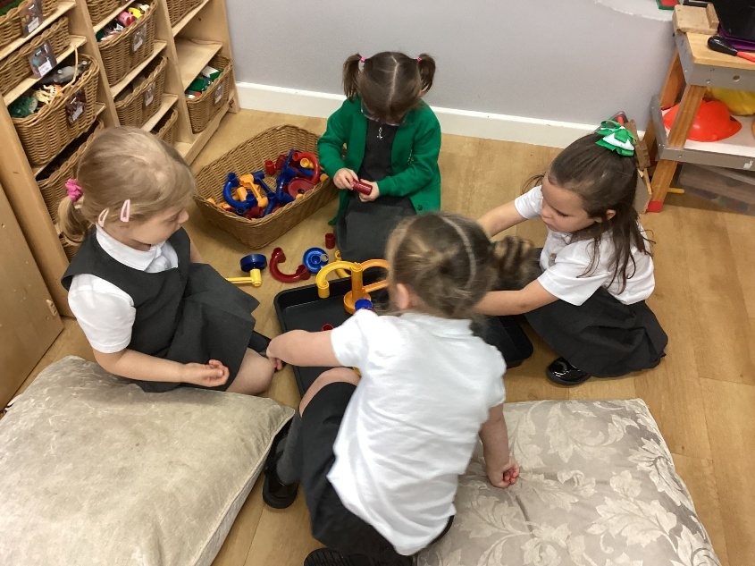

**ADMISSIONS POLICY**

The responsibility for determining the admissions for nursery age children lies with Burscough Village Primary School.

We have twenty-six places available for nursery age children in any session.

Parents must sign up for a minimum of four sessions per week. (2 full days)

Any sessions taken over and above the funded, thirty hours, weekly provision will be chargeable.

**When our nursery has more applicants than places available, children are offered places in the following order:**

1. Children in public care (Looked After Children), Previously Looked After or those children at risk of becoming Looked After and those adopted from overseas.
2. Children with EHC plans for Special Educational Needs (SEN) and those with exceptional/strong SEN reasons for attending a particular nursery setting.
3. Exceptional/strong medical, social, welfare reasons (associated with the child and/or the family) for attending a particular school/setting.
4. Children who will have a sibling attending the primary school at the time of their admission.
5. Parents/carers who provide evidence of training/education at a local establishment, working locally or established local childcare arrangements (at the time of the child's admission).
6. Those living nearest the nursery setting.

In addition to the application criteria -

* Parents/carers must provide the necessary evidence and contact names/email/telephone numbers/birth certificate with their application.
* Siblings are defined as brothers, sisters, step-brothers, step-sisters, half-brothers, half-sisters, adopted and fostered children living with the same family at the same address.
* The distance tiebreaker will be used should there be oversubscription within any of the stated admission criteria.

In most cases, children will be admitted to the nursery however there may be some occasions when the nursery will receive more applications than there are available places. Parents/carers will be able to seek provision elsewhere and can also request that their child's name be placed on a waiting list for places at Burscough Village should places become available, then these will be offered in accordance with the published admission criteria **and not on a first come first served basis**.

**ADDITIONAL NURSERY SESSIONS AND CHARGES**

Additional nursery sessions are subject to availability and will be allocated on a first-come, first-served basis.

* Parents are invited to place their child’s name on an ‘expression of interest’ list; however, this does not guarantee a place in the nursery.
* Sessions are charged at £18.00 for three hours, and this charge will be reviewed annually.
* For children who are placed in the nursery full time (thirty hours), there will be a charge of £22.50 per week above the funded hours.
* Any children staying for a school dinner will be charged at £2.00.
* There will be a charge for daily rolling snacks, at a cost of 25p per day, the cost will depend on how many sessions your child attends.
* Additional sessions and fees will be outlined in the parent/school contract.
* Additional sessions must be arranged termly in advance in agreement with the school.
* A term’s notice will be required if parents wish to cancel sessions at

Burscough Village Nursery. The school reserves the right to charge a term’s fees should parents not provide this notice.

**MID-TERM ADMISSIONS**

If there are still sessions available after the beginning of the new term and requests for additional sessions have been allocated, new intake requests for nursery sessions will be considered. Please note that no places can be reserved if taken mid-term.

**PAYMENT METHODS**

Invoices for payment of additional nursery sessions will be issued at the beginning of each

term. The invoice will take account of nursery top-up sessions for the whole of the term. We request payment through ParentPay, the Tax-free childcare scheme, or Childcare vouchers. Monthly payment plans are available on request. Information that you will need to set up payments is available through the school office. If a child is absent, refunds or reductions are not available. Proof of payment and remittance will be required for those choosing to pay using the Tax-free childcare scheme or Childcare vouchers.

**PAYMENT ARREARS**

Top-Up session arrangements will be cancelled if payments are not received in line with contractual arrangements. Nursery session payments must be made in advance unless agreed by the monthly payment plans. Your child will not be able to attend Nursery if agreed payment plans are not paid for regularly. Monthly payment plans must be adhered to.

**FUNDING FORMS**

The school will send termly funding forms to parents to be completed and signed in full the term before. E.g. Summer Term funding form will need to be completed by the end of Spring. Full details of the term dates can be found on our school website. In the case of forms being filled in incorrectly and this cannot be resolved, please note that an invoice will be issued for any discrepancies.

**CANCELLATION OF NURSERY CONTRACT**

* Parents/Carers cannot transfer or cancel any of the fifteen hour funded entitlement sessions unless one term’s notice is provided. Parents/Carers will be required to sign an updated parent/school contract if changes are made.
* A term’s notice is required to cancel additional (charged) sessions.
* Any permanently cancelled sessions will be made available to children on the nursery waiting list.
* Once additional sessions are cancelled, the school cannot guarantee re-instating the pupil.