Burton Agnes Ce Primary School | COVID-19 – Infection Prevention and Control (Schools) Risk Assessment and Safety Systems of Work January 2022
Date of Assessment: January 2022 | Name of School Assessor: Helen Jameson
There has been a requirement to have in place a COVID-19 safe system of work from the outset of the pandemic. COVID-19 remains a health risk and therefore preventative measures must continue to be in place, and all employees have a legal duty to comply with prevention controls. This risk assessment also takes account of a potential rise in other respiratory viruses and exposure to other infections.

The system of controls provides a set of principles and if schools follow this advice, they will effectively minimise risks. All elements of the system of controls are essential. All schools must cover them all, but the way different schools implement some of the requirements will differ based on their individual circumstances.

Schools must continue to regularly review their own control measures, discussing with staff and recording any revisions to arrangements. Any changes must be communicated as necessary. This is particularly important where a COVID ‘outbreak’ occurs. Guidance contained within the ERYC Schools Coronavirus (COVID-19) Support and Guidance document should be followed.

An outbreak, as defined, is whichever threshold from the following is reached first:

- 5 children, pupils, students or staff, who are likely to have mixed closely, test positive for COVID-19 within a 10-day period; or
- 10% of children, pupils, students or staff who are likely to have mixed closely test positive for COVID-19 within a 10-day period
- For special schools, residential settings, and settings that operate with 20 or fewer children, pupils, students and staff at any one time: • 2 children, pupils, students and staff, who are likely to have mixed closely, test positive for COVID-19 within a 10-day period

Schools should have in place a reporting procedure for positive cases, and a contingency plan. Additional measures identified (in conjunction with Public Health) must be included as part of the school’s infection prevention and control risk assessment as part of ongoing review.

Schools must also familiarise themselves with Notifiable Diseases and the reporting procedure:

https://www.gov.uk/guidance/notifiable-diseases-and-causative-organisms-how-to-report

Risk assessments should be uploaded to school websites to ensure ongoing communication with stakeholders.

The following are the system of prevention controls.

Schools must always implement the following:

- Ensure good hygiene for everyone
- Maintain appropriate cleaning regimes
- Keep occupied spaces well ventilated
- Follow Public Health advice on testing, self-isolation and managing confirmed cases of COVID-19.

In addition, schools should continue to:

- Ensure individuals wear the appropriate personal protective equipment (PPE) where appropriate
- Minimise the frequency and duration of close contact amongst staff to safeguard health and business continuity.

Prevention of Direct Transmission (Coming into close contact with individuals with an infection)
Any individual who meets any of the following criteria must stay at home and self-isolate in line with national requirements:
They have symptoms of COVID-19
They have received a positive lateral flow test result
They have received a positive PCR test result
They are awaiting results of a PCR test result following a positive lateral flow test

They must not attend the school and must follow the following guidance:

Stay at Home: Guidance for Households with Possible or Confirmed Coronavirus (COVID-19) Infection

This must be reiterated through communication with staff and parents. All staff should be encouraged to receive vaccinations against COVID-19 and other vaccines in line with the national immunisation programme (such as MMR or BCG.)

Schools are permitted to refuse access to any individual who is displaying symptoms but who cannot confirm a negative test.

- Schools are encouraged to continue to manage arrivals/departures at their site to avoid crowds and pinch points.
- All staff must continue, as far as possible, to reduce the number of contacts, the duration of contact, and the frequency of contact across the school day.
- Large staff meetings should continue to be held virtually where possible and consider zoning staff rooms or allocating dedicated welfare areas for groups of staff.
- Whole school gatherings are recommended to be avoided where contingency measures have been ‘stepped up.’
- In secondary schools, staff are encouraged to continue to work from a ‘teacher zone’ at distance from students as much as possible.
- Seating in secondary schools is recommended to be side-by-side rather than face-to-face as much as possible.
- Schools are encouraged to continue recommending adult visitors and students to the school wear a face covering when moving around the site and in communal/shared spaces.
- Schools are encouraged to implement a ‘keep left’ system in corridors. Furniture/displays should be minimised as much as possible to ensure walkways are unobstructed and do not create ‘pinch points’
- Records, such as registers, must continue to be made of attendance to support in contact tracing of close contacts of a positive case.
- Details of visitors must be recorded. This includes the date and time of visit, who they visited and their contact details.
- Tissues should always be readily available in classrooms for good respiratory hygiene. Everyone should be regularly reminded to use a tissue or their sleeve to capture droplets. Hands must be washed after coughing or sneezing – staff should monitor children doing this within their class where applicable.
- Ensure bins are available in each classroom and other key locations to encourage ‘catch it, bin it, kill it.’ Bins must be emptied frequently.
- Use outdoors for activities as much as possible.
- Encourage staff and secondary students to undertake asymptomatic testing through lateral flow device tests regularly, such as twice weekly. If a positive lateral flow result is received the individual must self-isolate and arrange a PCR test.
- Make use of electronic communication to staff and parents as much as possible

Potential Hazards and Injuries:  - Contact with bodily fluids, droplets and airborne transmission leading to transmission of COVID-19 within school and in the wider community due to failure to adhere to public health guidance  - Spread of infection due to poor practices.  Who Might be Affected:  - Staff  - Contracted staff  - Students  - Supply Staff  - Visitors/Contractors | Do:  Record details of visitors to the school  - Minimise close contacts as much as possible  - Promote the ‘catch it, bin it, kill it’ message and have plentiful supply of tissues | Don’t:  - Attend work if you have symptoms of infection  - Arrange large staff gatherings where this can be done through safer means, such as MS Teams.

Indirect Transmission (Contact with infection through contaminated equipment or surfaces)
- Display posters which support the key messages of infection control prominently throughout the school site.

- Access to handwashing facilities or hand sanitiser should always be available throughout the school, including in toilets and each classroom if possible. Cleaning hands must be done more frequently and thoroughly than usual by staff, students and visitors, including (but not limited to):

  - Upon arrival at school,
  - Before and after eating,
  - After coughing or sneezing,
  - When they change rooms
  - After using shared equipment (such as photocopiers, trim trails, curriculum resources)

Soap and water is preferable before eating. Hand sanitiser must include a minimum alcohol content of 60%. For younger children, or children with skin sensitivities, skin friendly cleaning wipes are an acceptable alternative.

- Ensure that all cuts, grazes or other areas of broken skin are covered by clothing and/or a waterproof dressing.

- Prepare a cleaning regime that includes shared spaces (such as toilets and kitchens), regularly touched surfaces (such as door handles, banister rails, light switches, hand dryer buttons, the kitchen servery, etc) and equipment (sports equipment, IT equipment). The cleaning solution must meet the EN14476 standard which is effective against coronavirus, and ideally be completed using disposable cloths or wipes. A dedicated cleaning safe system of work is available. You may wish to consider devising a checklist and making record to verify that cleaning has been completed.

- Prepare a ‘Disinfection & Hygiene Station’ within each classroom with access to disposable towels and disinfectant spray, tissues and hand sanitiser to allow teaching staff to regularly sanitise as required.

- Consider the use of shared staff equipment such as photocopiers, telephones, or kitchen appliances. Cleaning supplies must be available for use in between individuals. Make staff aware of the need to clean before using and make this is as easy as possible by making cleaning supplies accessible.

- Ventilate occupied spaces to minimise transmission through inhalation and contact with contaminated surfaces. Ventilation can be achieved through:

- Mechanical ventilation systems – these should be adjusted to increase the ventilation rate wherever possible, and checked to confirm that normal operation meets current guidance (if possible, systems should be adjusted to full fresh air or, if not, then systems should be operated as normal as long as they are within a single room and supplemented by an outdoor air supply)
- Natural ventilation – opening windows (in cooler weather windows should be opened just enough to provide constant background ventilation, and opened more fully during breaks to purge the air in the space). Opening internal doors can also assist with creating a throughput of air (as long as they are not fire doors and where safe to do so). If necessary external opening doors may also be used (taking in to account safeguarding and security arrangements.)

- If concerns are raised regarding poorly ventilated spaces, prioritise monitoring of the room using a CO2 monitor and regularly record details in line with the DfE guidance document – ‘How to Use CO2 Monitors in Education and Childcare Settings.’ If readings are high (above 1500ppm) and you would like support, contact either Safety Services or your ERYC I&F Buildings Locality Lead.

- Thermal comfort must not be compromised. Heating can, and should, be used as necessary in occupied spaces.

- Furniture may need to be rearranged to reduce direct draughts.

NOTE: Guidance on operating heating systems has been provided by ERYC. If you have queries or concerns regarding your heating or ventilation systems, please contact Building Facilities.

- Communicate to staff and parents that to reduce the risk of infection, ventilation will need to be increased. Staff and students may therefore wear additional and suitable indoor clothing.

Potential Hazards and Injuries:  - Contact with bodily fluids, droplets and airborne transmission leading to transmission of COVID-19 within school and in the wider community due to failure to adhere to public health guidance  - Spread of infection due to poor practices.  Who Might be Affected:  - Staff  - Contracted staff  - Students  - Supply Staff  - Visitors/Contractors | Do:  - Clean hands frequently and thoroughly  - Have a cleaning regime in place that pays particular attention to shared areas and equipment | Don’t:  - Work in unventilated or poorly ventilated areas for extended periods

First Aid or Intimate Care where a child presents NO symptoms

There is no need for additional PPE over and above standard infection control procedures. PPE must only be used for one activity before being discarded appropriately.

In an emergency, call 999 if someone is seriously ill or injured, or their life is at risk
Specific guidance has been produced for settings where aerosol generating procedures have been identified as taking place.

Personal Protective Equipment:

Disposable Gloves

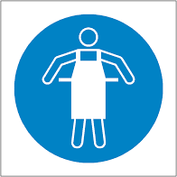
Disposable Apron*

*If there is likely contact with blood and/or bodily fluids as part of the activity.

Preparing for the Task:
- Clean hands thoroughly using soap and water
- Put on the required PPE as above

Completing and Finishing Task:
- Deliver care in adherence with your infection control guidance and training, and health care plan if applicable.
- Remove and double bag PPE in the immediate area
- Any contaminated clothing should be double bagged and securely stored until it is sent home with the child for washing.
- Hands MUST be washed using soap and water immediately after removing PPE
- Door handles and surfaces must be cleaned before entering and leaving the affected area.
- Thoroughly wash all your clothing as soon as you arrive home at the end of a day. Avoid shaking clothing before placing in the washing machine.
- Vehicles should be decontaminated frequently. Sanitiser should be used to clean down seats, gear sticks, steering wheel, door handles, etc.

Potential Hazards and Injuries:  - Contact with bodily fluids, droplets and airborne transmission leading to transmission of COVID-19  - Unpredictable behaviours leading to scratches and bites etc.  - Failure to respond to child’s injury or health care need, leading to acute or chronic health implications | Do:  - Wear appropriate clothing.  - Wear appropriate PPE.  - Maintain good hygiene and infection control standards.  - Regularly wash your hands | Don’t:  - Deliver care without wearing PPE.  - Use the same PPE for more than one task.  - Touch your eyes, nose and mouth.  - Consume food and drink until you have removed all PPE and washed your hands.

First Aid or Intimate Care Procedure for Dealing with Symptomatic Individual
Should a child start to display symptoms of COVID-19 whilst at school then they must be isolated in a separate, self-contained and ventilated room away from others or ensure they are situated 2 metres from others if isolation is not possible. If they require use of a bathroom whilst awaiting collection they should use separate facilities if possible, which should be thoroughly cleaned and disinfected before being used by anyone else.
999 must be called in the event of emergency, such as becoming seriously unwell or injured. Symptomatic individuals must not otherwise be advised to attend their GP, pharmacy, urgent care centre or hospital. They should be advised return home immediately, have a COVID-19 test as soon as possible and isolate whilst awaiting results.
To support the schools reporting protocols, results of the test must be communicated to the school.
Specific PPE requirements are recommended when caring for a symptomatic individual within close proximity (ie less than 2 metres.) New PPE must be worn and discarded of upon completion of the care.

Personal Protective Equipment:

Disposable Gloves

Disposable Apron
Disposable Fluid Resistant Face Mask (Surgical Face Mask)
Eye protection where contact is within 2 metres (either goggles or a face visor)

Preparing for the Task:
- Wash hands thoroughly following hand hygiene regime.
- Put on all the required PPE BEFORE entering the isolation area. You may wish to consider placing PPE and hygiene supplies outside of the dedicated room for ease.

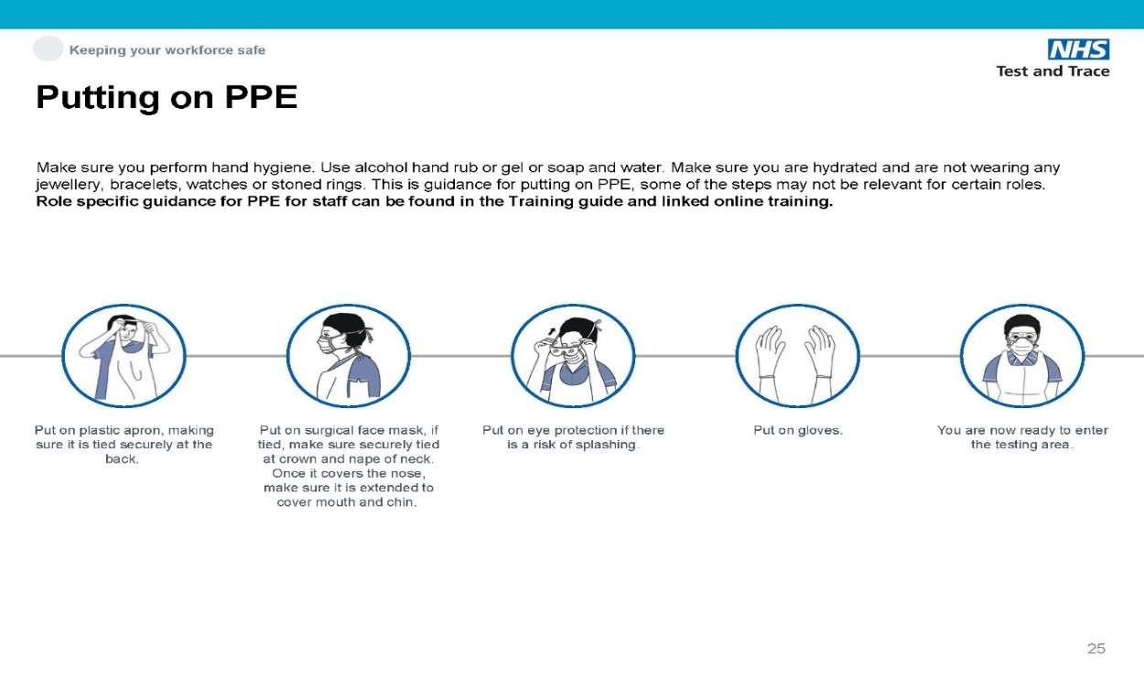

- Ensure the room is as well ventilated as possible.

Completing and Finishing Task:

- Deliver care in adherence with your infection control guidance and training, and health care plan if applicable.
- Any contaminated clothing should be double bagged and securely stored until it is sent home with the child for washing.
- On completion of the task, step outside the room and immediately remove the PPE. This and any soiled items MUST be double bagged in disposable rubbish bags and securely tied and left in a designated room for 72 hours before being disposed of in the usual waste stream.

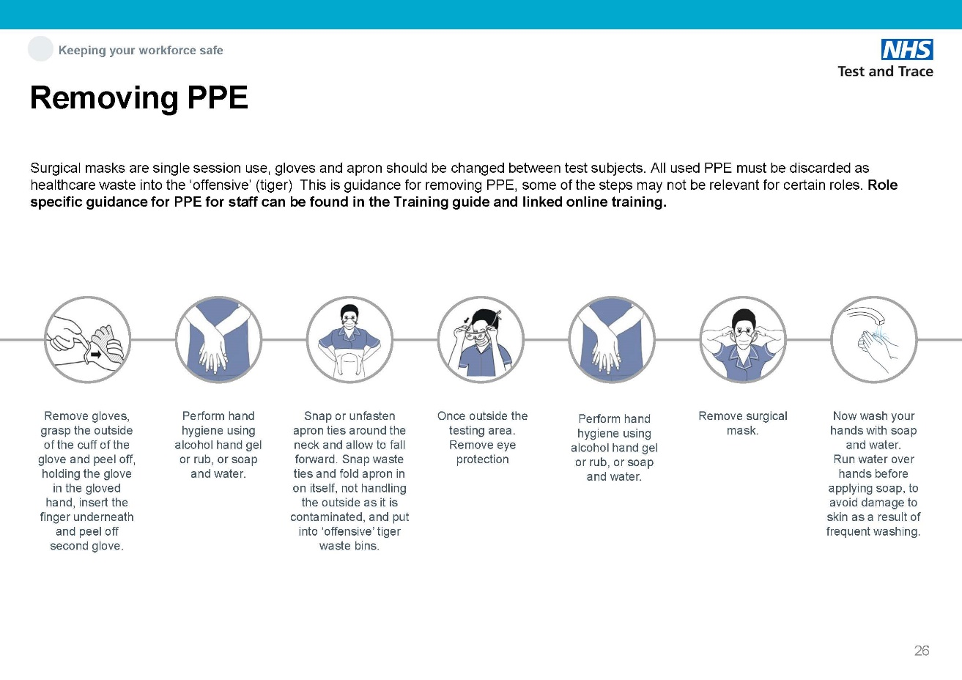

- Hands MUST be washed immediately after removing PPE
- The affected area must be secured and thoroughly cleaned and disinfected using appropriate cleaning products before being accessed by anyone else.
- Continue to ventilate the space after using.
- Thoroughly wash all your clothing as soon as you arrive home. Avoid shaking clothing before placing in the washing machine.
- Vehicles should be decontaminated frequently. Sanitiser should be used to clean down seats, gear sticks, steering wheel, door handles, etc.

Significant identified hazards | Control measures required to reduce level of risk to acceptable level.
Exposure to contagious disease | - Staff and students do not attend school if they are infectious or are awaiting test results for COVID-19. This is reiterated through regular communication with staff and parents.  - Guidance regarding the incubation period within the Managing Medical Conditions at School Management Resource Pack is followed to reduce likelihood of spread.  - All staff provided with basic information and instruction on good hygiene practice  - Staff immunised against some infections through the national immunisation programme. Staff are encouraged to verify their own immunisations with their GP.  - Procedures in place to manage a ‘notifiable disease’ or positive case of COVID-19.  - Staff always exercise good hygiene practice – hand-washing facilities available throughout the school (warm water and hand soap)  - Staff encouraged to ensure that all cuts and abrasions are covered by waterproof dressings.  - Cleaning regime in place within the school, including fixtures, fittings and furnishings and toys and equipment to reduce cross contamination  - Cleaning chemicals and PPE, including disposable gloves and aprons, available.  - Occupied spaces are well ventilated.  - Possible exposure to infectious individuals is minimised through reducing the frequency and duration of close contact as much as possible.
Exposure to blood borne virus or bodily fluid – Direct contact with contaminated blood or bodily fluid or handling of an object contaminated with blood or bodily fluid from an infected person. | - All spillages of blood, faeces, saliva, vomit, nasal and eye discharges are cleaned up immediately.  - Staff wear disposable gloves where exposure is possible, and wear a disposable apron where there is a risk of splashing or contamination with blood/bodily fluids (such as nappy changing)  - Appropriate cleaning chemical used to clean the spillage.  - Dedicated COVID-19 cleaning risk assessment must be followed when cleaning following suspected or confirmed case of COVID-19 or other infectious disease.  - Mops not used – spillages cleaned by using disposable paper towels or appropriate spill kit only. Correct PPE worn in accordance with the cleaning chemical handling instructions.  - All cuts, abrasions or any area of broken skin must be covered with wash-proof dressing.  - Laundry dealt with in a dedicated facility. Soiled linen washed at the highest possible wash temperature (60° wherever possible). PPE worn when handling soiled linen. Children’s soiled linen is bagged to be returned home, never rinsed by hand.
Sharps/Needle Stick Injury | - Sharps bin available, conforming to relevant standards  - Staff trained in disposable of sharps.  - Sharps bin kept off the floor and out of the reach of authorised persons.  - First aid arrangements in place to deal with any needle stick injuries.  - Visual inspections of areas are completed prior to use, including outdoor play areas, for any evidence of potential sharps hazards. The area is isolated until any identified hazards have been safely discarded and an enhanced inspection regime of the area found is put in place to monitor future contamination.
Animal-borne virus spread by contact, scratching or biting or psychological impact due to fear/anxiety  (Permanent ‘residents’ of the school or temporary visitors) | - The school will not host animals deemed to be of higher risk, such as monkeys, apes, poisonous reptiles, or crocodiles or those which are not suitable for handling/petting.  - The school will ensure that any allergies or phobias of the children or staff are considered and risk assessed accordingly.  - Guidance from CLEAPPS will be sought relating to specific animals to ensure the needs of the animal can be met  - Animals to be kept in school will be sourced from reputable providers.  - Members of staff will be appointed to take responsibility for the environment, health and welfare of the animal and a proper care programme established.  - Children will be provided with information and instruction on how to handle the animal. Appropriate levels of close supervision will be in place.  - All those who handle or come in to contact with the animal or its environment will have access, and use, hand washing facilities. Younger children will be supervised when washing hands to ensure it is done thoroughly.  - Those who are coming in to contact with an animal will ensure that cuts, abrasions or any broken skin will be covered.  - Pregnant women may be excluded from activities where necessary to reduce the risk of infection to both themselves and the unborn baby.  - Any contaminated surfaces will be properly washed and disinfected.  - Any waste generated following animal-based activities will be disposed of suitably.  - The cage/aquarium etc of the animal will be maintained and regularly visually inspected to check for defects and will be subject to an appropriate cleaning regime.  - Appropriate public liability cover in place which covers animals on site
Clinical waste | - Arrangements in place to ensure that domestic and clinical waste are separated where possible.  - Contaminated items are double bagged and included in the normal waste stream if there is no clinical waste facility available.  - Used nappies, sanitary pads, gloves, aprons or soiled dressings, etc are stored in correct clinical waste bags, in foot operated bins.  - Clinical waste bags are emptied when reaching around 2/3 full and are secured from unauthorised access.  - Clinical Waste disposal arrangements in place through a registered waste contractor.  - Specific arrangements in place for managing COVID-19 waste in line with cleaning of non-healthcare settings. Dedicated safe systems of work in place for first aid/intimate care and cleaning.

Policies and Procedures Staff Signature List

Name of Document:

COVID-19 – Infection Prevention and Control (Schools) Safe System of Work

I acknowledge that I have read and understood the information relating to the above document and I confirm that I will work in accordance with this; informing my line manager should I require further clarification or training on this subject.

Staff Member | Signature | Date

