Logging on to teams - Please remember if you have your own Microsoft teams account you must log out of this first.
Section 1 – How to log in
If you have never used teams before you will see this.
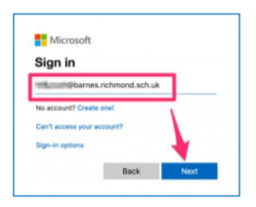
Type in your child’s school account username which ends @burtonagnesprimaryschool.co.uk then click ‘Next’.
You’ll now be prompted to enter the password which had been sent to you. If you have problems logging in please do not press Forgotten Password, please read the trouble shooting guide.
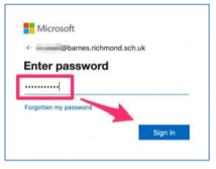
Enter the password and click ‘Sign in’.
You should now be logged into Teams and you should see the following screen with an icon for the class group for your child
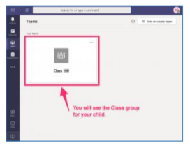
Note: The very first time you log in with a child’s account there can be a bit of a delay before you see the screen below. This is due to the current incredibly high levels of activity which Microsoft are dealing with due to half the world’s population trying to log in and work from home. Please be patient, wait 10 minutes and try again.

