Safeguarding in Education

Low-level Concerns Policy

Burton Agnes CE Primary School

August 2023

Table of Contents

1. Introduction………………………………………………………………...3
2. Purpose of a Low-level Concerns Policy ………………………………4
3. Allegations that may meet the harm threshold………………………... 4
4. Concerns that do not meet the harm threshold: Low-level concerns..5
5. A culture of vigilance and staff training on Low-level concerns………6
6. Sharing Low-level concerns ………………………………………6
7. Anonymity…………………………………………………………………. 7
8. Self-reporting……………………………………………………………... 7
9. Sharing and recording of Low-level concerns………………………… 8
10. Responding to a Low-level concern……………………………………. 8
11. Possible outcomes from a Low-level concern………………………….9
12. Storage of Low-level concerns………………………………………….12
13. Reviewing the Low-level concerns file………………………………….13
14. Retaining Low-level concerns…………………………………………... 13
15. Low-level concerns and references……………………………………. 13
Appendix 1 – Spectrum of Behaviour…………………………………………. 14
Appendix 2 – Reporting a Low-level concern – flowchart…………………….15
Appendix 3 – Low-level concerns form………………………………………… 16
Appendix 4 - Low-level concerns wheel………………………………………. .18

1. Introduction

1.1 This policy forms part of the Burton Agnes CE Primary School Staff Code of Conduct and should be read in conjunction with the school Child Protection & Safeguarding Policy. This Low-level Concerns Policy is based upon the statutory guidance Keeping Children Safe in Education 2023 (KCSiE 2023), the expectations within Guidance for safer working practice for those working with children and young people in education settings February 2022 and the principles within Farrer & Co’s Developing and Implementing a Low-level Concerns Policy 2022. These documents are referenced throughout the policy.

1.2 Creating a culture in which all concerns about adults (including allegations that do not meet the LADO ‘harm threshold’) are shared responsibly and with the right person, and recorded and dealt with appropriately, is crucial. If implemented well this should encourage an open and transparent culture, enable our school, to identify concerning, problematic or inappropriate behaviour early, minimise the risk of abuse and ensure that adults working in or on behalf of or at the school are clear about professional boundaries and act within them (this includes conduct inside and outside of the school setting), in accordance with the ethos and values of Burton Agnes.

1.3 Behaviour which is not consistent with the standards and values of Burton Agnes CE Primary School, and which does not meet the school’s expectations specified in the Staff Code of Conduct, needs to be addressed. Such behaviour can exist on a wide spectrum – from the inadvertent or thoughtless, through to that which is ultimately intended to enable abuse. Where a concern about an individual’s behaviour meets the threshold of an allegation, clear guidance exists to support the member of staff in responding to these concerns.
1.4 Behaviour which is not consistent with the standards and values of the school, includes any related incidents when an individual or organisation is using the school premises for the purposes of running activities for children, the school will follow our safeguarding policies and procedures, including informing the LADO' within 24 hours (KCSiE 2023).
1.5 It is important to recognise that, in practice, the words ‘allegation’ and ‘concern’ can be and are used interchangeably by different people. Sometimes individuals may shy away from the word ‘allegation’ and express it as a ‘concern’ instead. The crucial point is that whatever the language used, the behaviour referred to may, on the one hand, be capable of meeting the harm threshold (and hence be referred to the Local Authority Designated Officer - LADO), or, on the other, it does not meet the harm threshold (in which case it should be treated as a Low-level concern).
2. Purpose of a Low-level Concerns Policy

2.1 This policy enables all staff to share any concerns – no matter how small – about their own or another member of staff’s behaviour with the Headteacher, Helen Jameson. If the Headteacher is absent, the concern should be shared with Jo Kemp the DDSL.

2.2 Safeguarding and promoting the welfare of children is everyone’s responsibility. The purpose of the policy is to create and embed a culture of openness, trust, and transparency in which the clear values and expected behaviour set out in the Staff Code of Conduct, are upheld by all staff and challenged where appropriate.

2.3 In order to achieve this purpose, Burton Agnes CE Primary School, will:
- Ensure that staff are clear about what appropriate behaviour is and are confident in distinguishing expected and appropriate behaviour from concerning, problematic or inappropriate behaviour in themselves and others.
- Recognise the importance of professional boundaries and when to report.
- Empower staff to share any Low-level concerns with the Headteacher and to help all staff to interpret the sharing of such concerns as a neutral act.
- Address unprofessional behaviour and support the individual to correct it at an early stage.
- Identify concerning, problematic, or inappropriate behaviour – including any patterns – that may need to be consulted upon with, or referred to, the LADO.
- Ensure all concerns that are raised are handled sensitively and proportionately.
- Help identify any areas for development in the organisation’s safeguarding system as well as any training needs.

3. Allegations that may meet the harm threshold

3.1 The term ‘allegation of harm’ means that it is alleged that a person who works with children meets the harm threshold as specified below and has:
- behaved in a way that has harmed a child or may have harmed a child; and/or
- possibly committed a criminal offence against or related to a child; and/or
- behaved towards a child or children in a way that indicates they may pose a risk of harm to children; and/or
- behaved or may have behaved in a way that indicates they may not be suitable to work with children

3.2 Staff should follow the procedures outlined in the supporting school / college policies, Staff Code of Conduct and Whistle-blowing Policy in the event of concerns being identified relating to the conduct of adult colleagues

4. Concerns that do not meet the harm threshold: Low-level concerns

4.1 KCSiE 2023, states that, as part of their whole school approach to safeguarding, schools should ensure that they promote an open and transparent culture in which all concerns about all adults working in or on behalf of the school or college (including supply teachers, volunteers and contractors) are dealt with promptly and appropriately.

4.2 The term ‘Low-level’ concern does not mean that it is insignificant, it means that the adult’s behaviour towards a child does not meet the harm threshold as set out in Section 3. A Low-level concern is any concern – no matter how small, and even if no more than causing a sense of unease or a ‘nagging doubt’ – that an adult may have acted in a way that:
- is inconsistent with an organisation’s Staff Code of Conduct, including inappropriate conduct outside of work, and
- does not meet the allegation threshold or is otherwise not serious enough to consider a referral to the LADO – but may merit consulting with and seeking advice from the LADO.

4.3 Staff do not need to be able to determine in each case whether their concern is a Low-level concern, or if it is not serious enough to consider a referral to the LADO, or whether it meets the threshold of an allegation. Once staff have shared what they believe to be a Low-level concern, that determination should be made by the Headteacher and responded to in line with this policy.

5. A culture of vigilance and staff training on Low-level concerns

5.1 Burton Agnes CE Primary School,has a culture of openness and trust is fostered within the organisation so that staff can share any concerns about the conduct of colleagues and be assured that these will be received and handled in a sensitive manner.

5.2 If we educate adults to be informed about, and to identify concerning, problematic or inappropriate behaviour, rather than think they can recognise dangerous people, they can be prepared to act when they observe behaviour which violates.

6. Sharing Low-level concerns

6.1 It is critical that all Low-level concerns are received by the Headteacher. Having one recipient of all such concerns should allow any potential patterns of concerning, problematic or inappropriate behaviour to be identified, and ensure that no information is potentially lost.

6.2 It is important that Low-level concerns are shared with the Headteacher as soon as reasonably possible and, in any event, within 24 hours of becoming aware of the concern where it relates to a specific incident

6.3 Whilst staff should share information with the Headteacher as soon as reasonably possible, it should also be emphasised that it is never too late to share a Low-level concern and a delay should never be seen as a barrier to sharing

6.4 If the Headteacher is absent for any reason, Low-level concerns should be shared with a clearly identified deputy, Jo Kemp,who will inform the Headteacher immediately on her return

6.5 In the event of concerns about the Headteacher, these should be referred to the Chair of Governors, Andrea Lister.

7. Anonymity

7.1 If the staff member who raises the concern does not wish to be named, then the Headteacher will respect that person’s wishes as far as possible.

7.2 There may be circumstances where the staff member will need to be named (for example, where it is necessary to carry out a fair disciplinary process) and, for this reason, anonymity will never be promised to members of staff who share Low-level concerns. Where possible, we will try to encourage staff to consent to be named, as this will help to create a culture of openness and transparency.

8. Self-reporting

8.1 Occasionally a member of staff may find themselves in a situation which could be misinterpreted or might appear compromising to others. Equally, a member of staff may, for whatever reason, have behaved in a manner which, on reflection, they consider falls below the standard set out in the Staff Code of Conduct.

8.2 Self-reporting in these circumstances can be positive for several reasons:
- It is self-protective, in that it enables a potentially difficult issue to be addressed at the earliest opportunity
- It demonstrates awareness of the expected behavioural standards and self-awareness as to the individual’s own actions or how they could be perceived and, crucially,
- It is an important means of maintaining a culture where everyone aspires to the highest standards of conduct and behaviour

8.3 In line with KCSiE 2023, Burton Agnes CE Primary School, will ensure that there is an environment where staff are encouraged and feel confident to self-refer

9. Sharing and recording of Low-level concerns

9.1 Staff will be given the option of sharing their Low-level concern verbally with the Headteacher in the first instance, or by completing a simple Low-level concerns form, an example of which can be found in Appendix 3.

9.2 Where the Low-level concern is provided verbally, the Headteacher will make an appropriate record of the conversation, either contemporaneously or immediately following the discussion using the Low-level concerns form in Appendix 3.

9.3 Sound professional judgement will be exercised by the Headteacher in determining what information is necessary to record for safeguarding purposes. The name of the individual sharing the Low-level concern and their role should be stated, as should the name of the individual about whom the concern is being raised, and their role within the organisation at the time the concern is raised.

9.4 The record will include brief context in which the Low-level concern arose, and concise details (which are chronological and as precise and accurate as possible) of any such concern and relevant incident(s). The record must be signed, timed, and dated.

10. Responding to a Low-level concern

10.1 Once the Headteacher has received the Low-level concern, they will (not necessarily in the below order) in an appropriate sequence according to the nature and detail of the particular concern shared with them:
- speak to the person who raised the concern (unless it has been raised anonymously), regardless of whether a written summary, or completed Low-level concerns form has been provided
- speak to any potential witnesses (unless advised not to do so by the LADO /other relevant external agencies, where they have been contacted)
- speak to the individual about whom the Low-level concern has been raised (unless advised not to do so by the LADO / other relevant external agencies, where they have been contacted)
- review the information and determine whether the behaviour:
- is entirely consistent with their Staff Code of Conduct and the law.
- constitutes a Low-level concern.
- is not serious enough to consider a referral to the LADO – but may merit consulting with and seeking advice from the LADO.
- when considered with any other Low-level concerns that have previously been raised about the same individual, could now meet the threshold of an allegation, and should be referred to the LADO
- in and of itself meets the threshold of an allegation and should be referred to the LADO.

10.2 The Headteacher will always seek advice from the LADO (lado@eastriding.gov.uk) where they are in any doubt whatsoever.

10.3 While responding to any incident, the Headteacher will make appropriate notes of:
- all internal conversations – including with the person who initially shared the Low-level concern (where this has been possible), the adult about whom the concern has been shared (subject to the above), and any relevant witnesses (subject to the above)
- all external conversations – for example, with the LADO / Safeguarding in Education Team (SiET), (where they have been contacted)
- the action taken and the rationale for the decision taken.

11. Possible outcomes from a Low-level concern

11.1 If it is determined that the behaviour is entirely consistent with the school’s Staff Code of Conduct and the law, the Headteacher will:
- update the individual in question and inform them of the action taken as above
- speak to the person who shared the Low-level concern to provide them with feedback about how and why the behaviour is consistent with the organisation’s Staff Code of Conduct and the law
- consider if the situation may indicate that the staff code of conduct or Low-level concerns policy are not clear enough, or if further training is required.

11.2 If the same or a similar Low-level concern is subsequently shared about the same individual, and the behaviour in question is also consistent with the Staff Code of Conduct, then an issue may need to be addressed about how the subject of the concern’s behaviour is being perceived by others

11.3 If it is determined that the behaviour constitutes a Low-level concern, it will be responded to in a sensitive and proportionate way – on the one hand maintaining confidence that such concerns when raised will be handled promptly and effectively whilst, on the other hand, protecting staff from any potential false allegations or misunderstandings.

11.4 Any investigation of Low-level concerns will be done discreetly and, on a need-to-know basis.

11.5 Most Low-level concerns, by their very nature, are likely to be minor. Some will not give rise to any ongoing concern and, accordingly, will not require any further action. Others may be most appropriately dealt with by means of management guidance and/or training.

11.6 In many cases, a Low-level concern will simply require a conversation with the individual about whom the concern has been raised. It has long been understood that lasting change in behaviour is least likely to be achieved by an approach experienced as critical or threatening.

11.7 Any such conversation will include being clear with the individual as to why their behaviour is concerning, problematic or inappropriate, what change is required in their behaviour, enquiring what, if any, support they might need in order to achieve and maintain that, and being clear about the consequences if they fail to reach the required standard or repeat the behaviour in question.

11.8 Ongoing and transparent monitoring of the individual’s behaviour may be appropriate. An action plan or risk assessment which is agreed with the individual, and regularly reviewed with them, may also be appropriate.

11.9 Some Low-level concerns may also raise issues of misconduct or poor performance. The Headteacher will also consider whether this is the case – by referring to the organisation’s disciplinary and/or capability procedure and taking advice from the school’s HR service (if necessary) –on a named or no-names basis where necessary. Where a Low-level concern does not raise misconduct or poor performance issues, it will not be a matter for HR.

11.10 Where a Low-level concern relates to a person employed by a supply agency or a contractor, that concern will be raised with their employers, so that any potential patterns of inappropriate behaviour can be identified. How an organisation responds to a Low-level concern may be different depending on the employment status of the individual who is the subject of the concern - i.e., whether they are an employee, or worker to whom the organisation’s disciplinary procedure would apply; or a contractor, governor, trustee, director, or volunteer who may be subject to alternative procedures.

11.11 Some concerns may trigger the school’s disciplinary, grievance or whistle-blowing procedures, which should be followed where appropriate. Where Low-level concerns are raised which in fact require other internal processes to be followed, it is sometimes difficult to determine how best to investigate the concern and which procedure to follow. The Headteacher will exercise their professional judgement and, if in any doubt, they will seek advice from other external agencies including the LADO or Safeguarding in Education Team (SiET).

11.12 If the school’s disciplinary procedure is triggered, the school will ensure that the individual has a full opportunity to respond to any factual allegations which form the basis of a disciplinary case against them.

11.13 If an organisation ultimately disciplines or dismisses a staff member for cumulative alleged breaches of the Staff Code of Conduct which were not brought contemporaneously to the individual’s attention, and to which they have not had a proper opportunity to respond, clearly there will be a lack of fairness and natural justice and the risk of a finding of unfair dismissal by an Employment Tribunal. Staff therefore need to understand that when they share what they believe to be a Low-level concern, the Headteacher will speak to the adult who is the subject of that concern – no matter how low -level the concern may be perceived to be, to gain the subject’s account – and to make appropriate records (as above), which may be referenced in any subsequent disciplinary proceedings.

11.14 If it is determined that the behaviour, whilst not sufficiently serious to consider a referral to the LADO nonetheless merits consulting with and seeking advice from the LADO, then action (if/as necessary) will be taken in accordance with the LADO’s advice.

11.15 If, when considered with any other Low-level concerns that have previously been shared about the same individual, could now meet the threshold of an allegation, then it should be referred to the LADO in accordance with Part 4 of KCSiE, 2023.

12. Storage of Low-level concerns

12.1 Burton Agnes CE Primary School, will retain all records of Low-level concerns (including those which are subsequently deemed by the Headteacher to relate to behaviour which is entirely consistent with the Staff Code of Conduct) in a central electronic/paper Low-level concerns file. These records will be kept confidential and held securely with limited access given to the Headteacher and any other member of the leadership team on a strictly need to know basis. Confidential records to be kept, held securely, and to comply with Data Protection Act 2018 and UK GDPR.

12.2 Where multiple Low-level concerns have been shared regarding the same individual, these will be kept in chronological order as a running record.

12.3 Low-level concerns will not be stored on personnel files. Saving Low-level concerns separately will allow leaders to spot any potential patterns of behaviour whilst reassuring staff to share Low-level concerns.

12.4 In circumstances where advise has been sort from the LADO and the outcome is that the concern did not meet LADO threshold, details should be recorded as a Low-level concern (not on the staff member’s personnel file).

12.5 Material on the Low-level concern file will be retained in accordance with Part 4 of KCSiE 2023, which requires schools and colleges in England to produce a clear and comprehensive summary of all allegations (except those which are found to have been malicious), details of how the allegation was followed up and a note of any action taken.
(Please note, any allegations that meets the threshold for LADO involvement are to be recorded in consultation with the LADO guidance and procedures)

13. Reviewing the Low-level concerns file

13.1 The Headteacher will review the central Low-level concerns file periodicallyto ensure that all such concerns are being dealt with promptly and appropriately, and that any potential patterns of concerning, problematic or inappropriate behaviour are identified. A record of these reviews will be made and stored alongside the file, along with any subsequent actions taken.
13.2 Governors will receive relevant data relating to Low-level concerns and review anonymised samples of Low-level concerns at regular intervals, to ensure that these concerns have been responded to promptly and appropriately.

14. Retaining Low-level concerns
14.1 Low-level concerns will be retained in a central Low-level concerns file (securely and applying appropriate access restrictions) unless and until further guidance provides otherwise.

14.2 When a staff member leaves and/or takes up new employment, that creates a natural point at which the content of the file may be reviewed to ensure it still has value (either as a safeguarding measure or because of its possible relevance to future claims) and is therefore necessary to keep. This is subject to the rights of individuals to object to or seek to erase or correct records about them under data protection law.

15. Low-level concerns and references

15.1 KCSiE 2023, prohibits schools/ colleges from referring to unsubstantiated, malicious, or false allegations in references. Only safeguarding allegations that have been substantiated should be included in references. KCSiE 2023, states that: “where a Low-level concern (or group of concerns) has met the threshold for referral to the LADO and found to be substantiated, it should be referred to in a reference”.

15.2 Low-level concerns (or a group of concerns) which have not met the threshold for referral to the LADO which relate only to safeguarding should not be included in references unless they relate to issues which would normally be included in a reference, for example, misconduct or poor performance.

Appendix 1 – Spectrum of Behaviour

Allegation
Behaviour which indicates that an adult who works with children has:
- behaved in a way that had harmed a child, or may have harmed a child; and/or
- possibly committed a criminal offence against or related to a child; and/or
- behaved towards a child or children in a way that indicated they may pose a risk of harm to children; and/or
- behaved or may have behaved in a way that indicated they may not be suitable to work with children

Low-level Concern
Does not mean that it is insignificant, it means that the adult’s behavior towards a child does not meet the threshold set out above. A Low-level concern is any concern – no matter how small, and even if no more than causing a sense of unease or a ‘nagging doubt’ – that an adult may have acted in a way that:
- is inconsistent with an organisation’s staff code of conduct, including inappropriate conduct outside of work, and
- does not meet the allegation threshold, or is otherwise not serious enough to consider a referral to the LADO – but may merit consulting with and seeking advice from the LADO, and on a no-names basis if necessary

Appropriate Conduct
Behaviour which is entirely consistent with the organisation’s staff code of conduct, and the law.

Appendix 2 – Reporting a Low-level concern – flowchart

KCSiE, 2023 now requires Low-level concerns to be shared with the Headteacher– unless they related to the Headteacher– as per paragraph 74 of KCSiE 2023 (set out in our main guidance).
Action Required

HT to consider whether concern also potentially raises misconduct or capability issues – taking advice from HR on a named or no-names basis where necessary – and, if so, to refer matter to HR
Review information and determine whether behaviour:
- is entirely consistent with the organisation’s staff code of conduct and the law
- constitutes a LLC
- is not serious enough to consider a referral to the LADO – but may merit consulting with and seeking advice from the LADO, and on a no-names basis if necessary
- when considered with any other LLCs that have previously been raised about the same individual, could now meet the threshold of an allegation, and should be referred to the LADO/other relevant agencies, or
- in and of itself meets the threshold of an allegation and should be referred to the LADO/other relevant external agencies
Where they are in any doubt, seek advice from the LADO – on a no-names basis if necessary
Speak to the individual about whom the LLC has been raised (unless advised not to do so by LADO/other relevant external agencies, where contacted)
Speak to any potential witnesses (unless advised not to do so by LADO/other relevant external agencies, where contacted)
Speak to the person who raised LLC (unless raised anonymously)
HT should – not necessarily in the below order but in an appropriate sequence according to the nature and detail of the particular LLC shared with them:
Share with HT (or in their absence with deputy), or a CoG as soon as reasonably practicable and within 24 hours
Share with HT (or in their absence with deputy), or a CoG as soon as reasonably practicable and within 24 hours

HT to make appropriate records of all internal and external conversations, their determination, the rationale for their decision, and details of any action taken, and to retain records in accordance with LLCs policy

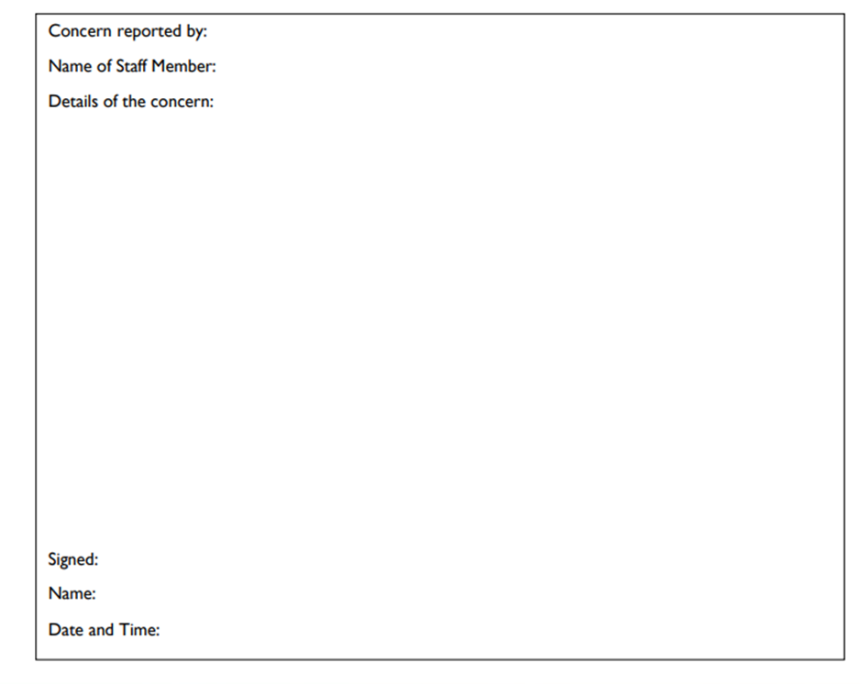
Appendix 3 – Low-level concerns form

Please use this form to share any concern – no matter how small, and even if no more than causing a sense of unease or a ‘nagging doubt’ – that an adult may have acted in a way that:
- is inconsistent with Burton Agnes CE Primary School,Staff Code of Conduct, including inappropriate conduct outside of work, and does not meet the allegation threshold, or is otherwise not serious enough to consider a referral to the LADO.

You should provide a concise record – including brief context in which the Low-level concern arose, and details which are chronological, and as precise and accurate as possible – of any such concern and relevant incident(s). Please use a separate sheet if necessary.

The record should be signed, timed, and dated.
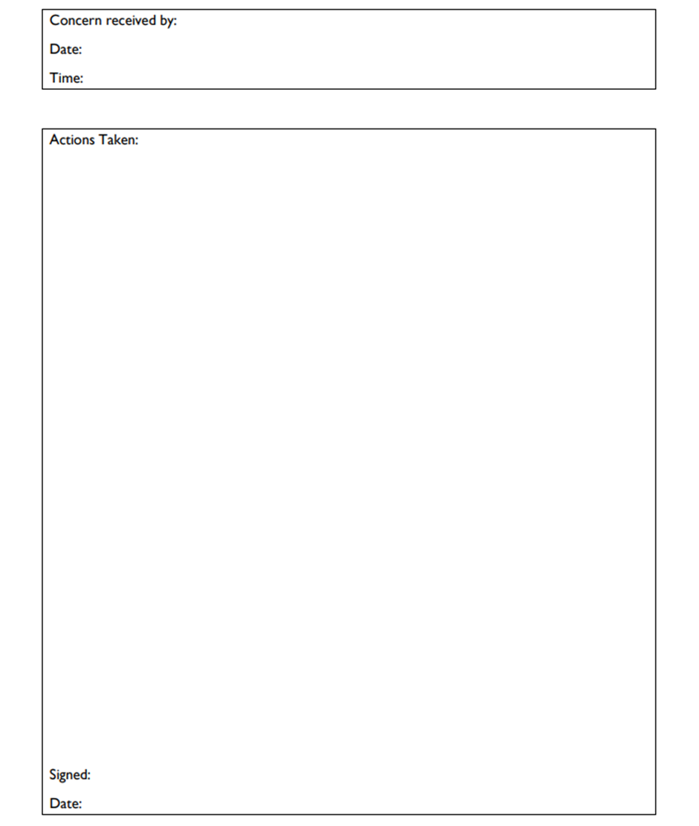

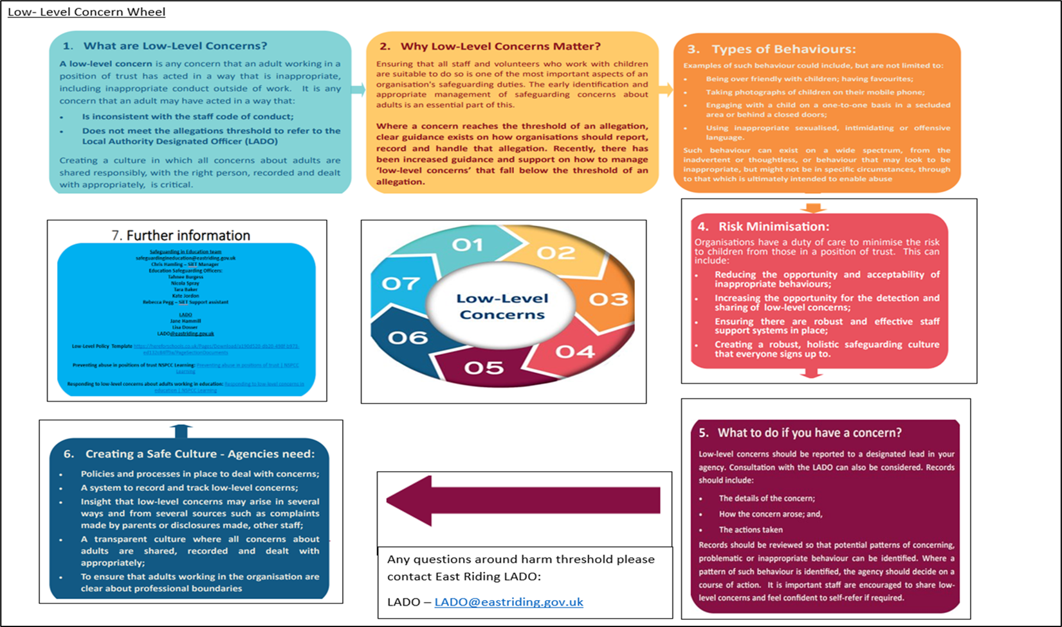
Appendix 4 – Low-level Concerns Wheel in brief

