Burton Agnes CE Primary School

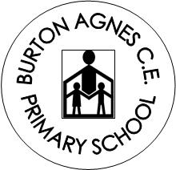

COVID 19 Outbreak Contingency Plan

September 2021

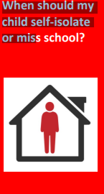 | 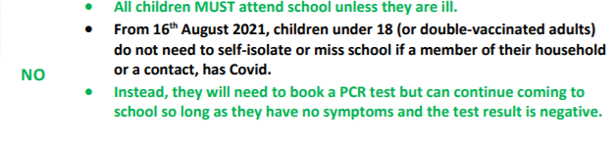
 | 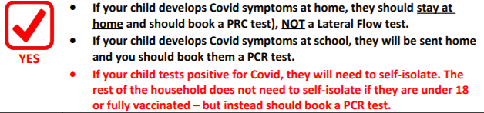

Covid Community Risk | Description | Actions
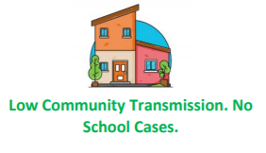 | - There have been no cases of Covid within school for 10 school days.  - Cases of Covid locally are low and/ or stable.  - Hospitalisation/ Deaths due to Covid nationally are low. | No Covid measures are necessary beyond:  • Reminding children of good hand-hygiene.  • Ensuring good ventilation encouraged where practical.  • Ensuring Children / Staff to stay at home if they have Covid Symptoms (and to book a PCR test).  Staff will continue to test themselves using Lateral flow tests until the end of September.
 | • No current Covid cases have been recorded at school, but…  • Cases of Covid are rising rapidly in the community causing disruption to other local schools.  • East Riding / Public Health England issue warnings of expected local/ national infection wave. | • Ventilation of classrooms increased & hand-washing supervised.  • Large indoor public performance audience numbers reduced.  • Staff-room capacity is reduced.  • Whole-school collective worship is replaced classes on a rota for hall use.  • Clinically Extremely Vulnerable staff meet with Line-Managers to review their individual risk assessment & discuss additional protection (e.g. use of face coverings)  • Children don’t move classrooms and class bubble reinstated
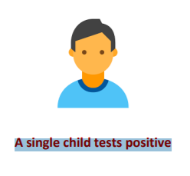 | • A single child tests positive for Covid in a class.  • There are fewer than 5 cases in the class.  • No other year groups are affected. | • The child self-isolates for 10 days. Remote learning will be provided if they are well enough to complete it  • The parents of the child are contacted directly by NHS Track and Trace to establish likely contacts.  • Likely contacts will be contacted by NHS Track & Trace and advised to book at PCR Test. The school will contact parents to advise this if close contacts are known.  • Children do not need to miss school or self-isolate whilst they wait for the result of the PCR test unless they have Covid Symptoms.
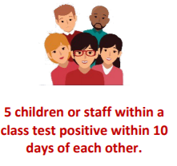 | • There have been 5 cases of Covid across a class within 10 days which could mean that Covid is spreading within that group of children. | • As above for each positive case.  • The school will discuss the outbreak with East Riding Health / Public Health England and agree strengthening protective measures for 10 school days, including:  o Encouraging the use of face masks in corridors and communal areas  o Adapting, limiting or postponing indoor sporting events, trips, open days and performances.  o Reducing the amount of classes staff work across.  o Resuming twice-weekly staff lateral flow testing.
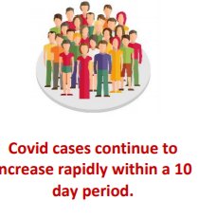 | • Despite the measures indicated above, Covid cases within the school continue to rise within a 10 day period with multiple classes and staff affected, suggesting that Covid is spreading widely throughout the school. | • Incident Management Team meeting held between the school and East Riding Public Health to agree further measures, for a further 10 school days, including:  o Re-introducing class bubbles.  o Reverting to class-based school lunches.  o Limiting all non-essential visitors to school.  o Postponing all non-essential events.  o Re-introducing remote learning for individual classes for 10 school days considered, as outlined on the school website.

In addition to the above information….

Shielding
We will adhere to national guidance on the reintroduction of shielding, which would apply to those on the shielded patient list (SPL). We will speak to individuals required to shield about additional protective measures in school or arrangements for home working or learning.

Other measures
If recommended, we will limit:
Residential educational visits
Open days
Transition or taster days
Parents coming into school
Live performances
If recommended, we will reintroduce:
Bubbles, to reduce mixing between groups
Face coverings in communal areas and classrooms for staff and visitors (unless exempt)
Attendance at afterschool clubs

Attendance restrictions
Attendance restrictions will only be recommended as a last resort.

If recommended, we will implement the measures in this section.
- Eligibility to remain in school In the first instance, we will stay open for:
- Vulnerable pupils
- Children of critical workers
- Reception, Year 1 and Year 2 pupils
- If further restrictions are recommended, we will stay open for:
- Vulnerable pupils
- Children of critical workers

Education and support for pupils at home
All other pupils will be required to stay at home and will receive remote education. We will aim to deliver remote education that meets the same quality and quantity of education that pupils would receive in school, as outlined in our [remotelearning plan which is found on the school website.
The school will continue to provide meal vouchers for pupils eligible for benefits-related free school meals while they are not attending school because of COVID-19 isolation guidelines

Wraparound care
We will limit access to before and after-school activities and wraparound care during term time and the summer holidays to those that need it most. We will communicate who will be eligible to attend once the restrictions are confirmed.

Safeguarding
We will review our child protection policy to make sure it reflects the local restrictions and remains effective. We will aim to have a trained DSL or deputy DSL on site wherever possible. If our DSL (or deputy) can’t be on site, they can be contacted remotely by burtonagnes.head.primary@eastriing.gov.uk

