The Assignments Area of Teams
Your child’s class teacher will set assignments for the class in the Assignments section.
This is shown in the ‘General’ channel.
Click Teams, click into your Class, click General, click Assignments to see the following screen:
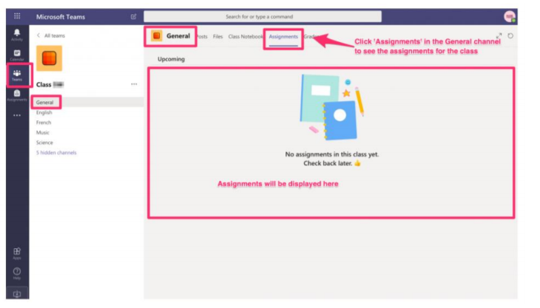
• You can also click ‘Assignments’
• All assignments for the class in every subject can be viewed here
• Follow the instructions for the assignment to complete it

