Uploading photos of your child's work using a smart phone
Often the easiest way to hand work in with Teams is just to take a picture of it with your phone and then add the picture as ‘My Work‘.
The simplest option is if you don’t already have Teams on your phone, you can download it then login with your child’s account, take pictures with the phone camera and upload them directly into Teams:
1. Download the Teams app onto your phone (from either GooglePlay or Apple App Store. Log in using the pupil’s account
2. Once in your class you can select Assignments (across the bottom of your screen).
3. Within the assignment you can ‘Add work’
4. You can upload a photo from your phone
5. You can see the image attached within the assignment. You can then either go out of the assignment where your image will be automatically saved or if your assignment is completed, ‘Hand in’
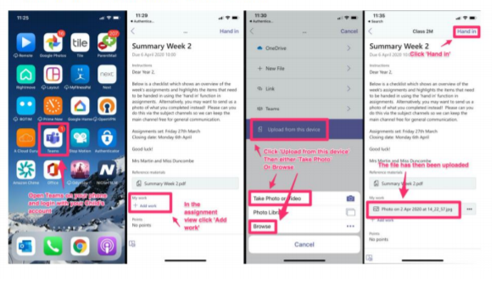
A good choice if you have Apple devices is just to use the free iCloud storage.
1. Take a picture of the work from your phone
2. Looking at the picture click the ‘share button’ (it’s a little box with an arrow pointing up)
3. Scroll down to ‘Save to Files‘
4. Create a new folder in your iCloud Drive if you like
5. Click Save
6. Now go to Teams and follow the steps above to add work, on any Apple device you’ll be able to select ‘Browse‘, ‘Files‘ and ‘iCloud‘ and find the file you just saved.

