What you will see when you have logged in
The school is still in the process of rolling out the functionality, so not all aspects of Teams are being used yet. This guide will be updated with additional sections when each new function starts to be used.
This is the screen you will see after you have successfully logged in:
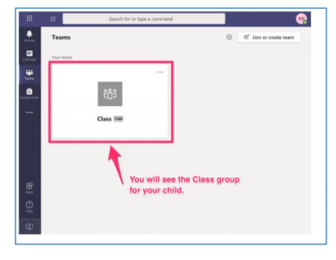

If you have used Teams for work: then this will be quite familiar to you but there are some differences to take note of as this is Teams for Education and it’s been customised for use by schools and pupils.

