



Year 9 Options Booklet

2020 - 2022



Contents

Introduction: 3

Our KS4 Curriculum: 3

The English Baccalaureate 3

Types of qualification: 3

GCSEs: 3

BTEC: 3

KS4: A Changing National Picture 3

Changes to GCSEs: 3

Changes to grading systems: 4

Changes to GCSE Assessment 4

Making your choices 4

Good reasons for choosing a course: 4

Bad reasons for choosing a course: 4

What happens next? 5

Reserve Choice: 5

How do I input my choices? 5

Core, Extended Core and Option Subjects: 6

Core Subjects 6

Extended Core Subjects 6

Option Subjects 6

CORE SUBJECTS 7

GCSE English Language and GCSE English Literature 7

GCSE Mathematics 9

GCSE Trilogy Science (double award) 10

10

GCSE Religious Studies 11

Life Skills 12

Work Experience 12

EXTENDED CORE SUBJECTS: (Continued from year 9) 13

GCSE Geography 13

GCSE History 14

OPEN OPTION SUBJECTS: 15

BTEC Tech Award in Enterprise 15

GCSE Art and Design 16

Child Development 17

GCSE Computer Science 18

Cambridge Nationals in Creative iMedia 19

GCSE Drama 20

GCSE Music 22

GCSE Photography 23

GCSE French 24

GCSE Spanish 25

GCSE Physical Education 26

GCSE: Design and Technology 27

GCSE Food Preparation and Nutrition 29

GCSE Psychology 31

GCSE Sociology 32

BTEC First Award in Sport 33

Triple Science: GCSE Physics, GCSE Chemistry and GCSE Biology 34

# Introduction:

The purpose of this booklet is to provide you with details of the various courses and options that are available. We hope that you will find it helpful and informative.

Our KS4 Curriculum:In Year 10 and 11 our students will follow a broad and balanced curriculum that will provide solid foundations for all future educational and work-based pathways. All students will follow a common core of subjects and qualifications that will include:

* GCSE English Language and GCSE English Literature (9 hours per fortnight in total).
* GCSE Mathematics (9 hours per fortnight).
* GCSE Double Science (10 hours per fortnight) **or** Triple Science (GCSE Physics, GCSE Chemistry and GCSE Biology.
* GCSE History or Geography (students already studying either from year 9)
* Religious Studies (2 hours per fortnight).
* Students will study Physical Education as part of the core offer; this is not an examined course.
* Life Skills will studied during the EEL day programme.

### The English Baccalaureate

This pathway is a suite of qualifications that includes a higher grade pass (Grade 5 or above) in English, Maths, 2 Sciences (e.g. Core and Additional Science or Physics and Biology), a Modern Foreign Language and Geography or History.

The Government has firmly held the position that the best curriculum for young people is that of the English Baccalaureate. This pathways combines strong academic rigour with a breadth of study that provides a strong foundation for any students continuing their studies at A level and who have aspiration to study at Russell Group universities.

## Types of qualification:

GCSEs:General Certificates of Secondary Education are qualifications that are graded from 9-1 under the new grading system, with 9 being the highest grade. Further details about this are to be found in the following section**.**

BTEC: These GCSE equivalent, vocational qualifications support learning within work related contexts and are suitable for a wide range of students. BTECs are qualifications that have been developed to accommodate the needs of employers and will allow progression to post-16 courses and towards university. BTEC qualifications retain a greater proportion of coursework than GCSE qualifications so these courses may benefit students who may prefer this type of assessment. The assessment process for BTEC subjects is on-going, so it allows students to analyse and improve their own performance as they progress. Level 2 BTEC qualifications are graded as Pass (equivalent to GCSE Grade 4), Merit (equivalent to GCSE Grade 6) or Distinction (equivalent to GCSE Grade 8).

### KS4: A **Changing National Picture**

During the last few years there have been several national developments that have significantly changed the way that schools plan their Key Stage 4 curriculum that do have direct implications for our students.

### Changes to GCSEs:

In June 2017, Year 11 students were the first to sit the new GCSE specifications in English Language, English Literature and Maths. Not only do these new GCSEs have a new grading system, the level of demand is far greater than previous GCSE courses. This has been a real challenge and we have recognised that we have had to increase the amount of time that students spend studying these vital subjects if they are to achieve well. Your child will study new revised specifications in all GCSE subjects and in August 2021 will receive GCSE grades 9-1 in all GCSE subjects. All subjects now have more content and this content is often more challenging.

### Changes to grading systems:

The new GCSEs are graded from 9-1 instead of the old A*-G. 9 is the highest grade and 1 is the lowest. A ‘standard’ pass at GCSE is considered to be a grade 4, although a ‘good’ GCSE pass is considered to be a grade 5. However, in terms of what is needed to attain a new grade 5 it is the equivalent of what was required for a high C+ grade pass. This is far more challenging for students.

|  |  |
| --- | --- |
| New GCSE Grade system | Old GCSE grading system |
| 9 | Top A* |
| 8 | High A and low A* |
| 7 | A |
| 6 | Middle to high B |
| 5 | High C and low B |
| 4 | Low and middle C |
| 3 | D and high E |
| 2 | Middle F to E |
| 1 | G and low F |

### Changes to GCSE Assessment

In the majority of GCSE subjects, almost all of the work is now to be assessed by terminal examinations. Controlled assessments and coursework have been removed from most specifications. For those GCSE subjects with controlled assessments, these now take up a smaller proportion of the final marks. For example, the new Maths GCSE includes 4½ hours of terminal examinations.

We recognise that the change towards a greater number of longer and more challenging GCSE terminal examinations will place increased stress on our students. This is one reason why we have chosen to plan a curriculum that for the majority of students will result in them studying 10 subjects rather than studying greater numbers of subjects in less time.

# Making your choices

This booklet is designed to help you with your choices as the preferences you choose for year 10 and 11 will affect how you spend your time at school over the next few years. The choices you make may also influence what course or job you decide to do after Year 11.

How to choose an option:

1. Look at **all** options before you decide.
2. Don’t fall into the trap of thinking that some subjects are only for boys and some only for girls - this is not true.
3. If you have a firm career idea, choose subjects that you will need for the next stage of your career journey - the ones you need to study more in higher education or for an Apprenticeship or job with training.
4. If you do not have a firm career idea, choose subjects that allow you to keep your options open.
5. Do not be afraid to ask for help and advice from your teachers, tutors, careers advisor and other members of staff.
6. Be realistic about your abilities and match the correct courses for you.

## Good reasons for choosing a course:

* You are good at the subject.
* You think that you will enjoy the course.
* It fits into your career plans and aspirations.
* It goes well with your other choices.
* It will give you plenty of options for the future.
* You think that you may want to keep on studying it after Year 11.
* Your research shows that it will interest and motivate you.
* The way the course is assessed may help you achieve better.

## Bad reasons for choosing a course:

* Your friends are doing it.
* People say it is easy.
* You think it is a good course for a boy or girl.
* Someone else thinks that it is a good idea but you disagree.
* You like the teacher you have now for that subject.
* You did not have time to research your options properly.

## What happens next?

* You have your own copy of this Booklet which you need to take home and study very carefully. Make sure your parents see it too and talk to them about it. It contains a lot of detailed information about every course on offer.
* Don’t assume that you know what each course is about! Read about them.
* Talk to the teachers whose names appear at the bottom of each subject page. They’ll be delighted to help.
* If you make the wrong choices it will be very difficult to change in September and in some cases impossible.

**Make decisions for yourself.**

**DO NOT make decisions that suit your friends!**

Reserve Choice:At this stage we cannot guarantee that all of these courses will run, sometimes courses may have too few or too many students opting for it. In these circumstances you may be required to make a reserve preference choice. This will not be known until all students have made their option choices. We aim to accommodate as many students’ first choices as possible and many students will be spoken to individually about their options before final decisions are made. Where necessary, more time will be given for students and parents to discuss other possibilities in the event that we are unable to meet first preferences.

## How do I input my choices?

You will have been given a preferences sheet at the Key Stage 4 Transition Evening. Please complete this and hand in to Miss Dungey in the admin office no later than Friday 7th February 2020.

# Core, Extended Core and Option Subjects:

## Core Subjects

In year 10 and 11 students follow a common core of subjects:

* English Language and English Literature
* Mathematics
* Double Science (or Triple Science)
* RE
* Physical Education (non-examined)

These core subjects are worth 6/7 GCSEs.

## Extended Core Subjects

In year 9, students have already been studying either

* GCSE Geography
* GCSE History

And will continue to study these in years 10 and 11.

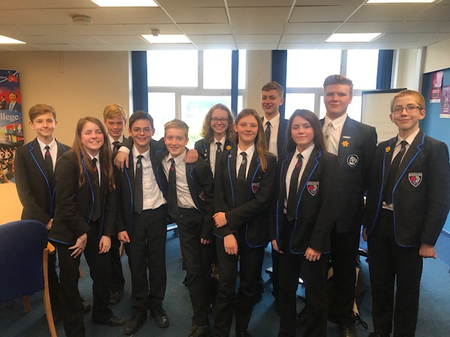

## Option Subjects

Students will choose **TWO** options from the Open Option Subjects:

* BTEC Technical Award in Enterprise
* GCSE Art & Design
* Cambridge Nationals: Child Development L1/2
* GCSE Computer Science
* Cambridge Nationals in Creative iMedia L1/2
* GCSE Drama
* GCSE Music
* GCSE Photography
* GCSE French
* GCSE Spanish
* GCSE Physical Education
* GCSE Design and Technology
* GCSE Food Preparation and Nutrition
* GCSE Psychology
* GCSE Sociology
* BTEC First Award in Sport
* GCSE Triple Science (GCSE Physics, GCSE Biology and GCSE Chemistry)

# 

# CORE SUBJECTS

## GCSE English Language and GCSE English Literature

**What will I study?**

GCSE English Language equips you with the tools to become confident readers and writers. You will experience a range of fiction and non-fiction texts and develop the skills to analyse and interpret these texts independently. You will also focus on developing your confidence and ability to write in a variety of writing styles, from persuasive writing to creative fiction. Speaking and listening skills will still be important, though these will be assessed and reported separately to your GCSE.

GCSE English Literature involves the study of a diverse range of texts: Shakespeare, classic novels, poetry and drama. In studying these, you will understand the themes, ideas, characters, relationships and language, as well as the enduring appeal of these texts today.

**What qualifications will the course lead to?**

Two separate GCSEs: English Literature and English Language.

**How would it help me in future?**

English is a fundamental, core demand of all employers and further education institutions. It is invaluable for your future, no matter what career you are aiming for. A good understanding of the English language, and the ability to produce these texts effectively, will help you every day – and benefit all your other GCSE subjects too! Whatever you end up doing, English is a must-have subject for college, university, work and - most importantly - life!

**How will my work be assessed?**

**English Language:** Paper 1 exam (50% of marks) involves reading Literature prose fiction and writing to describe/ narrate. Paper 2 exam (50% of marks) involves reading non-fiction and writing in order to present a viewpoint.

**English Literature:** Paper 1 exam (40% of marks) involves studying Shakespeare and a 19th Century novel. Paper 2 exam (60% of marks) involves the study of a Poetry Anthology and other unseen poetry

As you can see all assessment now occurs through a terminal exam at the end of Year 11. Don’t worry though; we’ll make sure you have plenty of practice over the two years leading up to this to ensure you are confident with taking the exams at the end of the course.

**Will all my study be in school?**

No. Home learning is an important part of the course. You will be encouraged to familiarise yourself with a diverse range of literature including non-fiction. We truly believe that the more you read outside of school, the more you will succeed in school. You will also be expected to complete regular, relevant personal study and develop revision techniques for assessments to monitor your progress.

**How will it be similar to what I have done in Year 9?**

Everything you have been working on in year 9 is in preparation for the demands of GCSE study so nothing should be a shock to you. We are always looking for opportunities to take students to the theatre to enable you to see the texts being brought to life. On EEL days within school, we may be able to arrange workshops which enrich your learning in a more informal setting.

**What will be especially important for me to succeed on the course?**

To succeed in these two very important GCSE subjects, you need to display a positive attitude to your learning at all times. You will need to have excellent organisational skills and a commitment to learning. You should also be prepared to conduct independent study outside of school, including reading newspapers, other styles of literature and researching the texts you are studying. These two GCSE subjects can be demanding; they are, however, extremely enjoyable and rewarding to those students who are prepared to work hard.

**Who are the best people to see for more information?** Please see Miss Owen or any of the teachers within the department.

## GCSE Mathematics

**What will I study?**

The content in GCSE mathematics is split into five main areas of study. They are Number, Algebra, Ratio proportion and rates of change, geometry and measures and finally statistics and probability. You will learn how to tackle various problems relating to these topic areas. You will learn how to apply the functional elements of the course to mathematics in everyday settings.

**How would it help me in future?**

This qualification in Mathematics encourages students to develop confidence in, and a positive attitude towards, mathematics in their own lives and to society. The ability to problem solve is an important life skill and this is increasingly being tested in the Maths GCSE. This qualification prepares students to make informed decisions about the use of technology, the management of money, further learning opportunities and career choices.

**How will my work be assessed?**

The GCSE in Mathematics is 100% exam based. At BBS we currently use the exam board Edexcel. Each pupil is required to sit three 90 minute papers, one where you are not allowed to use a calculator and two where the use of a calculator permitted and actually very much an important part of the exam. Each paper is out of 80 marks and the total on each of the three papers is added together to give the final grade. Therefore, a student can do very well on one paper and poorly on the others but still achieve the grade they are aiming for as long as they gain the required number of marks overall.

The foundation paper allows pupils to attain grades 1 - 5 and the Higher allows pupils to achieve grades 4 – 9.

**How will it be similar to what I have done in Year 9?**

You will need many of the skills you have developed in Maths during Year 9. Some of the topics and skills will be the same but they will be extended to the next level and other topics may be completely new to you.

**Who are the best people to see for more information?**

Mrs Corbett or any of the Maths teachers will be happy to help.

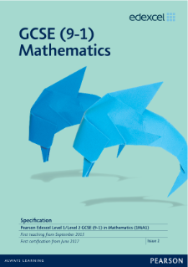

## 1GCSE Trilogy Science (double award)

**What will you study?**

## 1

**Biology:** Genetics, Environment, Evolution and speciation, Nerves and Hormones, Interdependence and adaptation, Cell division

**Chemistry:** Atomic structure, bonding, material science, crude oil, plastics, Earth and the atmosphere, rates of reactions and acids

**Physics:** Energy, Electricity, Waves, Forces and motion, radiation and nuclear power

**What exam board is it?**

AQA ([www.aqa.org.uk](http://www.aqa.org.uk))

**What qualifications will I finish with?**

Two science GCSEs, a double award in Combined Science.

**What might this course lead to?**

It can lead to further study of Sciences at A-Level if you achieve a B or above but will also provide you with a fantastic set of skills that are essential for further study and work such as data analysis and interpretation, practical skills and applications of numeracy.

In terms of careers it is easier listing careers that science will not help in! But science is essential for anyone wanting to enter medicine; engineering and a lot of modern media (e.g. computer games and visual effects) are reliant on a sound understanding of the world around us.

**Assessment:**

There will be six exams: two Biology, two Chemistry and two Physics Each exam is 1 hour and 15 minutes and is worth 70 marks. You will also be required to complete 16 practicals and you will also be assessed on your knowledge of these in the exams. You will receive 2 GCSEs in science, based on the total achieved in the 6 exams.

**How does it link to what I have studied previously?**

You have already started your GCSE Science course in Y9. You will continue within this in Y10 and Y11. By now you will have a good understanding of Energy, Forces, Cells, Particles and Interdependence and you will start to build on these and develop a more complex understanding of the word around you.

**Who should I see for more information?**

Your science teacher or you can speak to

****Mrs Stephens or Mr Phillips.

You may wish to speak with your Science teacher about your suitability to study Triple Sciences. More details about this can be found later on in this booklet.

## GCSE Religious Studies

**What will you study?**

You will study how religion affects people’s lives, behaviour and attitudes to ethical issues. Along the way you are going to learn more about yourself and your values and beliefs.

 In year 10 and 11 you will do a study of Christianity and Islam, along with ethical issues involved with:

* Relationships and family
* Crime and Punishment
* Issues of Life and Death
* Human Rights and Social Justice

These will be explored from two different religious traditions and from an atheist or humanist point of view.

**What qualification will the course lead to?**

This is a single award so you will achieve one GCSE pass in Religious Studies

**How would it help me in future?**

It helps you to become aware of other people’s beliefs and how they impact on life. Jobs such as nursing, social work, teaching, police, armed forces. Religious Studies can also help you to develop a good thoughtful approach to life and the world we live in today.

**How will my work be assessed?**

You are marked on your ability to justify your opinions and show an understanding of why people live as they do. There are 2 exams:

Paper 1: 50%

Paper 2: 50%

**Will all my study be in school?**

No, home learning is an important part of the course. It will be necessary for you to keep up with current affairs.

**How will it be similar to what I have done in Year 9?**

You will need many of the skills you have developed in Year 9 and some of the topics are revisited in much more depth later, too.

**What will be especially important for me to succeed on the course?**

It is very important that you enjoy finding out what matters to other people.

**What requirements do I need to be accepted onto the course?**

Religious Studies is a compulsory subject.

**Who are the best people to see for more information?**

Mrs Wynn, Mr Morgan and Miss Richards

## Life Skills

Life Skills helps students deal with some of the issues they face as they grow up. The course is taught over 4 EEL days in year 10 & 11 and covers issues such as:

* Personal Organisation and Study Skills
* Health, including alcohol and drug abuse
* Relationships and Sex Education
* The Law, relating to 14-18 year olds
* Cultural, Moral and Spiritual Issues
* Careers & Finance



## Work Experience

As part of the Careers programme all students take part in a two weeks work experience during the Summer Term of year 10.  Pupils will spend time in their Careers lessons preparing and evaluating this experience.

Who are the best people to see for more information?

* Miss Dungey/Mrs McClean – Work Experience Coordinator
* Mrs Kane – Careers Coordinator

# EXTENDED CORE SUBJECTS: (Continued from year 9)

## GCSE Geography

**What will I study?**

The new Edexcel A Specification focuses on the challenges faced by the United Kingdom in an ever changing world. You will cover a wide range of topics, including: weather hazards and climate change; ecosystems, biodiversity and management; the changing landscapes of the UK; changing cities; global development; and finally, resource management. You will carry out two full fieldwork days, developing key geographical enquiry skills, whilst furthering your human and physical investigations.

**What qualification will the course lead to?**

A GCSE in Geography. This is a single award so you end up with one GCSE pass in Geography. Geography is also an English Baccalaureate subject, so carries extra importance when considering further education.

**How would it help me in future?**

GCSE Geography opens the door to a fantastic range of jobs and interests. The subject covers a wide range of skills from navigation to investigation, problem solving and analysis, all highly sought after by employers. If you are interested in a variety of careers to do with the environment and our future; if you would like to deepen your understanding of the world around you, then Geography is for you.

Combining GCSE Geography with other subjects could lead to jobs in surveying, nature conservation, architecture, teaching, tourism, civil aviation, the police or armed services, selling and marketing products to mention but a few.

GCSE Geography is a course open to anyone with a mind that enquires into the world that surrounds us. Geographers are desirable in the workplace not only because of their diverse knowledge but also their well-balanced skill set.

**How will my work be assessed?**

Three written examinations on: the physical environment, the human environment and geographical investigations. There is no coursework.

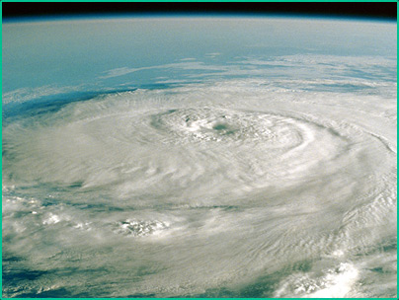

**Will all my study be in school?**

No, home learning and fieldwork are important parts of the course. It will be necessary for you to read around the subject at home and to have ‘open eyes’ when it comes to related affairs that regularly appear in the news.

**What will be especially important for me to succeed on the course?**

You need to have an interest in people, the way they live and the challenges they face in everyday life. Good Geographers often see themselves as managers, decision-makers, wanting to make a difference.

**Who are the best people to see for more information?**

Head of Geography Mr Warren or any of the subject teachers Mr Fountain or Mrs Fletcher.

## GCSE History

**What will I study?**

**Paper 1**

Thematic study. Crime and punishment through time, c1000-present and historic environment, Whitechapel. This is a study over a 1000 years that looks at change and continuity in crimes, law enforcement and punishments.

**Paper 2**

Period study: Superpower relations and the Cold War, 1941-91. This unit focuses on the rise in tension between the great powers, key crisis and the ending of the Cold War.

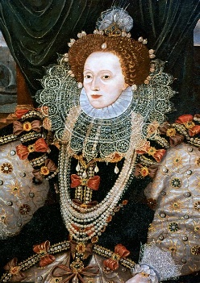

British depth study: Early Elizabethan England, 1558-88. This will focus on the religious tensions at the start of her reign, focusing on Mary Queen of Scots and the Spanish Armada.

**Paper 3**

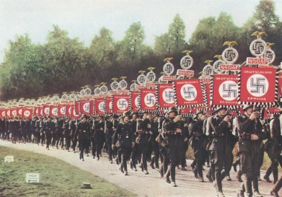Modern depth study: Weimar and Nazi Germany, 1918-39. The fall of the Weimar Republic and the rise of the Nazi Party into power. Interpretations of life in Nazi Germany will also be studied.

**What qualification will the course lead to?** GCSE Edexcel 9-1. This is a single award so you end up with one GCSE pass in History. History is also an English Baccalaureate subject.

**How would it help me in future?**

The world is changing fast and it can be scary. However, having an interest in the past can help us identify trends and patterns that our world might be going in. You will become a very well equipped student in the skills needed for life and work in the 21st Century. Your ability to question sources will help you make informed judgements in life. You’ll become more confident in forming & communicating an argument with strong evidence and explanation. You will become better at understanding a lot of information quickly and also being able to select what is important. These skills will equip you for all areas of working life.

**How will my work be assessed?**

There are three exams at the end of Y11:

**Paper 1:** **Written examination: 1 hour and 15 minutes 30% of the qualification**

**Paper 2: Written examination: 1 hour and 45 minutes 40% of the qualification**

**Paper 3:** **Written examination: 1 hour and 20 minutes 30% of the qualification**

**Will all my study be in school?**

You will be set regular homework; there will be independent research and background reading. Assessment will be based on practice exam questions; you’ll be regularly told what grade you’re working at and how to progress.

**What will be especially important for me to succeed on the course?**

Your literacy skills will help you to express your ideas clearly and develop your understanding. You will need to be an independent learner willing to take responsibility. You will learn from closing the gap feedback. Many pupils overachieve in History because of their open attitude to feedback!

**What requirements do I need to be accepted onto the course?**

It’s open to everyone but you should have a keen interest in how the past has impacted the world we live in today.

**Who are the best people to see for more information?** Ms Wigley

# OPEN OPTION SUBJECTS:

## BTEC Tech Award in Enterprise

**What will I study?**

The qualification consists of three components that give learners the opportunity to develop broad knowledge and understanding of the enterprise sector and relevant skills. Components one and two are assessed through internal assessment through the means of an assignment brief with a clearly defined deadline.

Your third assessment, for component three, will be an external assessment. This will be a task that set and marked by the award board. You will have a set time to complete this task. The task will be completed In Year 11 as it brings together what the learner has learned in components one and two.

**What qualification will the course lead to?**

Taking the BTEC Tech Award in Enterprise means that you will end up with one GCSE equivalent qualification in Business Enterprise.

**How would it help me in future?**

All Businesses need enterprising leaders and employees to drive their organisation forward.to have ideas and initiatives to promote growth, and to ensure that businesses survive in this fast-changing world. Enterprise is a key government focus, and is set to form an important part of the UK’s global economic status, both now and in the future. Enterprise skills provide a fantastic progression pathway into a number of roles in an organisation, and are transferable into all businesses.

**How will my work be assessed?**

The coursework that you do in Year 10 and Year 11 is assessed internally by completing the assignment briefs. In Year 11 you will be assessed externally by examination.

**Will all my study be in school?**

No, independent learning is really important No, independent learning is really important and you will be given research tasks to complete at home to use in your controlled assessments.

**How will it be similar to what I have done in Year 9?**

This will be a totally new topic to you. Exploring the world of business is an exciting opportunity.

**How will it be studying BTEC Business be different?**

This entire BTEC course is delivered through the eyes of actual businesses. We study why individual businesses trade the way they do, what they gain and what benefits us the consumer.

You will have BTEC Business for five lessons a fortnight either as a double or triple lesson.

**What will be especially important for me to succeed on the course?**

It is very important that you have a genuine curiosity about business and be prepared to carry out independent study on selected businesses.

**Who are the best people to see for more information?**

Mr McKenzie

## GCSE Art and Design

**What will I study?**

You will have the chance to try a lot of different media, techniques and processes. You will be encouraged from the start to research and analyse the work of other artists who inspire you, and as you go through the course you can choose to look at the artists who interest you the most. You gather marks for your GCSE by drawing and taking photographs, researching the work of other artists, developing your ideas by exploring different media, techniques and processes and creating a final outcome.

**What qualification will the course lead to?**

GCSE Art and Design.

**How would it help me in future?**

This course will allow you to refine your skills and express yourself in a visual way. It could be the first step towards an ‘A’ level or simply a way of nurturing your creativity and independence. This could lead to a degree in a number of Art and Design courses, or help you to be creative in another course you choose. The range of possible careers you could pursue is vast; you could become an illustrator, architect, interior designer, art therapist, arts manager, graphic designer, set designer, fashion designer, costume designer, web designer, games designer, car designer etc.

**How will my work be assessed?**

You are marked on your ability to record your ideas and observations in drawings and photographs, experiment with different techniques and develop your ideas to produce a final idea that is unique and personal to you. Your controlled assessment project is completed during Year 10 and 11 and counts for 60% of the final grade. The exam, completed in Year 11 is worth 40% of the final grade.

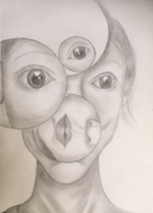

**Will all my study be in school?**

No, Personal Study is an important part of the course. It will be necessary for you to take photographs and complete research outside of school so that your artwork is unique and personal. You may also be expected to complete some of your creative thinking and practical work in your own time.

**How will it be similar to what I have done in Year 9?**

You will need many of the skills that you have developed in Art during Year 9. You will record and develop your ideas in a sketchbook and present your understanding in a final outcome. Using new media and techniques, and exploring your own individual ideas will be the main difference from the Year 9 course.

**What will be especially important for me to succeed on the course?**

It is very important that you enjoy Art and Design and have a **genuine** interest in the subject. You also need to have a positive attitude.

**Who are the best people to see for more information?**

Miss Barre and Mrs Corbishley

## Child Development

**Cambridge Nationals Level 1/2**

This qualification is designed to fit into the curriculum and offer the same size, rigour and performance points as GCSEs.

The qualifications are recognised by 16-19 providers as progression on to A level, Further Education or on to an apprenticeship or work.

**What will I study?**

All students will study 3 mandatory topics as follows:

* Health and well- being for child development.
* Understand the equipment and nutritional needs of children from birth to five years.
* Understand the development norms of a child from birth to five years.

**What qualification will the course lead to?**

This qualification is for students aged 14-16 who wish to develop applied knowledge and practical skills in child development.

It is designed with both practical and theoretical elements, which will prepare students for further qualifications in Child Care, Health and Social Care, Psychology, Sociology and Biology.

**How would it help me in future?**

Researching, planning, observing and evaluating skills are an integral part of this course and would be useful in further studies as these are transferable skills and therefore could be applied to many subject areas.

**How will my work be assessed?**

Two centre assessed units (worth 50%) as well as an examined unit (worth 50%) covering topics such as: responsibilities of parenthood, contraception and reproduction, antenatal, health, delivery, postnatal checks, illnesses and child safety.

**Will all my study be in school?**

You will have 5 hours of teaching in school per fortnight. Homework will be regularly and coursework tasks are completed in school.

**How will it be similar to what I have done in Year 9?**

This is a new subject which you will not have previously studied and therefore it is important that you are clear about what the course entails before embarking upon it.

**What will be especially important for me to succeed on the course?**

Firstly you will need to have a keen interest in how children develop. Secondly you must have a commitment to giving of your best in all aspects of the course and an ability to work independently.

**What requirements do I need to be accepted onto the course?**

Coursework is demanding and literacy skills are important if you decide to study this subject.

**Who are the best people to see for more information?**

Ms Reynolds – Head of Design and Technology

## GCSE Computer Science

**What will I study?**

The assessment consists of two written examinations.

1. Component 01 focuses on Computer Systems.
2. Component 02 is a new written exam, focused on computational thinking and algorithms. Students will be tested on the elements of computational thinking and logic. They are principally assessed as to their ability to write, correct and improve algorithms.

**Exam Board -** OCR

**What qualification will the course lead to?**

The course will lead to one GCSE at grades 9-1

**How would it help me in future?**

Computer technology is advancing rapidly. The growth in the use of mobile devices and web-related technologies has exploded, resulting in new challenges for employers and employees.

**Will all my study be in school?**

No, home learning is an important part of the course. There will be theory based homework for Unit 1 & Unit 2 Student will be expected to expand on their programming skills in between lessons independently.

**How will my work be assessed?**

|  |  |  |  |  |
| --- | --- | --- | --- | --- |
| Component | Title | Marks | Duration | Weighting |
| 1 | Computer Systems | 80 | 1:30 hrs | 40% |
| 2 | Computational thinking | 80 | 1:30 hrs | 40% |

**How will it be similar to what I have done in Year 9?**

There will be some elements of ICT in this course, for example, data handling and python.

**How will it be different to the ICT qualification?**

Computer Science is a discipline on its own and focuses on how the software works. You will gain an understanding of the fundamental concepts around creating software applications rather than using software that is already available at school.

**What will be especially important for me to succeed on the course?**

It is very important that you enjoy ICT currently and have a **genuine** interest in the subject. You also need to have a positive attitude, and be ready to try new things. You have to be very resilient when learning to code and persevere if code does not work as intended from the beginning. There are also very strong links with Maths as programming language follows rules of logic. You should enjoy Maths and be confident in using rules for sequences. The students that succeed the most in Computer Science are the students that make the most progress independently between lessons on their programming skills.

**What requirements do I need to be accepted onto the course?**

You must be a confident mathematician and a logical thinker.

**Who are the best people to see for more information?**

Mr McKenzie or Mr Dearlove

## Cambridge Nationals in Creative iMedia

**What will I study?**

The OCR Level 1/2 Cambridge National Certificate in Creative iMedia consists of two mandatory units…

1. R081: Pre-production skills

Written paper OCR set and marked

1. R082: Creating digital graphics

Centre-assessed tasks OCR-moderated

**Plus two optional units.**

1. R087: Interactive Multimedia

Centre-assessed tasks OCR-moderated

1. R092: Developing digital games

Centre-assessed tasks OCR-moderated

**Exam Board -** OCR

**What qualification will the course lead to?**

The course will lead to a GCSE at grades 9-1

**How would it help me in future?**

These qualifications will assess the application of creative media skills through their practical use. They will provide learners with essential knowledge, transferable skills and tools to improve their learning in other subjects with the aims of enhancing their employability when they leave education, contributing to their personal development and future economic well-being. The qualifications will encourage independence, creativity and awareness of the digital media sector.

**Will all my study be in school?**

No, home learning is an important part of the course, there will be, theory based homework for all units to enable understanding.

**How will my work be assessed?**

|  |  |  |  |  |
| --- | --- | --- | --- | --- |
| Component | Title | Marks | Duration | Weighting |
| 1 | R081: Pre-production skills | 60 | 1:15 hrs | 25% |
| 2 | R082: Creating digital graphics | 60 | 10 hrs | 25% |
| 3 | R087: Interactive Multimedia | 60 | 10hrs | 25% |
| 4 | R092: Developing digital games | 60 | 10hrs | 25% |



**How will it be similar to what I have done in Year 9?**

You will have been introduced to many of the elements already in Key Stage 3

**What will be especially important for me to succeed on the course?**

It is very important that you enjoy ICT currently and have a **genuine** interest in the subject. You also need to have a positive attitude, and be ready to try new things.

This subject enables learners to understand pre-production skills used in the creative and digital media sector. It will develop their understanding of the client brief, time frames, deadlines and preparation techniques that form part of the planning and creation process.

Planning is an essential part of working in the creative and digital media sector. This unit will enable learners to acquire the underpinning knowledge and skills needed to create digital media products and gain an understanding of their application.

**What requirements do I need to be accepted onto the course?**

You must be able to plan effectively to ensure you hit the required deadlines.

**Who are the best people to see for more information?**

Mr McKenzieor Mr Dearlove

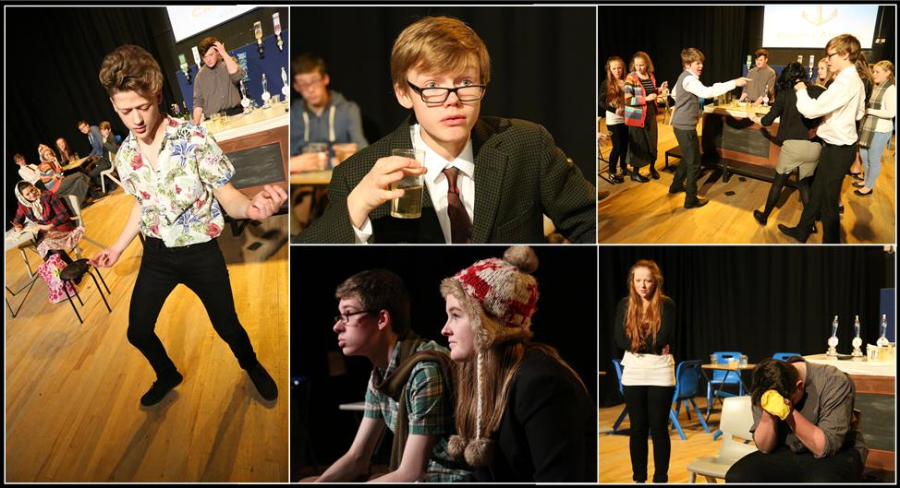**GCSE Drama**

**What will I study?**

GCSE Drama is about understanding what it is like to put yourself in someone else’s shoes. You will create your own work as well as look at plays written by other people. GCSE drama offers you the chance to refine and develop your performance and acting skills as well as developing your skills in problems solving, leadership, and group work. You will also have the opportunity to perform your work to a range of different audiences and to see pieces of live theatre.

**How would it help me in future?**

Drama enables you to develop a wide range of skills that are required for a range of careers in business, retail, social work, law and of course in theatre. It will develop your confidence in speaking so when it comes to important interviews you will have the skills to succeed. Skills developed will include: teamwork, creativity, presenting, time management, performing, acting, reasoning, leadership and empathy

**How will my work be assessed?**

There are 3 Units that make up this qualification.

**Component 1:** Devising (30%) - Students will research and explore a stimulus, work collaboratively and create their own devised drama. In groups they will explore a range of stimuli and produce a final performance based on the stimulus they have chosen to research. The students will create a portfolio detailing the process of how they created their drama using a range of different mediums that will accompany their performance. A recording of this performance will be sent to the examining body and there will be an audience present.

**Component 2:** Performance from Text (30%) – Students will perform two extracts from a play. Students will learn about staging a play and the theatrical skills that accompany performing in a play. They will then produce a performance of two extracts from the play that they have explored and perform this to an audience and a visiting examiner. They can do this as a group or as an individual. Students are marked on their performance ability.

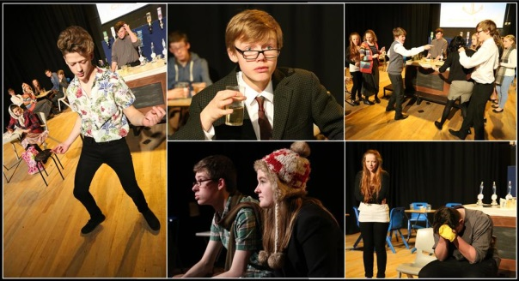**Unit 3:** Theatre Makers in Practice (40%) - For this component, students need to demonstrate knowledge and understanding of how drama is developed, performed and responded to. Learners must also be able to reflect on and evaluate the work of others. They are then assessed on the knowledge, understanding and skills they have learnt. Students will also go and watch a live theatre performance and evaluate this. They will be examined on a play which they have studied and their evaluation and analysis of a live performance that they have seen.

**Will all my study be in school?**

You will be required to complete work outside of school and that will have a direct impact on the work that you do in lessons. You will have to keep an up to date rehearsal journal in which you will record what you have done during the lesson and what you have learnt. This will be where you write about how you put a piece of drama together and the characters that you have played. This will be the basis for the written element of the course.

**How will it be similar to what I have done in Year 9?**

GCSE Drama follows on from drama work that you will have done at Key Stage 3. You will develop your improvisation and acting skills to a higher level. You will learn and experiment with new techniques and how use them to create drama. You will also look at plays in more detail and look at different ways of bringing a script alive on stage.

**What requirements do I need for this course?**

You should enjoy performing in front of an audience and working in groups. You need to be able to work independently as a group and to stay focused. You will be willing to attend after school and lunch time rehearsals for performance pieces. You will have to learn your lines!

**Who are the best people to see for more information?** Miss Burgess

## untitledGCSE Music

**What will I study?**

You will study the following units:

Unit 1 – Focuses on your instrument, you will have the opportunity to prepare and record a number of songs for your instrument you will then have the opportunity to compose a piece of music for your own instrument. This will all be done in the class and assessment by your teacher (30%)

Unit 2 – Focuses on group performances. You will need to perform a group piece; this can be with players from your class or outside the class. You will form bands and prepare pieces and record them in the recording studio. You will then have the opportunity to compose a piece of music for a group. This will all be done in the class and assessment by your teacher (30%)

Unit 3 – Focuses on different styles of music. During this unit you will study the concerto, Film music, Rhythms from around the world and pop music. There will be an exam in this unit at the end of year 11. (40%)

**What qualification will the course lead to?**

OCR GCSE Music. This is a single award so you will end up with one GCSE pass in Music.

**How would it help me in future?**

This course gives you opportunities to develop skills in performance and composition and help you to develop skills in teamwork and independent work. This course helps you build self-confidence through performance work; it shows that you are committed to working hard to achieve your goal. In a recent statement the government recognised that studying music and becoming a musician can improve numeracy, literacy and behaviour and that all students should have the opportunity to engage in the joy of musical discovery.

**How will my work be assessed?**

Controlled assessment over 2 years counts for 60% of the total marks. The remaining 40% is awarded through the listening paper.

**Will all my study be in school?**

Most of your work will be done in class, as it is controlled assessment work; however, it is important to practice regularly at home in order to make progress. There are opportunities to use our excellent facilities. All GCSE students get priority to use the practice rooms during lunchtime for rehearsals.

**How will it be similar to what I have done in Year 9?**

The course is very practical with a large amount of time spent on rehearsing, performing and composing. You will continue your band work from year 9 and record group performances. We will develop our knowledge further in topics already studied in year 9 such as Conventions of pop, Calypso and film soundtracks.

**What will be especially important for me to succeed on the course?**

That you can already play a musical instrument or sing to a basic level (equivalent of grade 1). If you are not at this standard you must be prepared to have lessons in school or privately.

**What requirements do I need to be accepted onto the course?**

You need to be able to play a musical instrument or sing to a basic standard.

**Who are the best people to see for more information?**

Mrs Ruston (Head of Music) or Miss Condrey

## GCSE Photography

**What will I study?**

During the Year 10 course, you will be taught how to use a DSLR camera, moving away from the automatic mode. You will explore traditional and digital photographic techniques and develop skills using Photoshop. You will develop projects using your own ideas in response to set briefs. In Year 11 Photography, you will use your own initiative and ideas to develop projects that demonstrate your new skills and reflect your experiences and interests.

**What qualification will the course lead to?**

GCSE Photography

**How would it help me in future?**

This course will allow students to refine their skills and understanding of exciting and creative media that the majority of students will already be familiar with. It could be the first step towards an ‘A’ level or simply a way of nurturing your creativity and independence. It encourages organisation skills, thoughtful reflection and presentation skills. This could lead to a degree in a number of Art and Design courses, or help you to be creative in another course you choose. The range of possible careers you could pursue is enormous; including a photojournalist, fashion photographer, graphic designer, magazine features editor, medical illustrator, press photographer

**How will my work be assessed?**

60% Coursework 40% Exam. Work completed throughout both Year 10 and 11 contributes to the coursework grade.

**Will all my study be in school?**

No, home learning is an important part of the course. It will be necessary for you to take photographs outside of school so that your Photography work is unique and personal and you will be expected to complete some of your creative thinking and practical work in your own time.

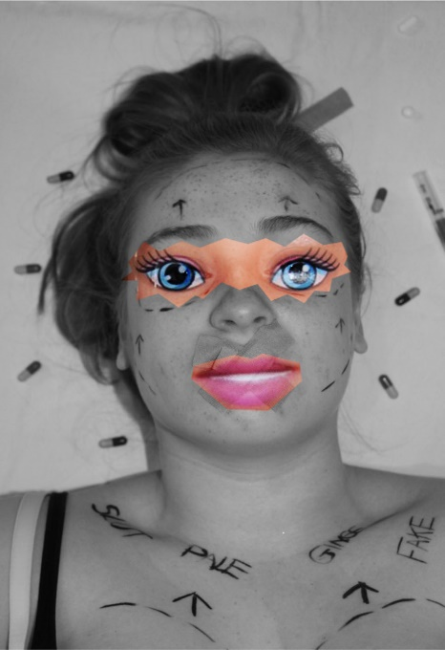

**How will it be similar to what I have done in Year 9?**

You will need many of the skills you have developed in Art during Year 9. You will record and develop your ideas and present your understanding in a final outcome. Developing techniques and exploring your own ideas will be the main difference from the Year 9 course.

**What will be especially important for me to succeed on the course?**

You will need to be an independent learner with good time management. A genuine interest and enthusiasm for photography is also important. An ability to listen and act upon academic guidance and feedback and present your work creatively will also be helpful.

**What requirements do I need to be accepted onto the course?**

You should have an interest and a curiosity for photography. Organisational skills to keep up with coursework and some I.T skills, to build your digital portfolio.

**Who are the best people to see for more information?**

Mrs Corbishley and Miss Barre

## GCSE French

**What will I study?**

You will cover the following five main topic areas:

1. Identity & Culture
2. Local area, Holiday & Travel
3. School
4. Future Aspirations, Study & Work
5. International and Global Dimension

You will be given the opportunity to improve your written and spoken communication skills as well as deepening your understanding of the French culture and language.

Lessons will include the opportunity to listen to contemporary French language music, undergo web research and use ICT to communicate with others abroad and create multimedia presentations

**What qualification will the course lead to?**

EDEXCEL French GCSE (Linear)

**How would it help me in future?**

Learning a foreign language is becoming increasingly more important with the introduction of the English Baccalaureate as well as being a sought-after skill in many employment types. You do not need to be fluent in a language in order for it to help you in your career, so even if you do not continue after GCSE, you will be recognised (and paid!) accordingly.

Learning a foreign language encompasses a whole range of skills which are essential for your future. Linguists learn how to communicate effectively both in their writing and speaking. You also train to listen for key details and to read using different techniques such as skim reading, reading for detail and reading for inference. All of these skills make you more employable and show a potential employer you have broad horizons.

**How will my work be assessed?**

You will get continual feedback from your teacher on how to improve your skills. You will complete four examinations (Listening, Reading, Speaking and Writing) at the end of the GCSE course in Year 11. Each examination is 25% of the overall GCSE.

**Will all my study be in school?**

Lessons will be conducted in school, but you will have the opportunity to take part in educational trips to France and there will be opportunities to go to the cinema or the theatre to see French films and plays as well as other visits which will enhance your language.

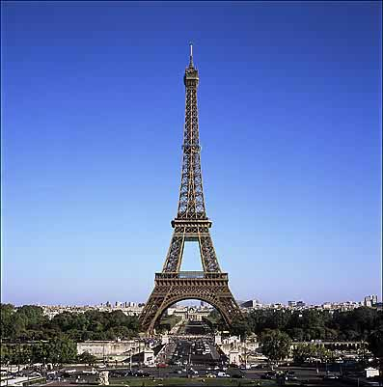

**How will it be similar to what I have done in Year 9?**

You will come across some familiar topic areas but the depth in which you cover them and the way in which you are taught will be very different. There will be an emphasis on using authentic materials such as TV programmes, songs and films to help you understand that learning French is not just about learning a language but also about exploring a culture.

**What will be especially important for me to succeed on this course?**

You must have a desire to learn another language and explore different cultures. Learning a language is not always easy so you need to demonstrate resilience and resourcefulness. You also have to take responsibility for your own learning. You could demonstrate this by reading an article in French on the internet or downloading some French music, in order to enhance your understanding of French.

**Who are the best people to see for more information?**

Mrs. Irvine-Remson or Mrs Paginton.

## http://ferrebeekeeper.files.wordpress.com/2011/02/flamenco03.jpgGCSE Spanish

This course is open to students who have previous knowledge of Spanish from KS3

**What will I study?**

You will cover the following five main topic areas:

1. Identity & Culture
2. Local area, Holiday & Travel
3. School
4. Future Aspirations, Study & Work
5. International and Global Dimension

You will be given the opportunity to improve your written and spoken communication skills as well as deepening your understanding of the Spanish culture and language.

Lessons will include the opportunity to listen to contemporary Spanish language music, undergo web research and use ICT to communicate with others abroad and create multimedia presentations.

**What qualification will the course lead to?**

EDEXCEL Spanish GCSE (Linear)

**How would it help me in future?**

Learning a foreign language is becoming increasingly more important with the introduction of the English Baccalaureate as well as being a sought-after skill in many employment types. You do not need to be fluent in a language in order for it to help you in your career, so even if you do not continue after GCSE, you will be recognised (and paid!) accordingly.

Learning a foreign language encompasses a whole range of skills which are essential for your future. Linguists learn how to communicate effectively both in their writing and speaking. You also train to listen for key details and to read using different techniques such as skim reading, reading for detail and reading for inference. All of these skills make you more employable and show a potential employer you have broad horizons.

**How will my work be assessed?**

You will get continual feedback from your teacher on how to improve your skills. You will complete four examinations (Listening, Reading, Speaking and Writing) at the end of the GCSE course in Year 11. Each examination is 25% of the overall GCSE.

**Will all my study be in school?**

Lessons will be conducted in school, but you will have the opportunity to take part in educational trips to Spain and there will be opportunities to go to the cinema or the theatre to see Spanish films and plays as well as other visits which will enhance your language.

**How will it be similar to what I have done in Year 9?**

You will come across some familiar topic areas but the depth in which you cover them and the way in which you are taught will be very different. There will be an emphasis on using authentic materials such as TV programmes, songs and films to help you understand that learning French is not just about learning a language but also about exploring a culture.

**What will be especially important for me to succeed on this course?**

You must have a desire to learn another language and explore different cultures. Learning a language is not always easy so you need to demonstrate resilience and resourcefulness. You also have to take responsibility for your own learning. You could demonstrate this by reading an article in Spanish on the internet or downloading some Spanish music, in order to enhance your understanding of Spanish.

**Who are the best people to see for more information?**

Mrs. Morgan.

## GCSE Physical Education

**What will I study?**

Throughout Years 10 and 11 you will study practical and theoretical aspects of Physical Education. You will be taught a wide range of sports with the aim of achieving a high level of performance in three of these activities, which, in turn, will contribute to your final grade. Theory topics, worth 60% of your final grade, include: diet, components of fitness, training methods, social reasons for participation in sport, skill acquisition and applied anatomy and physiology.

**What qualification will the course lead to?**

GCSE in Physical Education (Edexcel syllabus)

**How would it help me in future?**

GCSE PE is an excellent foundation for moving on to Advanced Level PE, or a Level 3 BTEC award. Many students have then gone on to sport-related degrees and careers such as physiotherapy, teaching and sports coaching.

**How will my work be assessed?**

Your performance in three practical activities (from a list of permitted activities) will contribute towards 30% of your overall mark. Students will write a Personal Exercise Programme that’s is worth 10% of the overall grade, and two written theory exams make up the other 60%.

**Will all my study be in school?**

Most of the time your study will be based in school, but as part of your commitment to the course you will need to play sport in your own time, either through clubs, at local sports centres or by representing the school and attending practices. Students will be offered the opportunity to go on trips to take part activities we cannot provide for in school. Home learning and through preparation for examinations is fundamental to success on this course.

**How will it be different to the Edexcel BTEC Level 2 First Certificate in Sport?**

30% of your overall grade will be based on your practical performance and there will be two written theory exams.

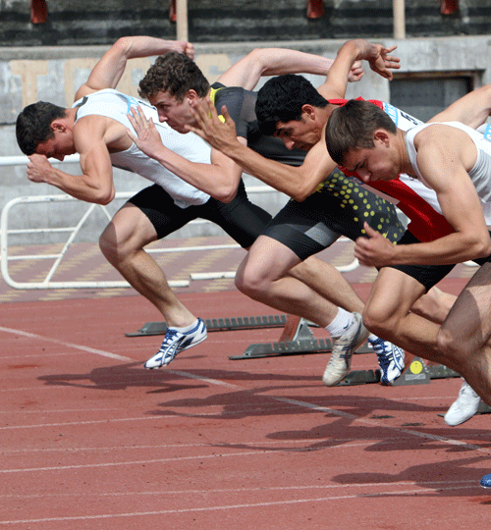

**How will it be similar to what I have done in Year 9?**

You will continue to develop your practical skills in a range of sports. Some of these activities will be familiar to you such as netball and football. Others may be new like handball and rock climbing. The theory will follow on from some topics you may have covered during your PE lessons, such as fitness components.

**What will be especially important for me to succeed on the course?**

A strong commitment to playing sport and the commitment to regular practice in at least 2 sports**.** This might be through our extra-curricular programme or as a member of a local sports club. An interest in theoretical aspects of Physical Education such as how the body moves and how we train to improve our performance is essential.

**Who are the best people to see for more information?**

Mr Mainwaring

## [https://upload.wikimedia.org/wikipedia/commons/1/1b/%D0%9F%D1%8B%D0%BB%D0%B5%D1%81%D0%BE%D1%81_Dyson_DC37.jpg](https://www.google.co.uk/url?sa=i&rct=j&q=&esrc=s&source=images&cd=&cad=rja&uact=8&ved=0ahUKEwixs72Z9JTKAhUFPBQKHRQzDWcQjRwIBw&url=https://en.wikipedia.org/wiki/List_of_Dyson_products&psig=AFQjCNGGmQADJtXaRzY4I1YymSel_MuAXA&ust=1452160119885091)GCSE: Design and Technology

**What will I study?**

If you are interested in working with and making creative and stunning products, packaging, fashion clothing in wood, metal, fabrics, boards and plastics then this is the subject for you. If you want to know how a business builds and develops on the back of an idea then DT is for you. Choose DT If you want to know what has made some of the most successful creative minds successful such as James Dyson. You will be expected to work in groups and as an individual solving real life and theoretical problems. Limitations on this subject are your imagination and thirst for innovation. There will be a wide variety of activities where you will learn to demonstrate creativity, research skills, modelling designs, making and critical evaluation. There will be the opportunity to experience practical assessments with guidance and support to enable you to achieve your full potential and gain confidence. You will be building on your prior learning and will be involved in many exciting learning opportunities. End products may be varied and diverse, ranging from personalised jewellery or innovative fashion outfits to the design of a new child’s toy or eco-friendly garden product.

**What qualification will the course lead to?**

A Levels in Product Design or Engineering

Apprenticeships

Higher Education – Degrees in a whole range of sectors from Mechanical Engineering to Creative Interior/Product Design and Fashion

**How would it help me in future?**

Design and Technology will support and prepare you for life whether it be putting those shelves up so they don’t fall down or solving the bigger problems like global warming. A wide choice of diverse careers are available including engineering, science, construction, jewellery, fashion, games design, packaging or even television set design - the world is your oyster. Design and Technology is the very heart of any successful business. This course encourages investigation, research, design, business management and processes and practical skills. It is a course where both boys and girls can succeed in at the highest standard. This course is one of the most useful if you want to move into the manufacturing industry or perhaps even build your own business.

**How will my work be assessed?**

You are assessed regularly through the course on your ability to produce creative and imaginative solutions to problems and your ability to apply your knowledge and understanding of materials and manufacturing methods. This will take the form of assessed modules that build into a portfolio of evidence that both you and the class teacher review on a regular basis. There is one controlled assessment worth 50% of the final grade and one final 2 hour examination worth 50%

[](http://www.google.co.uk/imgres?imgurl=http://www.rnrassociates.com/wordpress/wp-content/uploads/2010/12/conceptbmw-product-design.jpg&imgrefurl=http://toplowridersites.com/integral-design-services-concept-style-development/www.anima.es*files*galerias*735*TRAMONTANA_ANIMA_003.jpg/&h=343&w=550&tbnid=IjEavC37WSZNUM:&zoom=1&docid=r-5Ov_kRzvnXuM&ei=G9e4VOPSKojVavPugKAN&tbm=isch&ved=0CFUQMyhNME04rAI)**Will all my study be in school?**

Homework is an integral and valuable part of this course and will include research and design analysis tasks as well as theory. The controlled assessment must be completed in school with some homework time for research tasks.

**How will it be similar to what I have done in Year 9?**

You will build on the skills you have developed in

Design Technology during KS3. Practical skills will be further developed and you will use a wider range of techniques and equipment.

**What technology will you use?**

You will develop skills in using 3D Computer Aided Design (CAD) software, 3D printers, Laser cutters, Welding, Brazing, Workshop equipment, DTP software and Graphics software

**What will be especially important for me to succeed on the course?**

You will need to have an interest in creative design, materials, business processes and enjoy being practical. Having a creative mind and being willing to try new ideas is important. You must be organised and manage time well.

**Who are the best people to see for more information?**

Miss Mansell

## GCSE Food Preparation and Nutrition

## What will I study?

This qualification is designed for learners with an interest in food, nutrition and cookery. It will provide learners with experience of using different cooking techniques and methods and gain an in depth understanding of different food groups, nutrition, special diets and the factors affecting food choice

The objectives of this qualification are to help learners to:

* be able to demonstrate effective and safe cooking skills by planning, preparing and cooking a variety of food commodities whilst using different cooking techniques and equipment

* develop knowledge and understanding of the functional properties and chemical characteristics of food as well as a sound knowledge of the nutritional content of food and drinks

* understand the relationship between diet, nutrition and health, including the physiological and psychological effects of poor diet and health

* demonstrate knowledge and understanding of functional and nutritional properties, sensory qualities and microbiological food safety considerations when preparing, processing, storing, cooking and serving food

* understand and explore a range of ingredients and processes from different culinary traditions (traditional British and international) to inspire new ideas or modify existing recipes.

**What qualification will the course lead to?**

Learners who achieve this GCSE could progress on to the following courses:-

* A level in Design and Technology: Food Technology
* A level in Home Economics (Food, Nutrition and Health)
* Diploma in Advanced Professional Cookery (Preparation and Cooking)
* Level 2 Diploma in Hospitality
* Professional Cookery Studies

**How would it help me in future?**

Possible career sectors include:-

* Catering , Hospitality
* Research and new product development
* Dietician, Food Scientist
* Health and safety, Environmental Health Officer
* Food Marketing, Food Buyer
* Child care worker

**The units covered are broken down below:-**

* Food Commodities
* Principles of Nutrition
* Diet and good health
* The science of food
* Where food comes from
* Cooking and food preparation skills

**How will my work be assessed?**

50% Written examination

50% Non-exam assessment

* NEA 1 - Food investigation (15%)
* NEA 2 – Prepare and cook a menu (35%)

**Will all my study be in school?**

Homework is an integral and valuable part of this course. The controlled assessment must be completed in school with some homework time for research tasks.

**How will it be similar to what I have done in Year 9?**

You will build on the skills you have developed in

Food Technology during year 7, 8, and 9. The course will build on the knowledge and practical skills within a food preparation area.

**What will be especially important for me to succeed on the course?**

You will need to have an interest in food and enjoy being practical. Having a creative mind and being willing to try new ideas is important. You must be organised, manage time well and be prepared to provide ingredients for practical lessons.

**Who are the best people to see for more information?**

Mr Weir or Ms Reynolds

## GCSE Psychology

**What is Psychology?**

Are you interested in why people behave the way they do? Are you interested in understand what makes people tick? If yes, then this could be the subject for you.

Psychology is the scientific study of the human mind and behaviour. It focuses on how we think, feel, act and interact individually and in group situations.

**What will I study?**

**Year 10: Compulsory Units.**

* Development – How did you develop?
* Memory – How does your memory work?
* Psychological problems – How would psychological problems affect you?
* The brain and neuropsychology – How does your brain affect you?
* Social influence – How do others affect you?

**Year 11: Optional Units.**

We will study two of the following units:

* Criminal psychology – Why do people become criminals?
* The Self – What makes you who you are?
* Perception – How do you interpret the world around you?
* Sleep and dreaming – Why do you need to sleep and dream?
* Language, thought and communication – How do you communicate with others?

In both year 10 and 11 you will look at research methods within psychology including how psychological research is carried out, key psychological studies and ethical issues within psychological research.

**What is the exam board?**

Edexcel.

**How will it help me in the future?**

Throughout life you will come across different people in different situations, psychology provides you with the skills to deal these varied situations by understanding the mental processes and behaviours people have. You will develop communication skills, the ability to analyse information and interpret results. These skills are highly transferable to later study and future careers.

**Will all of my study be in school?**

Lessons will take place in school, however home learning will be essential for you to complete. Home learning may involve consolidating learning from lessons, researching psychological studies and keeping up with current affairs. Revision before assessments and exams is expected to embed learning and enhance performance.

**How will I be assessed?**

There will be two exams:

Paper 1 – covers the compulsory topics – 1 hour and 45 minute paper, 98 marks. 58% of the overall grade.

Paper 2 – covers the 2 optional units and Research Methods (drawing on knowledge from compulsory units) – 1 hour 15 minute paper, 70 marks. 42% of the overall grade.

The papers consist of multiple choice, short answers and extended writing questions.

**Who shall I see for more information?**

Mrs Felstead

## GCSE Sociology

**What will I study?**

Sociology explores human society in all its varied forms and looks at the impact of culture and society on us as individuals.

The Year 10 course looks at:

* Gender and stereotyping
* Family and education
* Nature versus nurture
* How does the media cause moral panic and influence our behaviour?

The Year 11 course looks at the above, plus:

* Inequality in Modern Britain
* Crime and deviance
* Work and unemployment.

**What qualification will the course lead to?**

This is a single award so you will get one GCSE pass in Sociology.

**How would it help me in future?**

It helps you to become aware of society and how it changes over time. It helps you to understand what makes people into who they are. What makes people tick? Jobs such as nursing, social work, teaching, police - you name it!

**How will my work be assessed?**

You are marked on your ability to justify your opinions and show an understanding of why people live as they do. The exam is 2 papers, each lasting 1 hour and 45 minutes

**Will all my study be in school?**

No, home learning is an important part of the course. It will be necessary for you to keep up with current affairs by reading newspapers and watching the news on a regular basis.

**How will it be similar to what I have done in Year 9?**

You will need many of the skills you have developed in Year 9 in other subjects.

**What will be especially important for me to succeed on the course?**

Please note that data analysis and research methods are an important part of the course, as is critical thinking- what if we had to pay for healthcare, if men had babies, if people were born criminal?

**What requirements do I need to be accepted onto the course?**

Good literacy and numeracy skills are recommended as is an interest in what makes people who they are and society what it is.

**Who are the best people to see for more information?**

Mrs Wynn

## http://www.promotepr.com/images/lifetime%20award%20(medium).jpgBTEC First Award in Sport

**What will I study?**

The main aims of the course are for student to

1. Have an understanding of how organisations in sport operate.
2. Develop the key skills required to work in the industry.
3. Know about the key concepts and principles related to the world of sport.

The core units you will study are:

1: Fitness for Sport and Exercise

2: Practical Sports Performance

You will also study 2 other units that will be selected to best suit the interests of students.

**What qualification will the course lead to?**

Edexcel BTEC Tech Award in Sport, which is equivalent to 1 GCSE.

**How would it help me in future?**

BTEC Sport is an excellent foundation for moving on to study Edexcel BTEC Level 3 in Sport or Advanced Level Physical Education. The qualification can lead to direct entry into roles such as sport centre based assistants.

**How will my work be assessed?**

Most progress is measured throughout the course, allowing students to gauge their own performance on a continual basis. If you feel you would succeed better this way it may be the course for you. Each unit is assessed and graded and an overall grade for the qualification is awarded. Evidence consists of work you produce as well as results from online tests. The assignments will include, for example, investigations, projects, performance-observation records, practical assessment, presentations and audio visual recordings. Two of the eight units covered will be externally assessed.

**Will all my study be in school?**

The course will be school-based with the opportunity for various sport-related visits throughout the two years. You will also have numerous assignment based home learning tasks.

**Who are the best people to see for more information?**

Mr Mainwaring

## 1Triple Science: GCSE Physics, GCSE Chemistry and GCSE Biology

All students have already started their GCSE Science Studies. GCSE Triple Science leads to 3 GCSEs in science (Biology, chemistry and physics). It will be available as an option subject ONLY. It will not be offered in core teaching time. Triple Science is an academically demanding course and you will have 15 hours of science lessons a fortnight.

To be eligible for triple science, you must have a BBS target grade 6 or above for science and maths, or endorsement from your science teacher.

**What will you study?**

You will study:

**Biology:** Cells, organisation, bioenergetics, infection and response, homeostasis, genetics, ecology.

**Chemistry:** Atomic structure, bonding and the properties of matter, chemical changes, organic chemistry, chemical analysis, chemistry of the atmosphere.

**Physics:** Forces, waves, magnetism, energy, particle model of mater, atomic structure, space, radiation.

**What exam board is it?**

AQA (www.aqa.org.uk)

**What qualifications will I finish with?**

Three GCSEs in Biology, Chemistry and Physics

**What might this course lead to?**

Triple Science is strongly recommended if you intend on studying sciences at A-Level and further. As with the other science courses it will also provide you with a fantastic set of skills that are essential for further study and work such as data analysis and interpretation, practical skills and applications of numeracy.

The careers that science students go into are not limited to the obvious science ones. Physics graduates are highly sought after in business as they understand how to interpret complex data. Academic Science is still funded relatively well by the government as the new ideas and applications that young scientists come up with are essential to help the growth of the country’s economy!

Other careers: Marine Biologist, Computer game programmer, Geneticist, Material scientist…the list is endless!

**Assessment:**

There are 2 papers for each subject (6 in total), each lasting 1 hour 45 minutes and worth 100 marks. You will also be required to complete 8 practicals for each subject (24 in total) and your knowledge of these will also be assessed in the exams. Your grade for each science will be awarded based on the total achieved in the 2 exams in that subject.

**How does it link to what I have studied previously?**

You have already started you GCSE in Science in year 9. By now you will have a good understanding of Forces, Cells, Particles and organisation and you will start to build on these and develop a more complex understanding of the word around you.

**Who should I see for more information?**

Your science teacher or you can speak to Mrs Stephens or Mr Phillips.