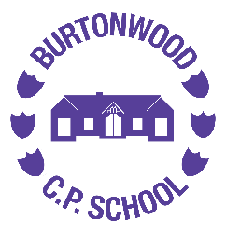
Music Long Term Plan

MUSIC | Autumn 1 | Autumn 2 | Spring 1 | Spring 2 | Summer 1 | Summer 2
EYFS | Exploring Sound | Music and Movement | Celebration Music | Big Band | Musical Stories | Transport
Year 1 | Musical Vocab | Pulse and Rhythm | Classical music, dynamics and tempo | Timbre and Rhythmic Patterns | Pitch and Tempo | Vocal and Body Sounds
Year 2 | Call and response | Orchestral Instruments | Musical Me | Dynamics, timbre, tempo and motifs | On this Island: British Songs and Sounds | Myths and Legends
Year 3 | Keyboards |  |  | Creating compositions in response to animations | Developing singing techniques | Pentatonic melodies and composition
Year 4 | Body and tuned percussion | Samba and carnival sounds and instruments | Adapting and transposing motifs | Guitar
Year 5 | Composition notation | Musical Theatre | South and West Africa | Keyboards
Year 6 | Guitar |  |  | Songs of WW2 | Film Music | Composing and performing a leavers’ song

