Brookhaven Schools

ASPIRE Curriculum

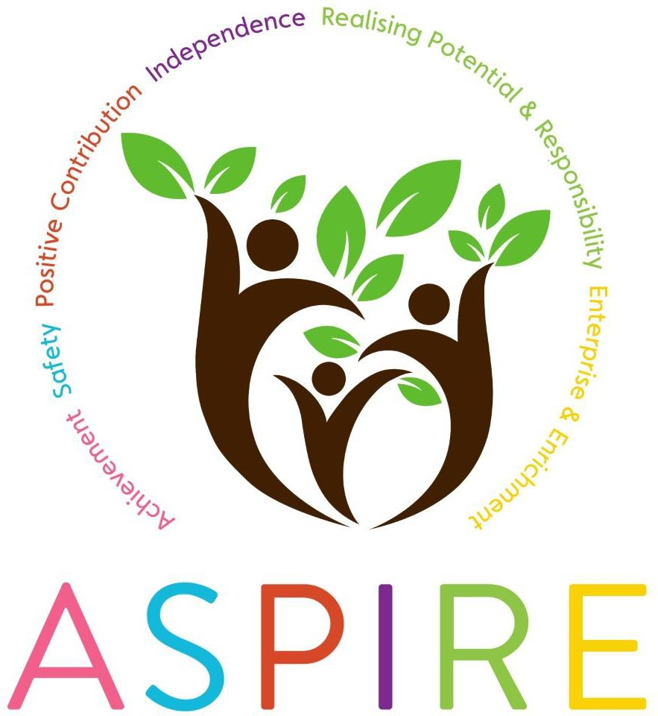

At Brookhaven School we are committed to:

- Providing an outstanding educational experience
- Enabling each student to develop a positive sense of worth and self-esteem
- Working in partnership with parents and our local community for the benefit of all
- Creating a caring environment
- Valuing, respecting and supporting each other.
We have developed a creative and ambitious curriculum which is underpinned by six key elements of our ASPIRE programme. These six elements are at the core of all learning experiences in classrooms, displays, assemblies, visits and residentials, accreditation pathways, partnerships and community work.

- Achievement
- Safety
- Positive contribution and choices
- Independence
- Realising potential and Responsibility
- Enterprise and Enrichment

Achievement | Celebration in assembly  Options at KS4 on- and off-site Forest School  Work experience  Differentiated curriculum pathways | Rewards  Principal’s Award Reports  Credit system  GCSE maths / English
Safety | Personal Behaviour Support Plan Physical boundaries eg gates  Playground safety rules  Visitor’s register & lanyards Fire drills | School nurse Road safety  Stranger danger Staying safe online  Lockdown procedures
Positive contribution and choices | Credit system ILWS / PSHE  Awareness Days  Careers events & options Individual behaviour strategies | Student certificates Student council  Enrichment choices  Celebration lunches/breakfasts  School rules – ready, respectful, safe
Independence | Meeting new people, visitors etc Collecting the register  Work experience Life skills eg cooking  Understanding & managing relationships | Small animal care  Phased support in lessons Sensory- & self-management Shopping  Telling the time / tying shoelaces
Realising potential and responsibility | Option choices at KS4  Using technology appropriately Cooking own lunch  Football contract  Organising own equipment eg PE kit | Anti-bullying  Careers curriculum throughout Next steps transition visits Writing own shopping list  Talent shows & other performances
Enterprise and  Enrichment | Spruce class run a weekly café PGL residential trips  Themed days eg Den Day Forest School  Trips on the Beatrice | Leavers’ Prom  Lunchtime clubs eg Makaton club Christmas Fayre  Carol Service

How does ASPIRE link to other curriculum areas?

Achievement
Student achievement is celebrated in all subject areas at Brookhaven School. Our curriculum is tailored to suit the learning needs of students through our flexible learning pathways, and student achievement within each pathway is monitored, shared with students and celebrated. Achievement in lessons is rewarded through the school’s behaviour credit system; students take a real pride in their work and exceptional achievement in lessons receives a Principal’s Award. Achievement at The Brookhaven is not limited to formal accreditation pathways; our intention is that our curriculum challenges all students to achieve at whatever level is most appropriate for them.
For example, some students at key stage 3 take part in the Fresh Start intervention programme for English, enabling them to succeed in elements of literacy where perhaps they have struggled in the past. In science, some students have the opportunity to gain a Gateway accreditation at Level 1 or
2. A small number of students from KS4, for whom it is deemed appropriate, take the GCSE in Maths or English Language. We also celebrate end of year achievement through our annual Celebration Evening with subject specific internal awards and external qualifications.

Safety
Safety is threaded through the entire curriculum at The Brookhaven, particularly when students are applying their knowledge to real life contexts. For example, in maths, students would also consider road safety and stranger danger when applying money maths skills in a shop, recognising that they need to encompass learning from other areas to ensure successful application. In ICT, students learn how to stay safe online. In Food Technology, students gain the knowledge and understanding of how to be safe in a food environment through the development of food knowledge and practical skills. This ensures that they can safely and hygienically prepare and cook foods using a range of equipment. In PSHE, students cover a wide variety of issues related to safety, including knife crime, bullying and the safe use of social media.

Positive Contribution and Choices
Students at Brookhaven School are supported to make positive contributions to their learning and are given the skills necessary to make positive choices, both in school and outside school. Positive contributions are encouraged in lessons through sharing of knowledge or findings and completion of group tasks. Encouraging positive contributions from students can raise self-esteem and boost confidence. It can also support peer led learning.

In maths, for example, students are encouraged to identify the best strategy or resource for them and select this in order to ensure positive outcomes. In music, students are encouraged to share what they have learnt in the lesson by performing to the rest of the group. In addition, the school nurse gives talks about aspects of health and wellbeing or sex education that will enable students to make positive and informed choices in wider aspects of their lives. Work in Food Technology about healthy eating also supports this.

Independence
At Brookhaven, one of the main aims of our curriculum is to develop our students to be independent young people, both in terms of how they work during lessons, and in their wider lives. Students are encouraged to work independently where possible; for example, they are encouraged to make positive choices when selecting the necessary resources to allow them to work independently. Students are also given the skills to rely less and less, where appropriate, on the support of a teaching assistant working with them during lessons.
For example, in practical lessons such as art or food technology, students are encouraged to prepare and clean their working space independently. Some students take part in a programme of travel training, which may result in them being able to travel to school on their own. As part of our careers programme, all students complete a work experience placement in Year 11 (though this was suspended during the COVID pandemic), again helping to develop their independence.

Realising Potential and Responsibility
Students take responsibility for the presentation of their work, their work area, their equipment and their behaviour during lessons. Students are challenged throughout lessons and are encouraged to realise their potential in all subject areas. This is done through mini-plenaries, extension tasks, investigation tasks and giving students the opportunity to make links between subject areas and everyday life. In all subject areas, students are able to fulfil and sometimes exceed their potential for success.
For example, in maths, students are given opportunities to make links between subject areas and jobs, giving students the opportunity to realise that maths is an integral part of many areas of employment. Students are also given opportunities to apply maths skills to real life contexts. Our careers programme enables students to make informed choices about next steps, to take responsibility for those choices and to realise their potential to go on to further study or training.

Enterprise and Enrichment
Learning is taken outside the classroom where appropriate at various points throughout the year. Curriculum trips are made to enhance teaching and develop life skills, giving students the opportunity to apply their skills in real world contexts. For example, in science, students are given the opportunity to visit both the local and national Big Bang science fairs. In art, students visit museums and exhibitions as well as taking part in workshops with visiting artists
Every week, students make three choices of enrichment activity for Friday afternoon, and the allocation of activities is dependent on the credit score achieved in lessons during that week. Last year, Key Stage 3 students took part in an overnight residential where they participated in Forest School activities.

