Reading Matters at Brookhaven School

At Brookhaven, we know that reading is an essential skill that our students will use not only throughout the school but also throughout their lives. As well as teaching reading skills, we also hope to foster a love of reading for pleasure in our students. We promote and reward reading in a variety of ways and use reading skills throughout the curriculum.

In English lessons, schemes of work are taught that are based on some challenging texts – for example ‘Of Mice and Men’, ‘A Christmas Carol’ or ‘Macbeth’. Where appropriate, staff will use easier versions of the text to enable all students to access the story – EAL texts are often very useful.

Reading during any curricular lesson is recognised by awarding reading bonuses as part of our credit system. No student will be forced to read aloud, but when they do so, reading bonuses will again be awarded. We have also given certificates for the ‘Reader of the Week’ to the student within each Key Stage who has earned the most reading bonuses.

We have a dedicated DEAR (Drop Everything And Read) slot on the timetable for the whole school on a Friday morning. Students can access a variety of reading materials during this session: fiction texts, Barrington Stoke books (age-appropriate texts for students whose reading age is considerably lower than their chronological age), audio books with text to follow that can be accessed via a QR codes on student iPads, non-fiction text on websites such as Newsround or BBC News and so on. Very soon, students will also be able to access our online library, which we are currently in the process of setting up. Students also love to be read to by a member of staff, and this is also a feature of some DEAR sessions.

# Phonics

Students who are unable to read are not only likely to struggle to make progress in English, but across the curriculum. Without reading, it is impossible to access written information, on paper or online. Those who cannot read are also excluded from most social media. Crucially, being unable to read significantly narrows the range of work and life opportunities a person can access. We aim to develop our students’ literacy skills so that they can, as a minimum, function effectively within society.

Some students arrive at Brookhaven in Year 7 without the basic understanding of phonics that is required to enable them to de-code words. Clearly this is an issue that needs to be addressed, so we use the Ruth Miskin ‘Fresh Start’ programme with these students.

The aim of this programme is to rescue struggling readers and writers who are below age-related expectations, using a phonics-based approach. The programme uses a range of high-quality, engaging, age-appropriate reading and writing materials. Students are assessed in September and their progress is tracked using the Fresh Start assessments. We currently have nine trained members of staff who can deliver the programme as required. In addition, all school staff use the ‘pure sounds’ method with our struggling readers, and we have an annual refresher for all staff each September.

A reminder for staff, students and parents/carers about the pure sounds can be found here: <https://www.youtube.com/watch?v=TkXcabDUg7Q>

# English lessons

Students are streamed for English. This means that we can target specific groups of students at KS3 with the sorts of reading support that they require. Students in group 6 follow the Read Write Inc Fresh Start programme stringently, with all of their English lessons focusing on RWI for the first two terms whereas groups 4 and 5 use RWI strategies within lessons when required.

# Comprehension

Many of our students can de-code but struggle to understand what they are reading, and specific comprehension interventions have worked well in the past. Using SALT resources has helped students to show their understanding of images and their ability to infer information, before translating these skills back to the written word.

# Progression

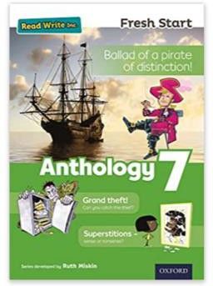

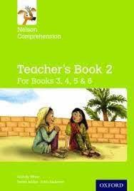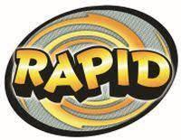

At Brookhaven, we do not use a specific reading scheme as we are a secondary school. Instead, we use a range of age-appropriate materials suited to the needs of our students. We use Fresh Start Anthologies, Nelson Comprehension and Spelling books and Rapid Readers as well as Barrington Stoke age-appropriate texts. We have also used comic-strip versions of texts, which the students have enjoyed.

Progress can be identified in termly data drops, progress through learning outcomes (see below), teacher comments and next steps, progress through reading material, performance in assessments and mini-tests/quizzes, reading and spelling age tests and the work that students might complete at home using Core 5 or Lexia. Appropriate interventions will be put in place for students who are not making the expected progress.

We have developed our own assessment statements for use on our data system, SOLAR. We have used information from a range of sources, such as the National Curriculum, Equals materials for English and specifications, mark schemes and assessment outcomes for a variety of accreditation pathways for English.

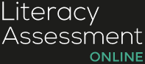

Reading and spelling ages are assessed using the Literacy Assessment Online programme. This not only assesses students’ abilities to de-code, but also their understanding, by placing the word to be read within a sentence.

# Spelling

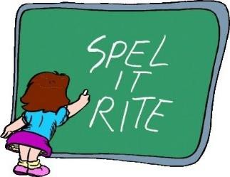

Students are encouraged to ‘have a go’ at spelling words themselves and phonetically plausible attempts are usually made. Many of our students have felt like ‘failures’ at primary school, so while we aim to correct some spellings in a piece of work, we would not highlight every incorrectly spelt word. In the past, weekly spellings have been learnt and tested in English at Key Stage 3. This is something we may look to re-implement in the coming academic year.

# Cross-curricular

Key words are identified on planning documents and staff are expected to highlight these in their teaching. Staff will use pure sounds to support students to decode words if necessary.

All staff are aware of students’ reading ages – this again is included on their planning documents. This information is referred to when planning lessons to ensure that any text or language used is not too complicated for the particular students being taught and that differentiation is appropriate.

Students are able to use their iPads in all lessons. Reading bonuses can be awarded when students don’t even realise they are reading – for example, when students are doing a Kahoot quiz, they are encouraged to read the questions and answers by themselves. In addition, the ‘read aloud’ function on Word documents is ideal for students who struggle to read and understand a text, and documents can be emailed to students so that they can access them in lessons by turning this function on. Some students in KS4 also use reading pens

Staff are aware that reading across the school is everyone’s responsibility. We had a training session about the reading strategy at the start of this academic year, reminding staff about the range of activities that use skills associated with reading, such as interpreting the words of songs or audio clips, labelled diagrams, inferring details from images, signs, logos, music videos etc. We are also incorporating VIPERS questioning (Vocabulary, Inference, Prediction, Explanation, Retrieval and Summarising/sequencing) into our starter activities, with questioning being at the correct level for the class or student.

**Reading throughout the curriculum**

When asked, staff identified that students develop their reading skills within their lessons in the following ways:

* reading out information from PowerPoint slides
* reading instructions on a task sheet or from the board
* sequencing and ordering instructions
* reading out daily meal options
* reading comments by other students in peer-to-peer assessment
* reading staff comments in books carrying out research

In science lessons, students read when they:

* relate the new keywords to where they may be used every day
* break down the word to relate it to the topic (for example ‘thermometer’ – therm is the name we give to heat, a meter is used to measure – therefore a thermometer is something we use to measure heat)
* define new keywords using the iPads, and write in own words
* read out information to others
* research to complete tasks – for example where radiation is used every day linked to benefits and risks – they have to identify the correct information.
* are provided information sheets or extra reading materials if they demonstrate an interest to find out more
* have support to construct longer answers

# Sora

Students are able to access this both in school and on their device at home. We have purchased a range of titles suitable for our students, including read-along titles for our

struggling readers, low reading age/ high interest age titles, comic books/graphic novels, non-fiction books, juvenile and teenage fiction. The app tracks what students read, when they read and how long they read for, and they can earn ‘achievements’ if they want to, adding a ‘game’ element to their reading.