Document Owner: | Dawn Platt
Approved By: | C-Suite
Queries to: | Education Team
Review Period: | 3 years or as appropriate
Date of last review: | 1st September 2024

Attendance Policy
CONTENTS Page

1. Who Is the Policy for? 3
2. Policy Aims 3-4
3. Legislation and Guidance 5
4. The Importance of School Attendance 6
5. Recording of School Attendance 7-8
6. Monitoring the Attendance Register 9
7. Completing the Attendance Register for Pupils Educated
Off Site 9
8. Legal Sanctions 9
9. Strategies for Promoting Attendance 9-10
10. Attendance Monitoring and Reporting 10
11. Roles and Responsibilities 10-11

1. Who is the Policy for?
The policy applies to all staff employed by the education establishments which form part of the Shaw Education Trust (SET) and any consultants undertaking work on behalf of the Trust.

2. Aim
The Trust takes a whole-school approach to maintaining excellent attendance and it is the joint responsibility of parents, pupils, and all staff members to ensure that children are attending school as they should be. Attendance is everyone’s business. We endeavour to work with families to make sure that any problems or circumstances, which may lead or be leading to poor attendance, are given the right attention and appropriate support. Our schools use evidence-informed practices, and a shared understanding of everyone's roles and collective responsibilities to promote exceptional attendance.
Shaw Education Trust expects all schools to ensure that attendance is a key priority for improving pupils’ outcomes and schools should follow the key principles below:

- Offer a clear vision for attendance, underpinned by high expectations and core values, which are communicated to and understood by staff, pupils and families.
- Make sure staff, pupils and families understand that absence from school is a potential safeguarding risk and understand their role in keeping children safe.
- Expect good attendance and punctuality from all members of the school community and make sure that pupils understand its importance.
- Convey clear messages about how absence affects attainment, wellbeing, and wider outcomes. Empower staff to take responsibility for attendance.
- Recognise attendance as an important area of school improvement. Make sure it is resourced appropriately (including through effective use of pupil premium funding) to create, build, and maintain systems and performance.
- Have a designated attendance champion in the senior leadership team with clearly assigned responsibilities which are identified within the attendance policy, escalation of procedures and school improvement plan.
- Make sure staff receive professional development and support to deploy attendance systems effectively.
- Academy Councils should have an accurate view of school attendance and engage in escalation procedures where appropriate.
- Where reasonably possible, schools should hold more than one emergency contact number for each pupil. This is good practice to give the school additional options to make contact with a responsible adult.

3. Legislation and guidance
This policy meets the requirements of the Working together to improve school attendance from the Department for Education (DfE).
Working together to improve school attendance
Other relevant government guidance that is also included for schools are listed below:
The Education Acts 1996 and 2002
The Children Act 1989
The Crime and Disorder Act 1998
The Anti-Social Behaviour Act 2003
The Education and Inspections Act 2006
The Sentencing Act 2020
The School Attendance (Pupil Registration) (England) Regulations 2024
The Education (Parenting Contracts and Parenting Orders) (England) Regulations 2007
The Education (Penalty Notices) (England) Regulations 2007, as amended
The Education (Information about Individual Pupils) (England) Regulations 2013
The Children and Young Persons Acts 1933 and 1963
The Equality Act 2010

4. The Importance of School Attendance
School attendance is not merely a requirement but a fundamental pillar of education. It plays a pivotal role in shaping academic success, personal growth, and future prospects, making it an indispensable aspect of any educational system.

Academic Achievement: Regular attendance directly correlates with academic success. Children who attend school consistently are more likely to keep up with the curriculum, perform better in exams, and improve their life outcomes.
Knowledge Acquisition: School is where children acquire knowledge and skills that are crucial for their personal and professional growth. Missing days means missing out on valuable learning opportunities.
Social Development: School provides a vital social environment for children and adolescents to interact with peers, develop friendships, and learn essential social skills. Consistent attendance ensures children remain connected to their peer group.
Building Routine: School attendance establishes a structured routine in children’s lives, teaching them time management and responsibility, which are valuable life skills.
Teacher Interaction: Regular attendance allows for meaningful teacher-child interactions. Teachers can provide personalised support, address questions, and assess individual progress more effectively when children attend regularly.
Preventing Knowledge Gaps: Frequent absences can lead to significant knowledge gaps, making it challenging for children to catch up with missed lessons, potentially resulting in long-term academic struggles.
School Engagement: Children who attend school regularly are more likely to engage in extracurricular activities, sports, and other enriching experiences that contribute to their overall development.
Legal and Parental Responsibility: Parents or guardians are legally responsible for ensuring their child's regular school attendance. Failing to do so can lead to legal consequences.
Community Well-being: High levels of school attendance contribute to the overall well-being of communities.

5. Recording Attendance
By law, all trusts (except those where all pupils are boarders) are required to keep an attendance register, and all pupils must be placed on this register. All schools in the Trust should ensure that school systems follow the guidance below:
4.1 Attendance Registers
The attendance register will be taken at the start of the first session of each school day and once during the second session. It will mark whether every pupil is:
- Present
- Attending an approved off-site educational activity
- Absent
- Unable to attend due to exceptional circumstances
- Any amendment to the attendance register will include:
- The original entry
- The amended entry
- The reason for the amendment
- The date on which the amendment was made
- The name and position of the person who made the amendment
A list of DfE attendance codes are available in the Working together to improve school attendance: (pg76 onwards) Only codes specified in the DfE’s school attendance guidance may be used in attendance registers and using the descriptors as given in the document.
4.2 Unplanned Absence
Parents must notify their child’s school on the first day of an unplanned absence – for example, if their child is unable to attend due to ill health – by 9:20am or as soon as practically possible. When a child is to be absent from school without prior permission, parents should inform the school by telephone on the first day of absence and let them know what date they expect the child to return. For a prolonged absence, this should be followed up with a written note from the parent/carer of the child. Alternative arrangements will be made individually with non-English speaking parents or carers.
Absence due to illness will be authorised unless the school has a genuine concern about the authenticity of the illness.
If the authenticity of the illness is in doubt, the school may ask parents to provide medical evidence, such as a doctor’s note, prescription, appointment card or other appropriate form of evidence.
If the school is not satisfied about the authenticity of the illness, the absence will be recorded as unauthorised, and parents will be notified of this in advance.
4.3 Medical or Dental Appointments
Missing registration for a medical or dental appointment is counted as an authorised absence; advance notice is required for authorising these absences. However, we encourage parents to make medical and dental appointments out of school hours where possible.
4.4 Lateness and Punctuality
A pupil who arrives late but before the register has closed will be marked as late, using the appropriate code. A pupil who arrives after the register has closed will be marked as absent, using the appropriate code. Persistent lateness may result in disciplinary action from the school. Persistent lates may be referred to the legal attendance process, including prosecution if lateness persists.
4.5 Following Up Absence
Headteachers must ensure that there are robust policies and practices in place for determining the reasons for absence of pupils. These processes include first-day calls and follow-up telephone calls, texts, emails, letters, home visits and the involvement of external agencies. It is good practice where attendance is an issue or is likely to become one, to invite parents and carers to a meeting to discuss attendance, ascertain any support required to secure good attendance and to outline the impact of poor attendance on educational progress and outcomes.
The school is expected to follow up any absences to ascertain the reason, ensuring proper safeguarding action is taken where necessary, identify whether the absence is approved or not and identify the correct attendance code to use.
4.6 Reporting to Parents
Attendance data will be reported to parents on their child’s termly and end of year reports. This may be more frequently if schools require for specific pupils.

6. Monitoring the Attendance Register
Attendance registers must be closely monitored, and trends and patterns of non-attendance identified and addressed. It is recommended that attendance rates of all groups of pupils are gathered and scrutinised weekly. Schools will of course have target groups of pupils who they are monitoring more closely, and it is expected that their attendance is considered on a daily basis.

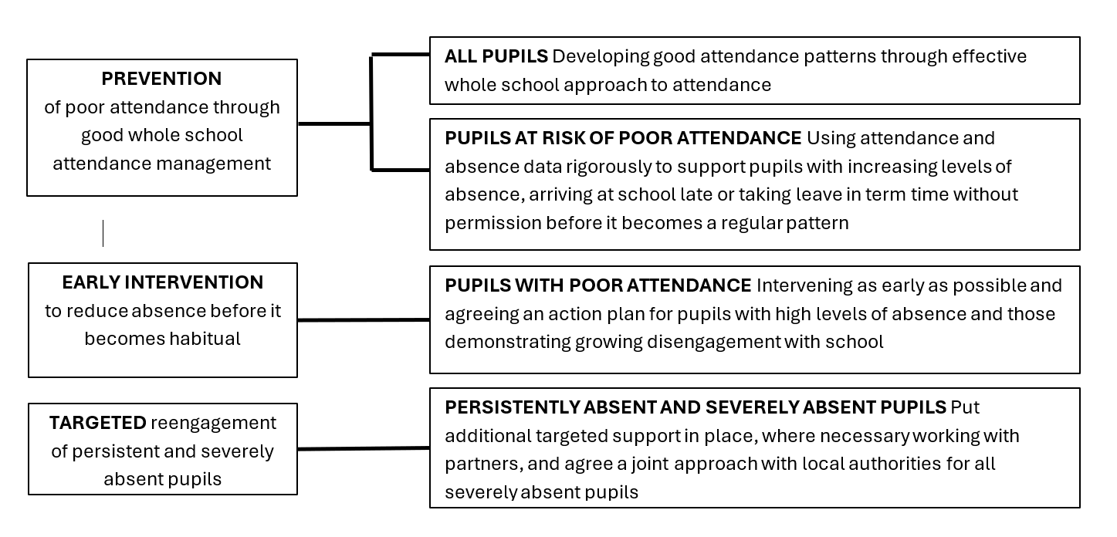

7. Completing the attendance register for pupils
educated off-site
Headteachers must ensure that robust arrangements are in place to check on the attendance of pupils attending alternative provision off-site. Alternative providers must be instructed to advise the home-school of any absence as it occurs. This will ensure that the appropriate checks and safeguards can be put in place and the registers can be completed accordingly. Attendance of pupils off site should only be updated on the day of contact and never in advance.

8. Legal Sanctions
Schools can fine parents for the unauthorised absence of their child from school, where the child is of compulsory school age. Schools should liaise with their local authority and follow local procedures for penalty notices. The decision to request a penalty notice ultimately rests with the school and Trust School Link. This may take into account:
A number of unauthorised absences occurring within a rolling academic year
One-off instances of irregular attendance, such as holidays taken in term time without permission
Where a suspended pupil is found in a public place during school hours without a justifiable reason

Our approach to attendance management is based on the principle of prevention, early intervention and targeted support. At all stages we aim to work in partnership with parents/carers to address and barriers to attendance and/or punctuality together. Where support is not successful. or is not engaged with, the law protects pupils’ rights to an education and provides a range of legal interventions to formalise attendance improvement efforts, and where all other avenues have been exhausted, enforce it thorough prosecuting parents.
We will work will Bury local authority to use the full range of legal interventions available to us to protect the pupils right to an education. These are:
Attendance contracts
Education supervision orders
Attendance prosecution
Parenting orders
Fixed penalty notices

Decisions on which intervention to take will be made on a case-by-case basis after considering the individual circumstances of the family.
9. Strategies for Promoting Attendance
All schools are expected to use a wide range of appropriate strategies to promote strong attendance. The Trust also provides support through the Trust School Link and the use of the ‘Attendance Toolkit Document.’ This document provides guidance to schools within Shaw Education Trust to support them to improve school attendance. Schools are also expected to attend any ‘Attendance Hub’ meetings that are offered by the Trust or external providers.
If we have concerns about a pupils attendance and/or their punctuality then we will work in partnership with parents/carers to support improvements. This may involve a meeting in school to support the family in identifying and addressing the barriers to attending school and/or attending school on time.
We will hold regular meetings with the parents of pupils who are severely absent (50% or more absence) those with patterns of absence and pupils who show an unexpected or unexplained dip in attendance.
Working with parents, we will identify pupils who need support from wider partners and will make the necessary referrals as quickly as possible, With parental consent, this may include exploring Early Help support through completion of the ‘Story so Far’ assessment.
If we have any concerns about the welfare and wellbeing of a pupil then, in line with our safeguarding policy and procedures, we will make the necessary referrals.

10. Attendance Monitoring and Reporting
Schools should ensure they are reporting their performance in relation to national statistics. All schools will report attendance information to various stakeholders at different times of the academic year. For example:
Governance Meetings (Termly)
Trust School Link Meetings (weekly)
Health Check Visits and on-site visits (Termly)

Schools are also expected to ensure that there is a direct link to school attendance figures through the trust management information system -Arbor. The Trust will use Arbor to access attendance information for Trustee Reports. (including reporting to other stakeholders such as school commissioners).
11. Roles and Responsibilities
8.1 The Board of Trustees
The Board of Trustees has responsibility for holding Shaw Education Trust to account for learners’ attendance across the academies within the Trust. The Board of Trustees is responsible for monitoring attendance figures for the whole trust on at least a termly basis. It also holds the Trust CEO to account for the implementation of this policy.

8.2 The Trust CEO
The Trust CEO is responsible for ensuring this policy is implemented consistently across the Trust, and for monitoring school-level absence data and reporting it to trustees. The CEO is also responsible for ensuring that the education team support schools effectively to improve or maintain excellence within attendance.

8.3 The Headteacher
Are responsible for ensuring that schools do all they can to improve or maintain excellent attendance. They will also ensure:
They follow reporting procedures for attendance within the policy
Have a clear vision for attendance that is communicated across their communities
They build a clear culture around the importance of attendance
Evaluate and monitor expectations and processes
Have a clear oversight of attendance data analysis
Have a clear vision and strategy for attendance improvement
Ensure that targeted support and intervention is delivered to pupils and families where appropriate
Reports any concerns about attendance to the Trust School Link.

8.4 Academy Council
The Academy Council will monitor pupils’ attendance and hold leaders across the school to account for attendance of pupils.
The Academy Council will also ensure that:
Systems within schools are producing clear, concise, and accurate information to support effective strategies in raising pupils’ attendance
They will ensure that headteachers and principals are held to account for whole school attendance figures.
A variety of quality assurance methods are undertaken to ensure the integrity of data at all times.
The school seeks the support from Trust Level Leaders when necessary to improve attendance.

8.4 Class Teachers
Class teachers are responsible for recording attendance on a daily basis, at the correct time, using the correct codes, and submitting this information to the school office or the school management information system (MIS).

This policy has been equality impact assessed and we believe in line with the Equality Act 2010. It does not have an adverse effect on race, gender or disability equality.



Shaw Education Trust Head Office,  Kidsgrove Secondary School, Gloucester Road,  Kidsgrove,  ST7 4DL | Twitter  LinkedIn  Call  Email  Visit | @ShawEduTrust  @ShawEducationTrust  01782 948259  info@shaw-education.org.uk  shaw-education.org.uk



