Monday 4th January 2021

Dear Parents/Carers,

Following the announcement this evening we are to close school for all pupils tomorrow. We will spend the day preparing for remote learning and the delivery of learning to the pupils that fall into the category of Key Workers. This, as last time, is for those parents whose work is critical to COVID-19. Please be mindful that if you can care for your children at home then you must, as we hope that this new nationwide lockdown will be the successful necessary step to support our NHS. We will have to limit our numbers to ensure that we are able to deliver remote learning effectively to those at home as well as those having to be at school.

While school is closed on this day please look at your home learning page to access educational activities.

As from Wednesday school will be open for Key Worker pupils and our Little Chicks only with remote learning provision accessible for all other pupils. Our remote learning package will provide a mixture of live teaching and videos along with links to websites and resources. We hope that the children will enjoy their learning and continue to make progress as they have been doing since September.

Please use the link below to book a key worker place. We will email confirmation of allocated places tomorrow afternoon.

https://docs.google.com/forms/d/e/1FAIpQLScxNne9J6Z9imSA4xh07qDKhreF95nv37O8uLnGoYmjX8ruAQ/viewform
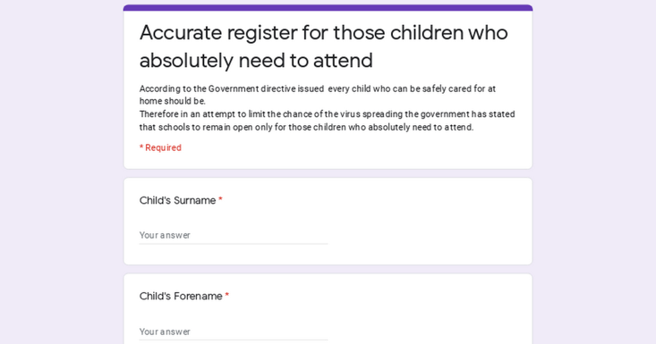 | Accurate register for those children who absolutely need to attend  According to the Government directive issued this evening every child who can be safely cared for at home should be. Therefore in an attempt to limit the chance of the virus spreading the government has stated that schools to remain open only for those children who absolutely need to attend.  docs.google.com

As always, we appreciate your patience and support with all school matters.

Yours sincerely,

Susan McGrath

